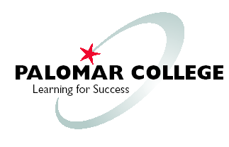

TECHNOLOGY MASTER PLAN
2019

PALOMAR COMMUNITY COLLEGE DISTRICT

Ron Ballesteros-Perez
Assistant Superintendent/Vice President
Finance and Administrative Services Division

TABLE OF CONTENTS

Executive Summary

Planning Framework/Process 4

Technology Ideas and Requests 5

Technology Guiding Principles 6

Technology Goals 6

Technology Goals - Alignment with Institutional Strategic Plan and Operations 7-8

Institutional Technology Resources 9-11

Goals, Objectives and Associated Projects 12-15

Appendix A - Technology Proposal Analysis Checklist

Appendix B - Institutional Strategic Goals

Executive Summary

The 2019 Palomar College Technology Master Plan identifies six broad technology goals designed to support the institution’s strategic goals and sustain ongoing operations. These technology goals are developed within the institutional planning framework briefly described in section 1. Section 4 identifies each goal and section 5 describes its alignment with the institution’s strategic goals and operations. In section 7, each technology goal is further defined by specific objectives and the technology projects and measurable outcomes that support those objectives.

Successful implementation and support for technology projects relies on thorough planning. Section 2 of this Technology Master Plan introduces a checklist that can be used to strengthen the institutional technology planning process and help clarify and prioritize technology projects. The checklist includes basic questions about a technology proposal that must be answered at some stage in the technology project planning or implementation process. Analyzing the questions early in the process helps prepare the proposal for review by planning councils and can strengthen the justification for funding or authorizing the project. This checklist is designed to aid the requestor in thinking through the impacts and considerations of their proposal in order to support successful execution of the project.

Section 3 of this plan describes the guiding principles used to validate and assess technology initiatives to ensure alignment with the institution’s technology strategy. Section 6 describes the departments that provide foundational support for institutional technology implementation and maintenance in both the academic and administrative functions.

The Technology Master Plan Work Group reviews institutional technology projects quarterly and incorporates project changes into the Technology Master Plan as part of their annual master plan review. Additionally the Work Group reviews Technology Proposal Analysis Checklists and provides supporting comments, additional justification or information that can help solidify the plan’s feasibility for implementation. This process is intended to facilitate the movement of a technology proposal through the existing institutional processes for approval and funding.

Planning Framework/Process

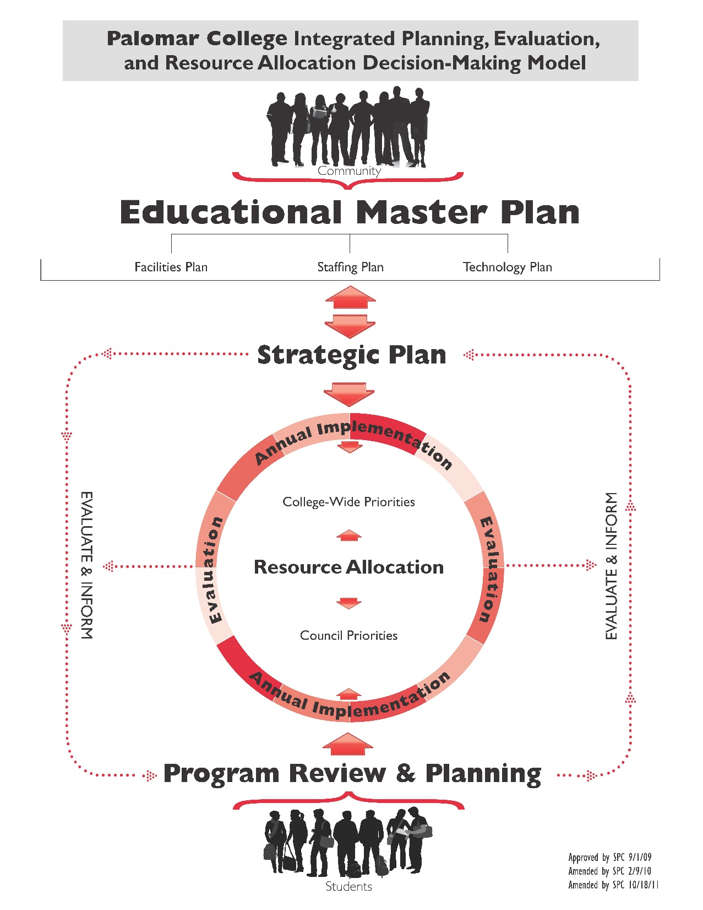
Palomar College relies on technology to facilitate and sustain the institutional mission, goals and operations. The strategic direction for the institution is defined by the Educational Master Plan which therefore serves as the primary source of input for technology planning. The Integrated Planning, Evaluation, and Resource Allocation Decision-Making Model shows the placement of technology master planning in the institution’s overall planning and evaluation process. By this diagram it is apparent that council and college-wide priorities

Technology Ideas and Requests

The Technology Projects identified in this Plan are reviewed quarterly by the Technology Master Plan Work Group to ensure that the Projects align with the Educational Master Plan and the institutional Strategic Plan, and continue to support institutional priorities. Quarterly reviews will include Project changes, updates and additions, based on Planning Council decisions. These reviews will serve as input to the annual Technology Master Plan review. Technology Master Plan adjustments will be made annually in order to keep the Plan current and to reflect Project activity and emphasis. Such adjustments may include changes to or removal of existing Projects identified in the Plan, or the addition of new Projects to this Plan.

To assist project requestors in fully forming new technology initiatives within the framework of this Technology Strategic Plan, the Technology Master Plan Work Group has developed the following process. Technology proposals or ideas are reviewed by the Technology Master Plan Work Group using a completed Analysis Checklist from the requestor. The Checklist is intended to aid the requestor in the clarification and prioritization of technology projects to benefit the institution. The Checklist should accompany the project recommendation to the appropriate Planning Council for approval through the existing institutional participatory governance process. Components of the Checklist include consideration of the impact of the project or idea on existing services, systems and resources, the benefits of the project, and how the project aligns with the institution’s Technology Goals. Developers of Program Review Plans with significant technology components can use the same analysis checklist to fully vet their plans and help solidify the PRP’s implementation feasibility. Refer to the Analysis Checklist in Appendix A.

Technology Guiding Principles

In the same way that our institutional values guide our institutional success, technology values establish the foundation from which technology initiatives can be confidently planned and executed. The following Guiding Principles are used to validate and assess technology initiatives to ensure alignment with the College’s technology strategy.

- Reliable, sustainable, vendor-supported technology solutions, implemented to reduce risk, ensure long-term viability and maintain technical currency.
- Secure and compliant technology solutions to protect student and institutional data, processes and resources.
- Quality, cost-effective and efficient technology solutions, implemented to protect and maximize institutional investments.
- Requirements-driven, automated technology solutions that are integrated with institutional systems and business processes to facilitate implementation, maintenance and ease of use.
- Platform-agnostic, flexible technology solutions that are simultaneously feature-rich, portal-based and mobile-aware.

Technology Goals

Technology Goal 1 - Ensure operational data integrity and reliable technology infrastructure.
Technology Goal 2 - Facilitate student services, and enhance teaching and learning objectives, through smart campus, classroom and online technologies.
Technology Goal 3 - Ensure sustainable technology by using current vendor-supported software, by reducing local customizations, and by participating in statewide technology initiatives.
Technology Goal 4 - Optimize business processes and facilitate decision-making through automated workflows, dashboards and targeted reports.
Technology Goal 5 - Train and support users for effective use of technology.
Technology Goal 6 - Maximize efficiency through planned resource stewardship; clarify technology replacement plan and stabilize associated operational funding.

Technology Goals - Alignment with Institutional Strategic Plan and Operations

Palomar College Technology Goals and Institutional Strategic Goals rely on a solid technology foundation. The technology goals described in this technology master plan are formulated to support the institutional strategic goals and initiatives, as well as to provide sustaining support for College operations. The following table defines our technology goals and shows their alignment with institutional strategic goals and operations:

Technology Goal 1
Ensure operational data integrity and reliable technology infrastructure
- Supports Institutional Operations
- Supports Facilities Master Plan
Technology Goal 2
Facilitate student services, and enhance teaching and learning objectives, through smart campus, classroom and online technologies
- Supports Institutional Strategic Goal 1: Implement Instructional Strategies that Strengthen and Connect Teaching and Learning across the College
- Supports Institutional Strategic Goal 2: Strengthen efforts to improve Outreach, Persistence, and Student Success
Technology Goal 3
Ensure sustainable technology by using current vendor-supported software, by reducing local customizations, and by participating in statewide technology initiatives
- Supports Institutional Operations
- Supports Institutional Strategic Goal 2: Strengthen efforts to improve Outreach, Persistence, and Student Success
- Supports Institutional Strategic Goal 5: Ensure the Fiscal Stability of the College and Increase Enrollments
Technology Goal 4
Optimize business processes and facilitate decision-making through automated workflows, dashboards and targeted reports
- Supports Institutional Strategic Goal 2: Strengthen efforts to improve Outreach, Persistence, and Student Success
- Supports Institutional Strategic Goal 3: Strengthen the College’s Message to our Community
- Supports Institutional Strategic Goal 5: Ensure the Fiscal Stability of the College and Increase Enrollments
Technology Goal 5
Train and support users for effective use of technology
- Supports Institutional Strategic Goal 4: Maintain and Support a Diverse Workforce
Technology Goal 6
Maximize efficiency through planned resource stewardship; clarify technology replacement plan and stabilize associated operational funding
- Supports Institutional Operations
- Supports Institutional Strategic Goal 1: Implement Instructional Strategies that Strengthen and Connect Teaching and Learning across the College
- Supports Institutional Strategic Goal 5: Ensure the Fiscal Stability of the College and Increase Enrollments

Institutional Technology Resources

Academic Technology Resource Center

The purpose of the Academic Technology Resource Center (ATRC) is to facilitate and enhance teaching and learning in a supportive environment for students, faculty, and staff at Palomar College through the use of technology. The ATRC

• provides resources for faculty, staff and students
• maintains computer labs
• administers the Learning Management Systems
• administers various college web servers / services
• provides technology training workshops / materials
• provides media services
• provides hardware for check out
• provides software usage guidance
• and more!

Adapted Computer Training Center

The Disability Resource Center’s Adapted Computer Training Center is designed to serve students with a variety of disabilities. The program goals are to explore vocational computer possibilities, provide training in the use of assistive technology and to support students as they enter other academic environments. Training classes offered each semester focus on the use of the computer as a tool in academics in combination with assistive technology.

Palomar College Television

Palomar College Television (PCTV) has been in operation for more than thirty-five years. The purpose of the department is to serve college faculty, staff, and students through the creation and use of media-rich content. PCTV staff support instruction through the development, production, and broadcast of video courses. PCTV fulfills this mission specifically by
- increasing student access, reducing educational barriers, and enhancing academic performance by advancing state-of-the-art technology and innovative academic programming.
- researching, evaluating, and revising processes adopted to meet this mission, and working toward professional staff development and program expansion.
- ongoing enhancement of our state-of-the-art program to complement and supplement the district's strategic goals.
- expanding upon important campus and extramural partnerships by offering a broad perspective of academic and technical learning opportunities.
- through an innovative marketing plan, increasing community outreach, awareness, and recognition of both Palomar College and the scope and effectiveness of the distance learning program.

Information Services

Information Services (IS) serves students, faculty, staff, administrators and the community through high quality technical support, information systems and services. The IS department takes pride in their role as a strategic partner with the District’s academic divisions, administrative and service departments, and with individuals, to advance institutional goals through student-centered technology solutions.

Information Services departments include the Help Desk, Technical Services, Systems and Programming Services, and Network and Data Center Services.

Help Desk
The Help Desk serves as the first point of contact for students, faculty, staff and administrators requiring technical services or support for computers, audio-visual and peripheral equipment, network services, software applications and access to District technology resources. This team receives technical requests either by phone, by email or in person; diagnoses technical problems and applies a full range of corrective actions, initiates work orders to the appropriate Information Services staff members or contacts vendors to resolve issues, and keeps requestors and constituent groups informed on problem-resolution status.

The Help Desk is responsible for system account security administration and offers password assistance to individuals. This team also facilitates general information announcements to various District groups. In addition, the Help Desk provides institution switchboard operation services, greeting callers and addressing their questions or connecting them with appropriate District service areas.

Technical Services
Technical Services provides District-wide computer, audio-visual, printer, mobile device, tablet and other technology planning, acquisition, replacement, configuration, installation and repair. The Technical Services team configures and supports instructional and conference room audio-visual systems, public address systems, instructional technologies such as classroom and laboratory computers, enterprise applications and specialized software and peripherals, as well as operational, service center and office equipment and workstation software.
Technical Services staff are skilled in working with both MAC and PC platforms and work to provide solutions, guidance, configuration planning and cost information in accordance with District technology standards and compatible with District infrastructure.
Systems and Programming
The Systems and Programming department provides development, programming, database administration and technical support for the College's administrative Student/Human Resources/Financial software applications and related systems. This team works closely with Business Analysts in various departments across the institution to advance business processes and address the reporting requirements in those service areas.

Network and Data Center Services
Network and Data Center Services provides, maintains, and supports the District’s technology infrastructure for data, voice, mobile devices, and processing capabilities.

Goals, Objectives and Associated Projects

Strategic Technology Goal 1 - Ensure operational data integrity and reliable technology infrastructure

Objectives
  - Implement and maintain reliable and secure information systems infrastructure
  - Maintain technical currency of Data Center and operational technology

Projects | Timelines | Measurable Outcomes
Replace/upgrade aging infrastructure in Data Center (includes firewall, VBlock) | December 2016 | Key infrastructure components operating reliably under warranty
Participate early in construction projects to ensure AV and data standards adherence | Ongoing | Reduction of change orders to address non-standard AV or data installations
Complete and relocate virtualized system for Escondido | December 2016 | Fully compatible Disaster Recovery and Data Center services at Escondido
Decommission HPUX system and secure destruction of data | November 2016 | HPUX surplussed without risk to institutional data
Expand port security to all buildings | October 2017 | No open ports
Migrate user data to new storage system | January 2017 | Retire legacy storage and use more efficient storage system

Strategic Technology Goal 2 – Facilitate student services, and enhance teaching and learning objectives, through smart campus, classroom and online technologies

Objectives
  - Reduce technology barriers to teaching and learning
  - Enhance services to students through technology

Projects | Timelines | Measurable Outcomes
Implement a single-sign-on identity management system to facilitate access to institutional systems and services | January 2017 | Students, faculty and staff use a unified username and password credential that provides access to institutional systems while also improving identity management
Provide access to key institutional services for students, faculty and staff through a comprehensive single-sign-on Palomar Mobile App that is available from App Stores. | November 2016 | Seamless student access to key applications through Mobile App
Implement a Payment Plan option for students | November 2016 | Students have the choice to use a payment plan as opposed to paying in full
Upgrade Exchange for Student Email Accounts from 2007 physical to Office 365/2013 virtual | February 2017 | Students receive MS Office and cloud storage at no cost to student or institution
Upgrade Global Viewer server |  | Maximize efficiency of Extron devices (used in classrooms)
Integrate new Online Orientation system with MyPalomar (eServices) | September 2016 | Eliminate manual administration and improve student access
Expand audio-visual capability in SU | August 2016 for interim solution | Enable integrated use of AV (TVs and projectors) for meeting support in SU

Strategic Technology Goal 3 - Ensure sustainable technology by using current vendor-supported software, by reducing local customizations, and by participating in statewide technology initiatives

Objectives
  - Maintain technical currency of institutional software applications
  - Implement vendor-delivered technology features and functions (reduce customizations)
  - Participate in statewide CCC initiatives

Projects | Timelines | Measurable Outcomes
Upgrade Campus Solutions PeopleTools 8.50 to 8.54 | May 2016 | Stable operation with new Tools version; increased capability
Implement cccApply | October 2016 | Reliable collection of admissions application data through cccApply into PeopleSoft
Implement cccAssess | November 2016 | Reliable utilization of cccAssess (in conjunction with Multiple Measures) to make placement recommendations for incoming students
Upgrade Human Capital Management PeopleTools 8.51 to 8.54 | November 2016 | Stable operation with new Tools version

Strategic Technology Goal 4 - Optimize business processes and facilitate decision-making through automated workflows, dashboards and targeted reports

Objectives

  - Implement automated workflows to facilitate business processes resulting in improved efficiencies and reduction of process backlogs

Projects | Timelines | Measurable Outcomes
Automate graduation evaluation business workflow | August 2017 | Faster graduation evaluations and notifications to students
Implement Abbreviated Education Plan for students and Counseling | April 2016 | Students complete Abbreviated Ed Plan in advance of initial Counseling appointment, enabling faster and efficient, targeted planning.
Improve class schedule search function | August 2016 | Users have access to refine search capabilities and can effectively identify scheduling options to meet their needs

Implement Comprehensive Education Plan

Strategic Technology Goal 5 - Train and support users for effective use of technology

Objectives
  - Improved access and efficiency
  - Increased availability of information and procedures surrounding use of technology

Projects | Timelines | Measurable Outcomes
Raise awareness and adoption of ProLearningNetwork (Grovo and Lynda) courses offered through CCCCO to enhance staff and faculty professional development | Fall 2016 | Increased participation by Palomar College employees
Implement new Professional Development platform | Spring 2017 | Streamlined processes for scheduling, tracking and reporting of PD activities

Strategic Technology Goal 6 - Maximize efficiency through planned resource stewardship; clarify technology replacement plan and stabilize associated operational funding

Objectives
  - Stabilize operational funds and support for technology replacement on a 5 year schedule
  - Maintain technical currency of classroom technologies, and student, faculty and staff computers
  - Maximize efficiency of building control system management

Projects | Timelines | Measurable Outcomes
Secure operational funds commitment for ongoing technology replacement | April 2016 | Funds available to replace technology on 5 year schedule – as warranties expire
Replace student, faculty and staff computers with expired warranties | June 2016 – December 2016 | Reduce inventory of expired warranty computers
Present replacement plan and associated procedure to planning councils | Fall 2016 – Spring 2017 | Increased understanding of technology replacement plan and procedure
Replace obsolete audio-visual equipment in classrooms and meeting spaces | January 2017 | Reduce inventory of obsolete and unusable equipment
Support Compass Energy Management Project |  | Reduce time to correction and work orders for building control systems
Replace old phones and integrate VOIP functions | Start Assessment May 2017 | Ensure all phones are current and vendor supported

Appendix A - Technology Proposal Analysis Checklist
Replace italicized text in the following checklist.

Project or Idea Name: | Short Title for this Project/Idea | Date:
Sponsor (and phone number): | Primary Stakeholder – usually an Administrator, but can be a Planning Council (list Council, Chair and Chair’s phone number) | Requestor/ Point of Contact (and phone number): | Person most likely to be making, collecting or coordinating tactical decisions, overseeing (or executing) major tasks
Additional Stakeholders
Anyone affected by the project’s implementation/outcome; Can be named individuals or groups (such as all students or all members of a department).

Scope/Description
Short description of the scope of the project; Should include basic requirements as described from the requestor’s perspective.

Benefits, Justification and/or Return on Investment
Brief explanation of why this Project or Idea is good for Palomar College.

Major Objectives/Deliverables
List the Project or Idea outcomes or results of implementing the Project or Idea in order to clarify expectations. Include any required or anticipated timeline for completion.

Technology Goal(s)
Identify which of the Technology Goals this Project or Idea supports:
 | Technology Goal | Work Group Confirmation
 | - Ensure operational data integrity and reliable technology infrastructure
 | - Facilitate student services, and enhance teaching and learning objectives, through smart campus, classroom and online technologies
 | - Ensure sustainable technology by using current vendor-supported software, by reducing local customizations, and by participating in statewide technology initiatives
 | - Optimize business processes and facilitate decision-making through automated workflows, dashboards and targeted reports
 | - Train and support users for effective use of technology
 | - Maximize efficiency through planned resource stewardship; clarify technology replacement plan and stabilize associated operational funding

Impact Considerations
Brief notes about the impact of this Project or Idea; Consider the following:
- Impact/implication to institutional policies and procedures
- State, federal, or regional initiatives
- Impact to current operational team and business processes in requestor’s area or other areas
- Integration with existing systems/environment/processes
- Level of effort by IS, ATRC and/or other departments
- Impact/interaction with other technology projects, initiatives and maintenance activities
- Technology infrastructure requirements

Budget
Are funds available or needed? Consider any ongoing operational budget requirements (for example, whether this requires budget for maintenance).

Resources (staff, special software/equipment)
Who and what is required to complete the project or implement the idea? Consider any ongoing operational staffing required to operate or maintain this Project or Idea.

Priority Checklist
Identify which of the Priority Considerations are addressed by this Project or Idea:
Y/N/? | Priority Considerations | Work Group Confirmation
 | Compliance (e.g., Federal/State Mandate, Accreditation Standards) please explain
 | Capacity to Implement, Use and Maintain (review Impact, Budget and Resource Considerations above)
 | Redundancy to existing resource please explain
 | Cost Savings to the District please explain
 | Return on Investment please explain
 | Solves institutional or operational problem or need please explain
 | Alignment with Strategic Plan Goals (or other goals, e.g., Instructional Requirements, Enrollment Management, Student Success) please explain
 | Time Constraints (review Major Objectives/Deliverables above) please explain
 | Technical Currency or Operational Maintenance Requirement please explain
 | Efficiency and may have multiple application to different areas please explain
 | Other (please describe):

Checklist submitted to Technology Master Plan Work Group: | date
Checklist returned to Requestor: | date
The Technology Master Plan Work Group reviews Projects and Ideas Quarterly on the third Wednesday of January, April, July and October, and provides a response to assist the requestor and the appropriate Planning Council in establishing the project’s priority.
Technology Master Plan Work Group Response

Appendix B - Institutional Strategic Goals
The following table identifies the approved Institutional Strategic Goals as of November 15, 2016:

 | GOAL | Summary of Objectives
Institutional Strategic Goal 1 | Implement Instructional Strategies that Strengthen and Connect Teaching and Learning across the College | Interdisciplinary dialogue and instruction; Examination of ILO: Knowledge of Human Cultures and the Physical and Natural World; strengthen and promote cultural fluency through professional development and other strategies.
Institutional Strategic Goal 2 | Strengthen efforts to improve Outreach, Persistence, and Student Success | Targeted recruitment strategies; educational pathways and student services; basic skills completion; implement user-friendly student technology; revise program review and planning process; address opportunity gaps.
Institutional Strategic Goal 3 | Strengthen the College’s Message to our Community | Integrated marketing/messaging communications plan.
Institutional Strategic Goal 4 | Strengthen, Promote and Support the College’s Diverse Workforce through Strategies focused on Recruitment, Hiring, and Retention. | Address critical staffing needs; Improve recruiting, hiring and professional development processes to increase diversity; Implement comprehensive professional development plan.
Institutional Strategic Goal 5 | Ensure the Fiscal Stability of the College and Increase Enrollments | Increase southern district course offerings; Strengthen and establish relationships with high schools and universities through access and transfer programs; Balance budget to align revenues and expenses; Implement enrollment management plan; Explore alternative revenue streams.

See Appendix A – Technology Proposal Analysis Checklist
See Appendix B - Institutional Strategic Goals

