Zoom
In Zoom, you can add your pronouns to your Zoom nametag either temporarily (for one meeting), or change them within your profile so that you don’t need to remember to add them each time you log on to a Zoom call. To add them at the profile level:
From https://zoom.us/:
- Sign in to Zoom
- Click on My Account
- Click on Profile
- Click on Edit next to your name
- You have two options for adding your pronouns:
  - There is now a field for Pronouns under your Display Name.
    - Add the pronouns you’d like displayed, and then choose from the drop down menu for when you’d like your pronouns displayed.

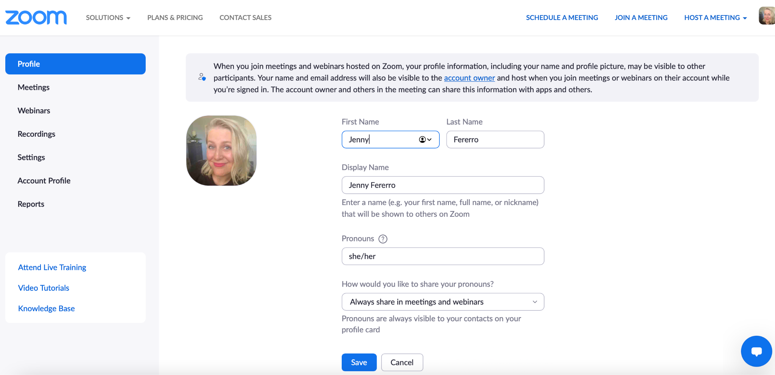

  - Within the name field for your last name, you can add your pronouns.
    - It’s recommended to use a hyphen or parentheses
    - If you have a long name, consider shortening your pronoun listing so that it will all show in your Zoom window nametag
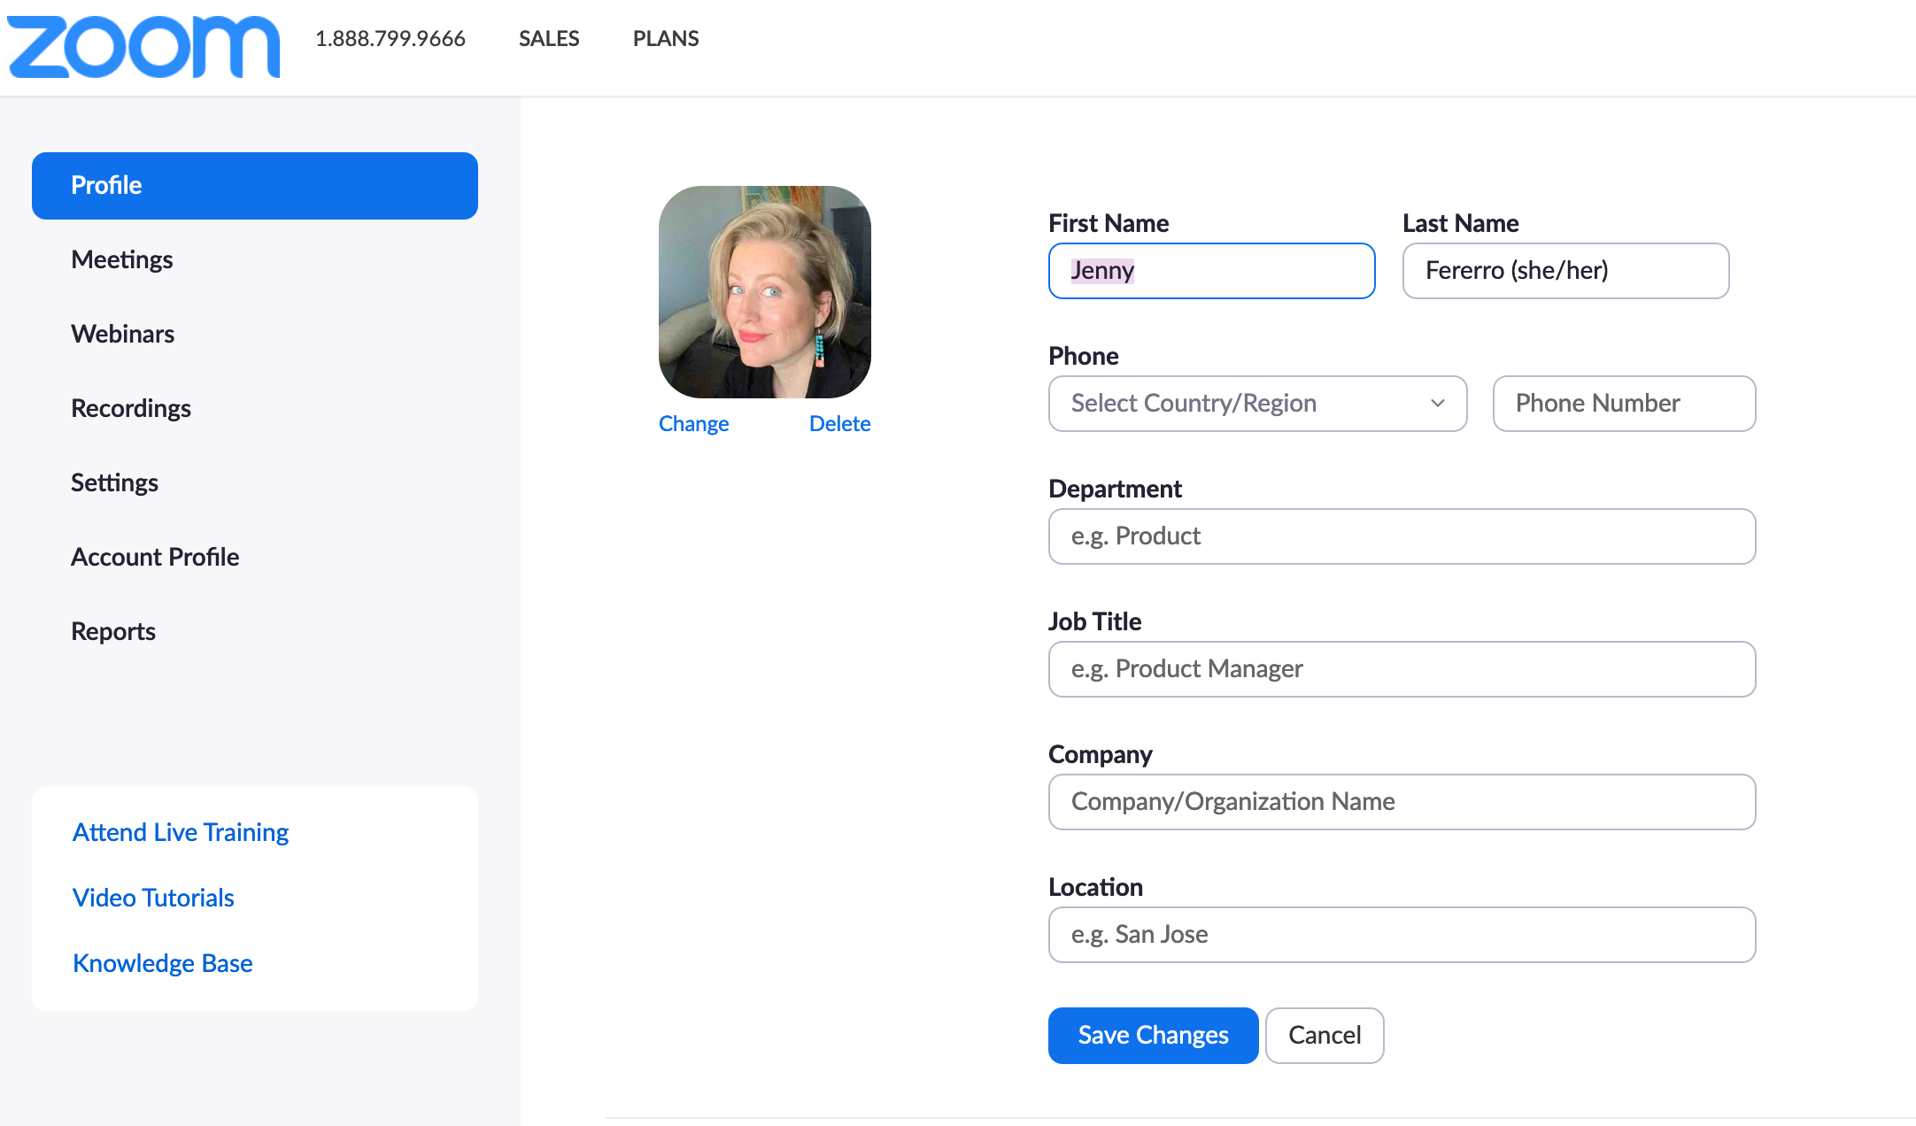

- Click on Save Changes

To add pronouns temporarily (for one meeting or class, for example):
- When you click a link to join a meeting or enter the meeting code, you can add your pronouns in your name field that will show up at that point.

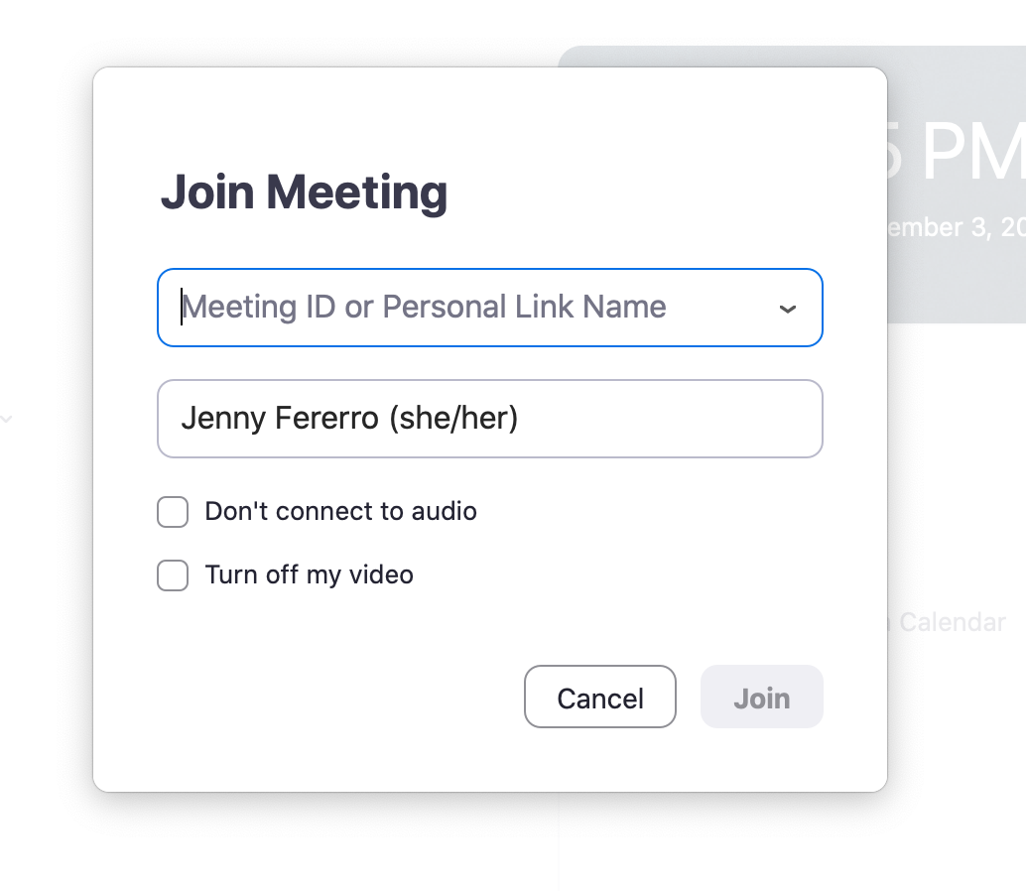
OR
- Once you are in the meeting, click on the three blue dots that appear if you hover your cursor over the upper right corner of your video screen box. Click on Rename and enter the pronouns you’d like to add for that meeting.
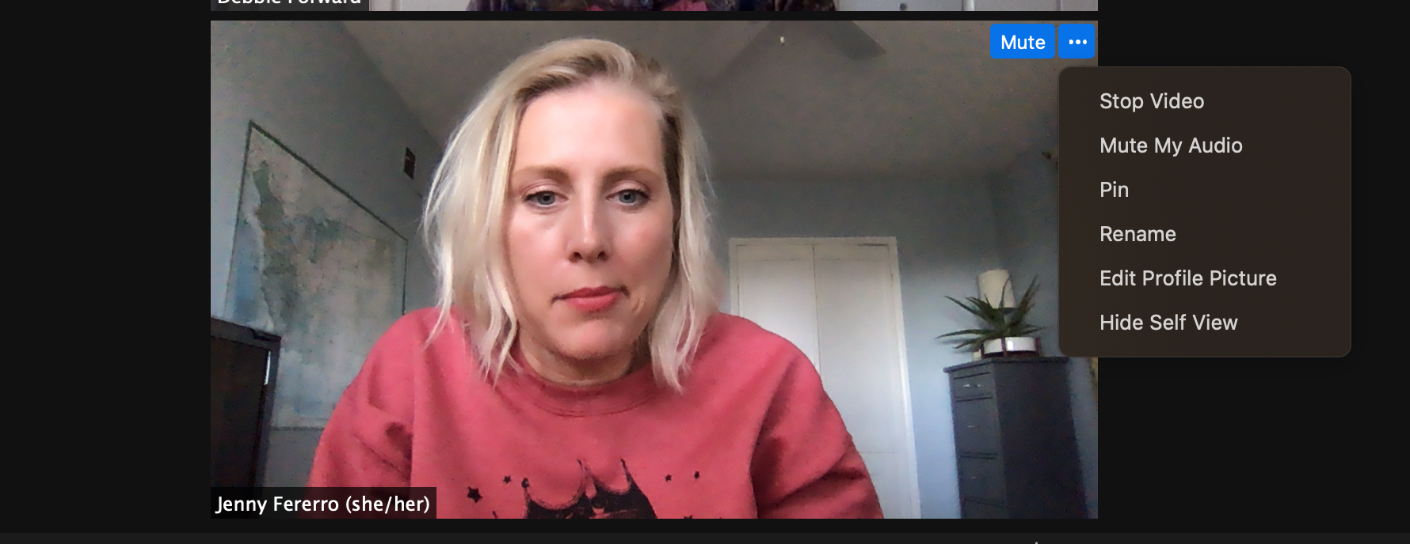
maybe the best face for a screenshot ever :/
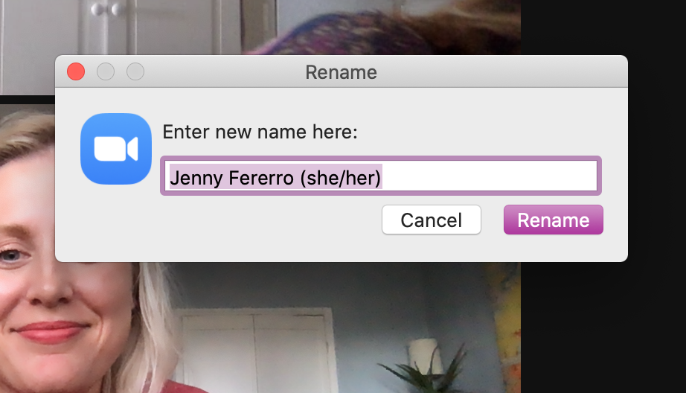

Canvas
Within Canvas, you have the option of adding your pronouns (from a limited list of choices- you can’t enter your own) that will appear next to your name everywhere that your name appears on Canvas. To do so:
- Sign in to Canvas
- Click on Account (from the web browser, this will be a personal image on the left hand toolbar.
- Click on Settings
- Click on Edit Settings (gray button on far right side with a pencil icon)
- Use the drop down menu next to Pronouns to select the pronouns you want displayed
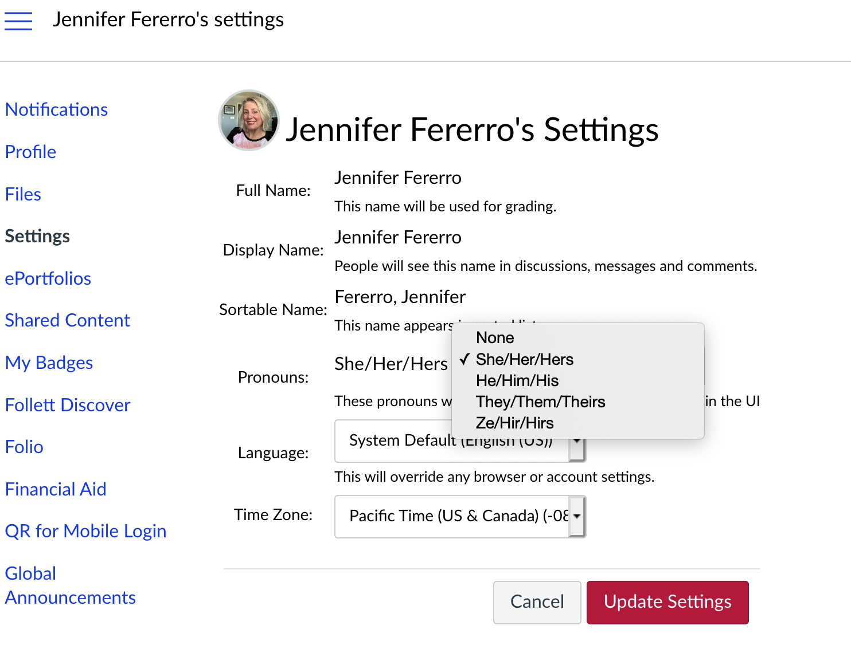
- Click the red Update Settings button

Outlook Email Signature
From the web browser for Outlook:
- Sign in to your Outlook email account
- In the upper right hand corner, click on the gear icon for Settings
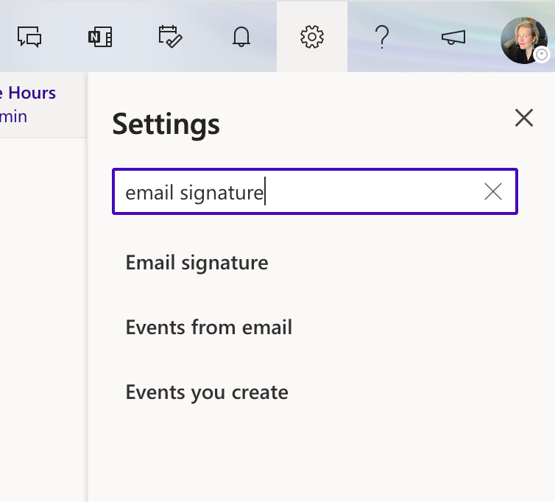
- Type “email signature” in the text box
- Click on Email Signature
- Use the provided window to make edits to your email signature. You can add hyperlinks if you are interested as well! Many people are making their pronouns link from their email signature to the Palomar College Pronouns Guide.

