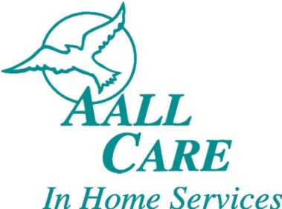

AALL CARE is seeking Home Care Aides, CNA's, CHHA’s and Nursing Students
To provide quality care for patients in their homes.

Job Description

- Bathing and Personal Care  - Safety Supervision  - Toileting / Incontinence Care  - Assistance with Ambulation  - Laundry and Linen Change  - Light Housekeeping  - Meal Preparation | - Companionship  - Shopping and Errands  - Escort / Transport to Appointments  - Medication Reminders  - Exercise / Range of Motion  - End-of-Life Care  - Respite Care

Employee Benefits

- Flexible Schedules  - 40 Hours Paid Sick Leave  - Referral Bonus – up to $100  - Kaiser Medical Insurance  - Paid Time & Mileage Between Cases | - Unlimited Free Online CEU units  - Assurant Dental Insurance  - Weekly Payroll  - Direct Deposit  - Pay Rate $15.00per hour

Send Resume: vicky@aallcare.org

San Diego (619) 297-9601

North County | (760) 471-7033

