**L&L Division Meeting 03/02/18**

**Our Vision -- L**earning for Success

**Our Mission --** Our mission is to provide an engaging teaching and learning environment for students of diverse origins, experiences, needs, abilities, and goals. As a comprehensive community college, we support and encourage students who are pursuing transfer-readiness, general education, basic skills, career and technical training, aesthetic and cultural enrichment, and lifelong education. We are committed to helping our students achieve the learning outcomes necessary to contribute as individuals and global citizens living responsibly, effectively, and creatively in an interdependent and ever-changing world.

**Our Values --** Palomar College is dedicated to empowering students to succeed and cultivating an appreciation of learning. Through ongoing planning and self-evaluation we strive for continual improvement in our endeavors. In creating the learning and cultural experiences that fulfill our mission and ensure the public’s trust, we are guided by our core values of excellence in teaching, learning, and service; integrity as the foundation for all we do; access to our programs and services; equity and the fair treatment of all in our policies and procedures; diversity in learning environments, philosophies, cultures, beliefs, and people; inclusiveness of individual and collective viewpoints in collegial decision-making processes; mutual respect and trust through transparency, civility, and open communications; creativity and innovation in engaging students, faculty, staff, and administrators; physical presence and participation in the community.

Division Meeting/Classified Staff, Directors

1. Check in
   1. How’s it going?
   2. Lanyards? Purpose?
2. Reminder to catch up with Palomar goings-ons
   1. Comet Information Exchange: https://www2.palomar.edu/pages/cie
   2. Palomar Three Minutes of News: <https://www2.palomar.edu/pages/pao/category/three-minutes/>
   3. Academic Spotlight
   4. Program Spotlight
   5. L&L Webpage: www2.palomar.edu/pages/lldivision
   6. Skillshops: https://www2.palomar.edu/pages/skillshops/events/list/
3. Accreditation Chart & Timeline (Mid-term Report due next March)
   1. https://www2.palomar.edu/pages/accreditation/
4. Guided Pathways
   1. https://www2.palomar.edu/pages/spc/files/minutes-agendas-newsletters/Attachments_2018-02-20.pdf
5. Budget
   1. Update/Gratitude
   2. Working on consistent quarterly/monthly method across areas (consistent shadow budgeting, training, etc.)
   3. When you send a request in, please let me know the balance of that account of what’s left after that purchase
6. Scheduling
   1. Working with a new tool (sharing it with chairs today)
      1. Have a look (flash drive)
      2. Moving closer to FTES goals & FTEF allocation goals by discipline and/or department
7. Enrollments
   1. About .002 down at last information
   2. 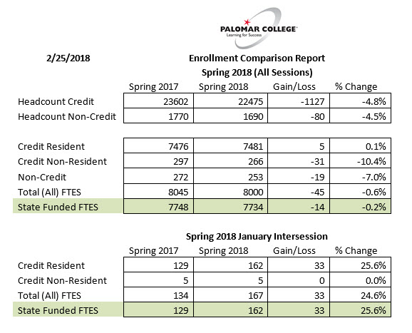
   3. FT2 – how you can help
      1. Refer to list of courses being offered
      2. Open Class Tool: My Class Finder: https://www2.palomar.edu/myclassfinder/open/
8. Supervision (Staff/Chairs or Faculty Leads/Dean)
9. External Partnerships – if you know of external partners we might be able to engage for a variety of reasons and have an idea or a connection:

* ASU – students finishing 4 year degrees online;
* Mostra Coffee – may serve as coffee cart vendor at SEC, also may be able to develop academic or enrichment programs with them;
* SONY – has donated equipment, also may be able to develop academic or enrichment programs with them;
* Harrahs – offering ESL classes, also may be able to reach out to the broader Native American population in our area

1. Safety concerns?
   1. Specialized equipment
   2. Other?
2. Absence Reporting – label your absences in this way (for my sanity): 01012018/your last name/timesheet/(kind of absence (PN, sick, bereave, FMLA) or request (vacation, college business)
   1. Comp Time/Overtime Requests – must be approved in advance
   2. Vacation time must be approved in advance
3. Time Away from Office
   1. PD? Committees?
   2. Being mindful of work to be done
4. Questions/Comments