L&L Division Meeting 03/02/18

Our Vision -- Learning for Success

Our Mission -- Our mission is to provide an engaging teaching and learning environment for students of diverse origins, experiences, needs, abilities, and goals. As a comprehensive community college, we support and encourage students who are pursuing transfer-readiness, general education, basic skills, career and technical training, aesthetic and cultural enrichment, and lifelong education. We are committed to helping our students achieve the learning outcomes necessary to contribute as individuals and global citizens living responsibly, effectively, and creatively in an interdependent and ever-changing world.

Our Values -- Palomar College is dedicated to empowering students to succeed and cultivating an appreciation of learning. Through ongoing planning and self-evaluation we strive for continual improvement in our endeavors. In creating the learning and cultural experiences that fulfill our mission and ensure the public’s trust, we are guided by our core values of excellence in teaching, learning, and service; integrity as the foundation for all we do; access to our programs and services; equity and the fair treatment of all in our policies and procedures; diversity in learning environments, philosophies, cultures, beliefs, and people; inclusiveness of individual and collective viewpoints in collegial decision-making processes; mutual respect and trust through transparency, civility, and open communications; creativity and innovation in engaging students, faculty, staff, and administrators; physical presence and participation in the community.

Division Meeting/Classified Staff, Directors
- Check in
  - How’s it going?
- PT Evaluations – TERB is a little behind; packets should be on the way soon.
- SLOs – hand out by department
  - From Wendy Nelson: We are working on the SLO section of the Annual Accreditation Report due at the end of March. We are trying to get all of our course and program SLOs in compliance with the college’s SLO cycle. All SLOs must be assessed every three years (which means each course must have two SLOs and each SLO must be assessed with results and action in TracDat every three years). We met with the SLO facilitators last week and gave them copies of the report for their disciplines. We asked them to put results for courses out of compliance in TracDat by March 16. Course out of compliance are highlighted in RED. We need your help to make this happen and increase our SLO assessment numbers for the report. Right now, approximately 40% of our courses are out of compliance. There are some courses on the report that will be deactivated before we run our final numbers – so those do not need assessment results in TracDat.
- Scheduling
  - Working with a new tool (sharing it with chairs today)
    - Have a look (flash drive)
    - Moving closer to FTES goals & FTEF allocation goals by discipline and/or department
- Reminder to catch up with Palomar goings-ons
  - Comet Information Exchange: https://www2.palomar.edu/pages/cie
  - Palomar Three Minutes of News: https://www2.palomar.edu/pages/pao/category/three-minutes/
  - Academic Spotlight
  - Program Spotlight
  - L&L Webpage: https://www2.palomar.edu/pages/lldivision/
  - Skillshops: https://www2.palomar.edu/pages/skillshops/events/list/
- Accreditation Chart & Timeline (Mid-term Report due next March)
  - https://www2.palomar.edu/pages/accreditation/
- Guided Pathways
  - https://www2.palomar.edu/pages/spc/files/minutes-agendas-newsletters/Attachments_2018-02-20.pdf
- Budget
  - Update/Gratitude
  - Working on consistent quarterly/monthly method across areas (consistent shadow budgeting, training, etc.)
  - When the ADA sends a request in, I have asked them to let me know the balance of that account of what’s left after that purchase.
  - Chairs should be checking in on the budget regularly for a basic understanding.
- Enrollments
  - About .002 down at last information
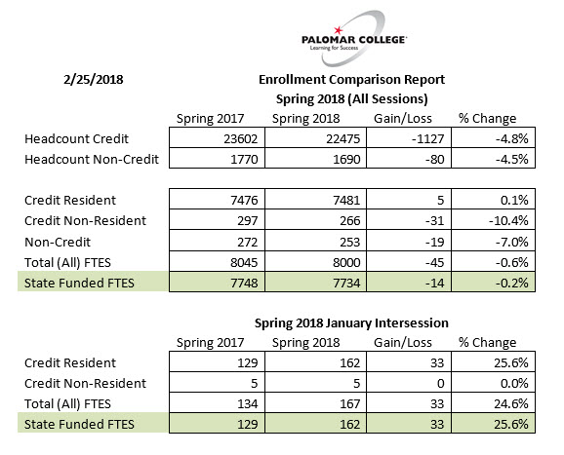
  - FT2 – how you can help
    - Refer to list of courses being offered
    - Open Class Tool: My Class Finder: https://www2.palomar.edu/myclassfinder/open/
- Supervision (Staff/Chairs or Faculty Leads/Dean)
- External Partnerships – if you know of external partners we might be able to engage for a variety of reasons and have an idea or a connection:
- ASU – students finishing 4 year degrees online;
- Mostra Coffee – may serve as coffee cart vendor at SEC, also may be able to develop academic or enrichment programs with them;
- SONY – has donated equipment, also may be able to develop academic or enrichment programs with them;
- Harrahs – offering ESL classes, also may be able to reach out to the broader Native American population in our area
- Questions/Comments

