GEAR UP
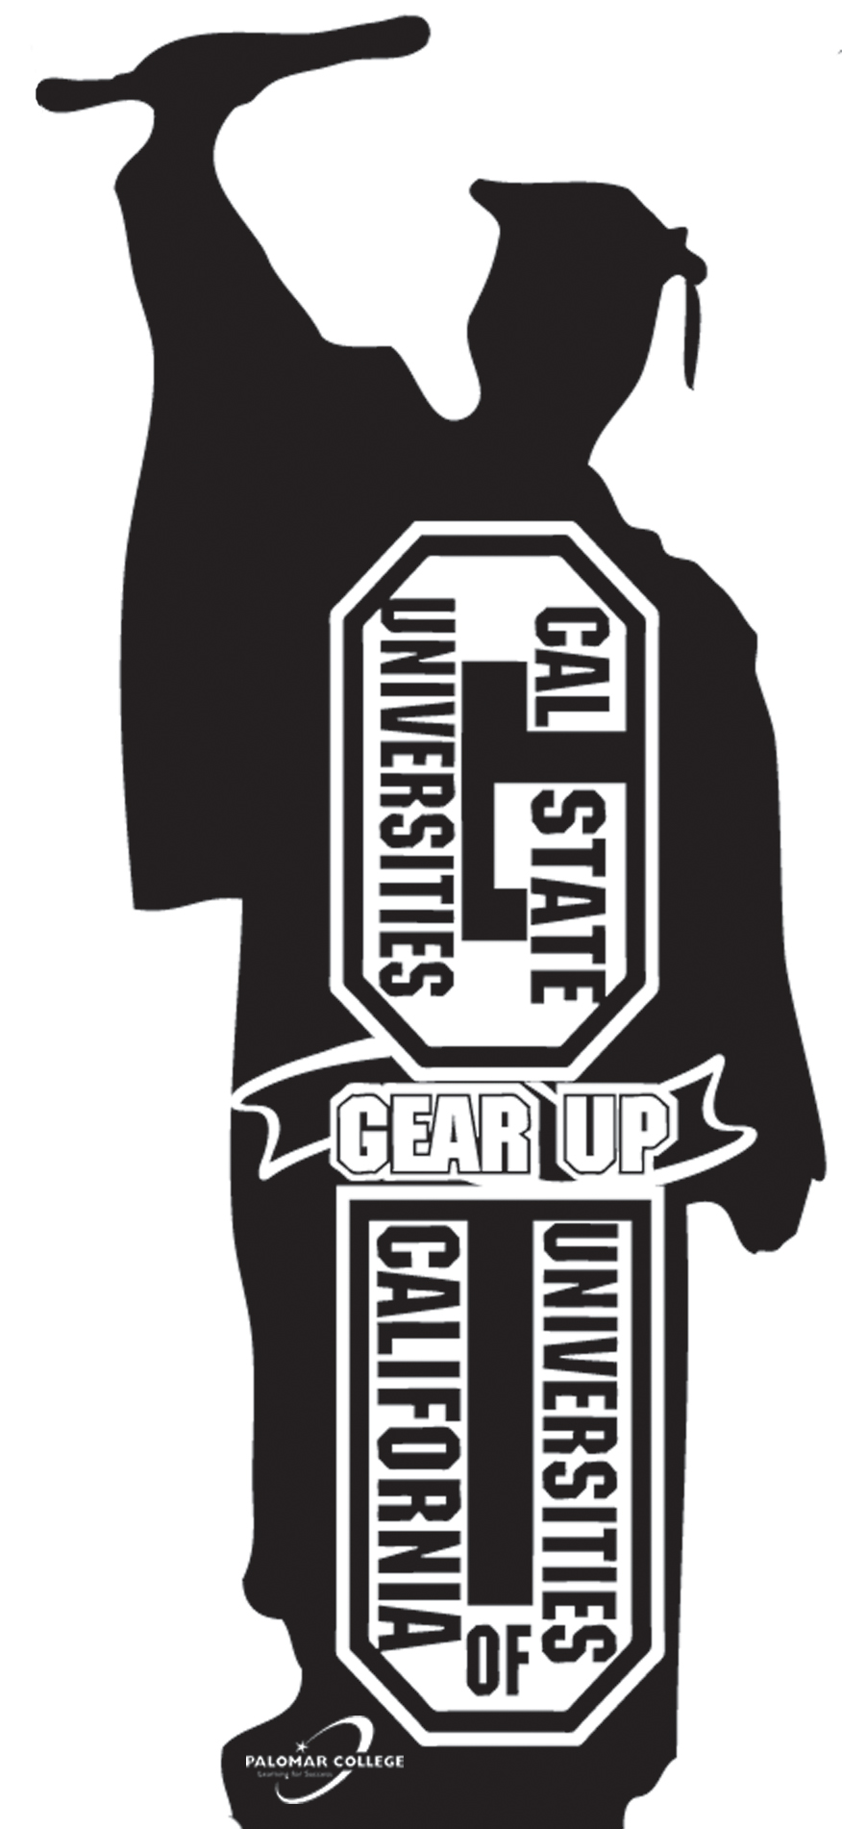
2005-2011 OBJECTIVES

- To increase student achievement, as measured by one and one-half year’s growth on the annual CAT 6; exceeding prescribed API growth.

- To increase the % of students, by cohort, who are academically prepared for post-secondary education, by 15% each year, based on college preparation coursework completed, grade point average, and individualized assessments, so that 80% are “college-ready” by 12th grade.

- To have 80% of the cohort students complete Algebra 1 by the end of the 8th grade or Algebra 1 benchmarks prior to the beginning of 9th grade.

- To have 100% of the parents and students receive annual knowledge of post-secondary education options and financing, based on cohort grade level.

- To increase the % of GEAR UP students, by cohort, compared to the classes from 2006-2010, who take and retake the practice PSAT, PSAT/NMSQT, SAT, ACT Explore, and ACT.

- To increase the % of high school graduates and college acceptances among GEAR UP Seniors compared to each Senior class from 2006-2010.

- To increase the number of honors and AP courses with a proportionate increase in the % of students taking and passing these courses and AP exams.

- To establish and maintain effective partnerships whereby 90% of partners are satisfied with the project, operations, and outcomes, as measured by pre-/post-surveys & annual evaluations.

