Calculation of Full Time Equivalent Faculty (FTEF – a.k.a. FTE)

(Percentage of Load)

- See the PFF Contract - Appendix B (page 143) for approved workloads by department and subject.
  - If a discipline is not listed, please contact your dean for direction.
- You can use the Quick Hours Calculator to calculate FTEF, or calculate using the formula below.
  - FORMULA: Catalog hours / Workload = FTEF
- Classes less than semester length have the same FTEF as if they were taught as a semester length class.

Example 1 – For classes with one instructor and one component.

ART 100 has 3 hours lecture per week for catalog hours.
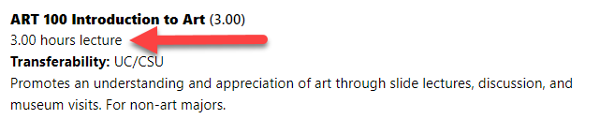
And the approved workload for ART lecture hours is 15.
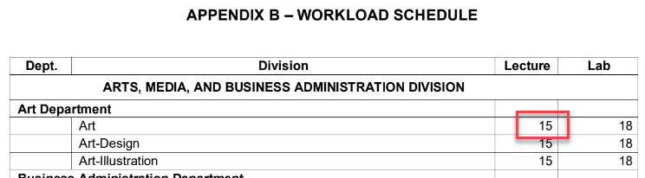

Divide 3 by 15 (3 / 15 = 0.2 = 20% FTEF), OR

Enter 15 for the Workload Factor and 3 for the Catalog Hours in the calculator.

Example 2 – For classes with one instructor and multiple components.

ART 250 has 1.5 hours lecture and 4.5 hours lab per week for catalog hours.
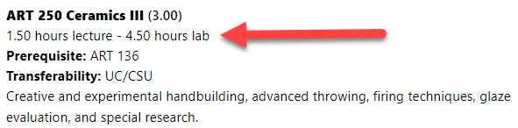
The approved workload for ART lecture hours is 15 and the approved workload for ART lab is 18.
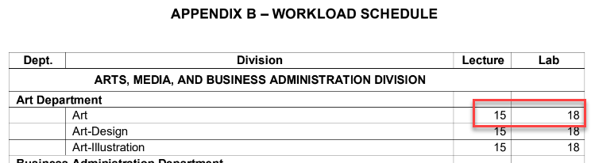

For one instructor calculate FTE:

- Lecture: Divide 1.5 by 15 (1.5 / 15 = 0.1 = 10% FTEF)
- Lab: Divide 4.5 by 18 (4.5 / 18 = 0.25 = 25% FTEF)

The total FTEF for the instructor for both components is 35%

Or enter the Workload Factors and Catalog Hours in the calculator.

Example 3 - For classes with multiple instructors and one component

If a single class is taught by more than one instructor, the FTEF value of the class should be divided among the instructors based on the number of contact hours they will teach.

First, find the total FTEF for the class:

ART 100 has 3 hours lecture per week for catalog hours.
And the approved workload for ART lecture hours is 15.

Divide 3 by 15 (3 / 15 = 0.2 = 20% FTEF), OR

Enter 15 for the Workload Factor and 3 for the Catalog Hours in the calculator.

Now divide the total FTEF for the class by the percentage of the class each instructor will teach.

The total contact hours for a class with 3 weekly catalog hours is about 54. If we have two instructors teaching ART 100, they will split the 54 total hours. For example:

- Instructor 1 has 40.5 hours
- Instructor 2 has 13.5 hours

To figure out the percentage of the FTEF for each instructor, divide each of their hours by the total hours, then multiply that percentage by the total FTEF for the class.
- Instructor 1: 40.5 hours / 54 total hours = 75% of the total hours * 20% total FTEF = 15% FTEF for instructor 1
- Instructor 2: 13.5 hours / 54 total hours = 25% of the total hours * 20% total FTEF = 5% FTEF for instructor 2

It may be easier to visualize it table format, it would look like this:

 | Hours | % of Class | % FTEF
Instructor 1 | 40.5 | 75 | 15
Instructor 2 | 13.5 | 25 | 5
Total | 54 | 100 | 20

Or you can use the Quick Hours Calculator to find the percentage assigned and FTEF for each instructor.

Note: When team teaching, there may be times when the class’s total FTEF will equal more with multiple instructors than it would with one instructor. Be sure to clear any excess FTEF with the department chair.

