

Budget Transfer

**Revised July 2025**

Table of Contents

Introduction 3

Prerequisites 3

Budget Pools 3

Fund Code 3

Project/Grant ID 3

Budget Period 3

Balanced Totals 3

Journal Date 3

How to Submit a Budget Transfer 4

Approval and Posting 7

## Introduction

The Budget Transfer module in PeopleSoft Financials (FSCM) is configured to allow departments to move discretionary funds between budget pool accounts.

For a Budget Transfer to be successful, it must meet all requirements, be fully approved and posted for the transfer to take effect.

## Prerequisites

The following prerequisites must be met to successfully complete a Budget Transfer. If your needs fall outside of these requirements, please contact the Budget Office for assistance.

### Budget Pools

Transfer of funds can only occur between the following budget pool accounts:

|  |  |  |
| --- | --- | --- |
| 230010 | 240010 | 400010 |
| 500010 | 600010 | 7XXXXX* |

*7xxxxx transfers can only be made in Fund 12, or Fund 11 within a designated project.

### Fund Code

Fund Codes must match. For example, you cannot transfer from Fund 11 to Fund 12 using this module.

### Project/Grant ID

Project/Grant ID must match. Like the Fund requirement, you cannot use this module to transfer between Project/Grant.

### Budget Period

Like the Fund Code and Project/Grant ID requirements, you can only transfer budgets within the same Budget Period (Fiscal Year).

### Balanced Totals

Regardless of the number of lines in your transfer, the total debits (-) must equal the total credits (+) to be balanced.

### Journal Date

The Journal Date on your budget transfer must be in the same Budget Period as your lines. For example, moving FY25 funds requires a Journal Date between 07/01/2024 and 06/30/2025.

## How to Submit a Budget Transfer

1. Navigation: Main Menu > Commitment Control > Budget Journals > Enter Budget Transfer
2. Select the Add New Value tab
3. Journal Header info:
   1. Business Unit: PALMR for district funds or ASGPC for ASG funds.
   2. Journal ID: use NEXT to assign the next available Journal ID.
   3. Journal Date: this date must be in the same fiscal period as the funds you are attempting to move. For example, FY25 funds cannot be moved with a Journal Date in FY24.
4. Click Add

*To find an existing Budget Transfer Journal use the ‘Find an Existing Value’ tab and search based on Journal ID, or User ID, etc.

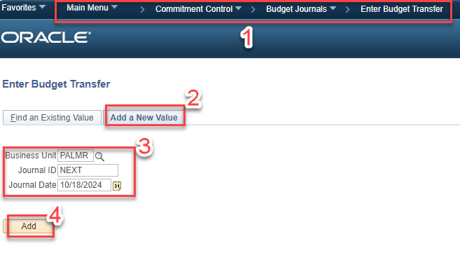

1. Budget Header:
   1. Set Ledger Group to PROJ_GRT.
   2. Currency to USD.
   3. Rate Type to CRRNT.
   4. Budget Entry Type to Transfer Adjustment.
   5. Long Description should include details explaining what the transfer is for.

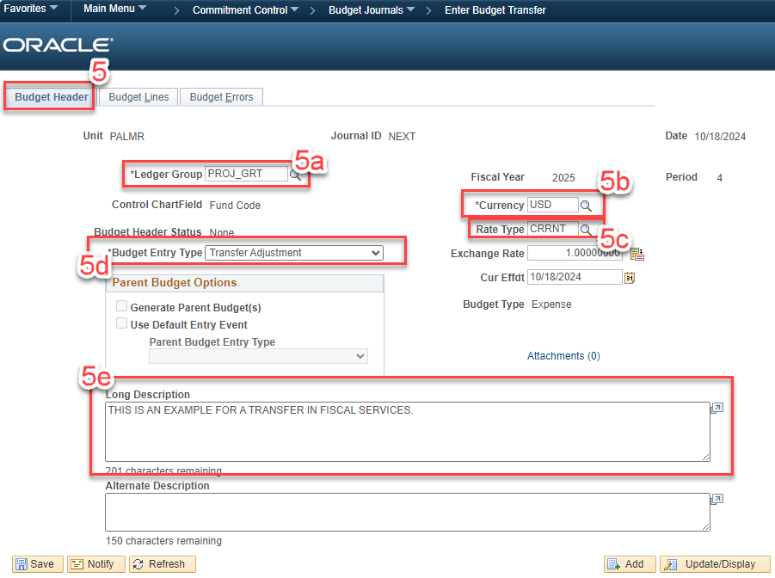

1. Budget Lines – total debits and credits must balance:
   1. Use the + or – symbols to add the necessary number of lines.
   2. Enter the desired budget period and account string in each line. Be sure to use budget pool accounts, not expense accounts, and keep prerequisites in mind.
   3. Click Save. This will assign a Journal ID.
   4. Set Process to Budget Pre-Check and then click Process.
   5. Click Yes to proceed.

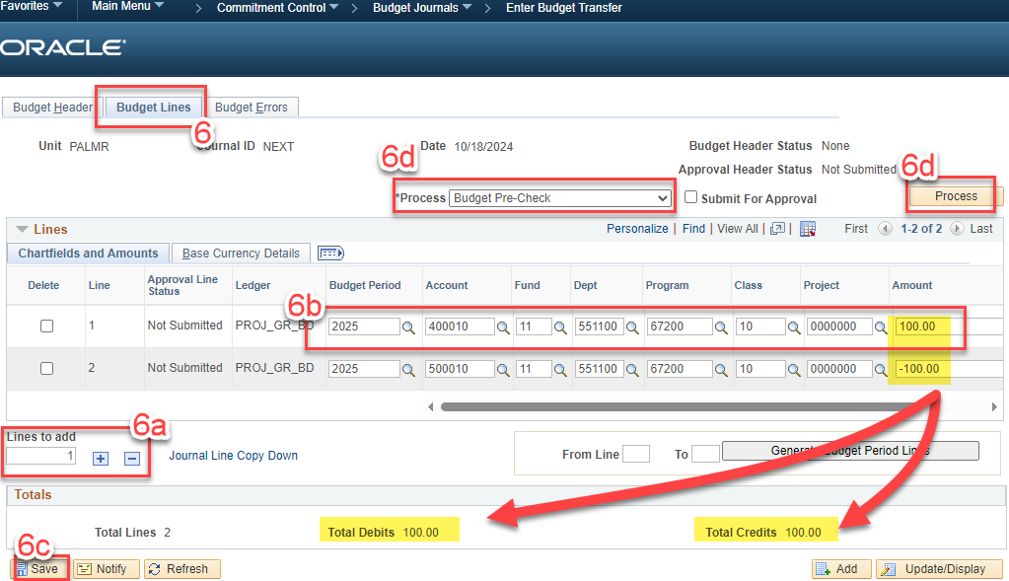

Prompt for Budget Pre-Check:

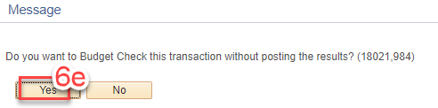

1. Submit for Approval
   1. If the Budget Check is successful, the Budget Header Status will display *Checked Only*.
   2. Set Process (step 6d, above) to *Submit Journal*. The *Submit For Approval* checkbox will automatically be set.
   3. Click Process (6d, above).

## Approval and Posting

The Department ID in an account string determines the routing for a Budget Transfer, but certain Project/Grant IDs may inject additional approvers. All Budget Transfers will route to the Budget & Payroll Manager for final approval.

Once a Budget Transfer has been approved, it will be posted automatically by the nightly posting process.