CAREER EDUCATION ADVISORY COMMITTEE HANDBOOK
The Career Education Advisory Committee Handbook provides faculty with practical guidance on running effective committees that add value to their programs, including minimum requirements for committee structure. It offers best practices to ensure committees align with industry needs, support student success, and contribute to program improvement.

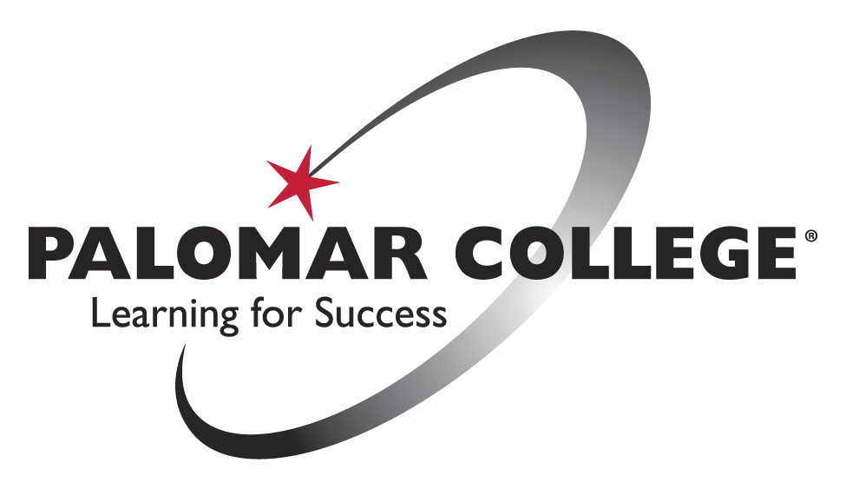

Table of Contents
Introduction 1
Purpose and Importance of Advisory Committees 1
Advisory Committee Membership 2
Diversity, Equity, and Inclusion in Committees 2
Membership Requirements and Selection 2
Committee Composition 2
Roles and Responsibilities 3
Industry Partner Role 3
Faculty Role 3
Student/Alumni Role 3
Meeting Guidelines and Expectations 3
Committee Activities and Best Practices 3
Meeting Procedures and Documentation 4
Agenda Development 4
Minutes Documentation 4
Appendix 5
Sample Agenda 5
Sample Meeting Minutes 5

Introduction
Palomar College is dedicated to providing students with relevant, high-quality education that prepares them for successful careers. Our Career Education programs, informed by industry professionals, ensure that students acquire the skills necessary to excel in today’s evolving job market. Advisory committees play a crucial role in aligning curriculum with industry standards and workforce needs.
In accordance with the California Code of Regulations, Title 5, §55601, Career Education Advisory Committees are required for vocational programs to ensure that educational offerings are directly connected to industry needs. These committees provide valuable insights into curriculum development, help identify emerging industry trends, and offer guidance on workforce demands, ensuring that students are well-prepared for employment upon graduation.
Palomar College is committed to fostering student success, promoting equity, and expanding access to quality education, as outlined in our Vision Plan 2035 Goals. Through collaboration with advisory committees, we ensure that our Career Education programs not only meet industry demands but also promote diversity, equity, and inclusion. This partnership creates pathways for all students, particularly those from historically underrepresented groups, to achieve their academic and career goals.
For more details on the requirements and best practices for vocational advisory committees, see the Academic Senate for California Community Colleges' guidelines: CTE Advisory Committees: Making Them Work for You!

Purpose and Importance of Advisory Committees
Career Education Advisory Committees play a vital role in advancing Palomar College's Vision Plan Goals by ensuring programs remain aligned with industry standards and workforce trends while focusing on equitable access, student success, and program completion. These committees ensure our programs:
- Provide equitable learning opportunities for all students, especially those from historically underrepresented communities.
- Foster student success by aligning curricula with industry needs and promoting career readiness.
- Address the needs of disproportionately impacted groups, ensuring that diversity and inclusion are central to program development.
- Remain responsive to evolving industry standards and workforce trends, equipping students with the skills and knowledge necessary to thrive in an ever-changing job market.
As a bridge between Palomar College and the industries we serve, Career Education Advisory Committees provide essential insights into curriculum development, facilitate discussions among educators, industry partners, and students, and ensure that our programs remain responsive to the evolving job market. Their efforts help maintain an inclusive workforce pipeline, connecting education to employment and supporting a diverse range of students in achieving their career goals.

Advisory Committee Membership

Diversity, Equity, and Inclusion in Committees
Palomar College is committed to promoting diversity, equity, and inclusion in all areas of education, as outlined in the Student Equity and Achievement Program Plan (2022-2025). Advisory committees must strive to include members that reflect the diversity of the communities we serve. Outreach efforts should target local businesses, workforce development organizations, and chambers of commerce to ensure diverse representation across gender, ethnicity, and industry expertise. Emphasis should be placed on recruiting individuals from historically underrepresented groups in various industries and addressing equity gaps within Career Education programs. This approach ensures that all students, regardless of their background, have access to high-quality education and comprehensive support. By having a diverse advisory committee, we bring together a range of perspectives that allow for better alignment with the needs of our diverse student body, ensuring the program supports students from all backgrounds in their career and educational goals.

Membership Requirements and Selection
The membership of each advisory committee should include individuals who:
- Have relevant industry experience.
- Are willing to participate fully in meetings and discussions.
- Represent the diverse industries and student populations served by Palomar College.

Committee Composition
Advisory committees are composed of:
- Industry Partners: Representing small, medium, and large businesses, across different management levels.
- Faculty: Providing educational expertise and insight into student progress and curriculum development.
- Students/Alumni: Offering firsthand perspectives on program strengths and opportunities for improvement.
- Additional Members: Representatives from chambers of commerce, regional directors, four-year institutions, and other stakeholders as needed.

Roles and Responsibilities

Industry Partner Role
- Provide insights into industry trends, labor market demands, and technological advancements, while highlighting opportunities to promote equity and diversity within career pathways.
- Offer feedback on curriculum development, identifying areas for improvement that align with industry needs.
- Assist in student career guidance by ensuring equitable access to internships, mentorships, and work-based learning experiences.
- Support initiatives that focus on preparing underrepresented students for success in their respective fields.

Faculty Role
- Attend and contribute to meetings, ensuring that program improvements align with Palomar College’s Vision 2035 goals.
- Provide program updates, including student performance data that highlight successes and identify equity gaps.
- Bridge the gap between industry requirements and educational objectives.
- Lead discussions aimed at enhancing access and outcomes for disproportionately impacted groups.
- Facilitate discussions and gather feedback from industry members on changes in the industry, emerging technologies, and evolving skill requirements.

Student/Alumni Role
- Share personal experiences to provide insights into challenges within the program and suggest improvements.
- Engage in discussions about student outcomes with a focus on promoting equity and inclusion in Career Education programs.

Meeting Guidelines and Expectations
Advisory committees play a crucial role in ensuring that programs remain aligned with industry needs and workforce trends. To maintain consistency and effectiveness, all advisory committees must meet the following requirements:
- Meet at least once per academic year, with a preference for meeting twice (once per semester).
- Include a minimum of three industry partners.
- Be open to industry representatives, faculty, staff, and invited guests.
- Ensure that industry members are representative of all programs when hosting joint advisory committees.
- Record meeting minutes

Committee Activities and Best Practices
Advisory committees are encouraged to:
- Leverage Palomar College’s Employer Relations Liaison (ERL) to help build and expand the advisory committee. Invite the ERL to attend meetings to provide support and gain a deeper understanding of your program.
- Alternate hosting advisory meetings at an industry partner sites and Palomar College.
- Review curriculum, assess alignment with industry standards, and provide feedback on student preparedness for workforce entry and career advancement.
- Discuss labor market data to ensure the program is meeting local job market needs within the region.

Meeting Procedures and Documentation

Agenda Development
Agendas should be prepared and shared with attendees at least 72 hours prior to the meeting. The agenda should include key discussion items, such as industry updates, curriculum reviews, and student outcomes, to ensure all participants are well-informed and prepared for the discussion.

Minutes Documentation
Minutes must be recorded at every meeting, including a list of attendees, discussion summaries, and action items. These minutes should be uploaded to the program’s annual program review (PRP) during the spring semester, ensuring the most recent meeting minutes are included. Committees are required to meet at least once per year, so the minutes uploaded should reflect the latest meeting.

Appendix

Sample Agenda
- Call to Order
- Welcome and Introductions
- Approval of Previous Meeting Minutes
- Industry Updates
- Curriculum Review
- Student Outcomes and Job Placement Data
- New Business
- Action Items
- Adjournment

Sample Meeting Minutes
- Call to Order
  - Date/Time [Insert Date and Time]
  - Location [Insert Location]
- Welcome and Introductions
  - Attendees:
    - Industry Representatives: [Names]
    - Faculty: [Names]
    - Students/Alumni: [Names]
    - Additional Members: [Names]
- Approval of Previous Meeting Minutes
  - Vote
    - Aye [Insert # votes]
    - Nay [Insert # votes]
    - Abstain [Insert # votes]
- Industry Updates
  - Capture the main ideas and decisions rather than documenting every comment. Note key contributors when their input is critical for accountability or follow-up.
- Curriculum Review
  - Capture the main ideas and decisions rather than documenting every comment. Note key contributors when their input is critical for accountability or follow-up.
- Student Outcomes and Job Placement Data
  - Capture the main ideas and decisions rather than documenting every comment. Note key contributors when their input is critical for accountability or follow-up.
- New Business
  - Capture the main ideas and decisions rather than documenting every comment. Note key contributors when their input is critical for accountability or follow-up.
- Action Items
  - Focus on Outcomes: Highlight decisions, action items, and next steps
- Adjournment
  - Time [Insert Time]

