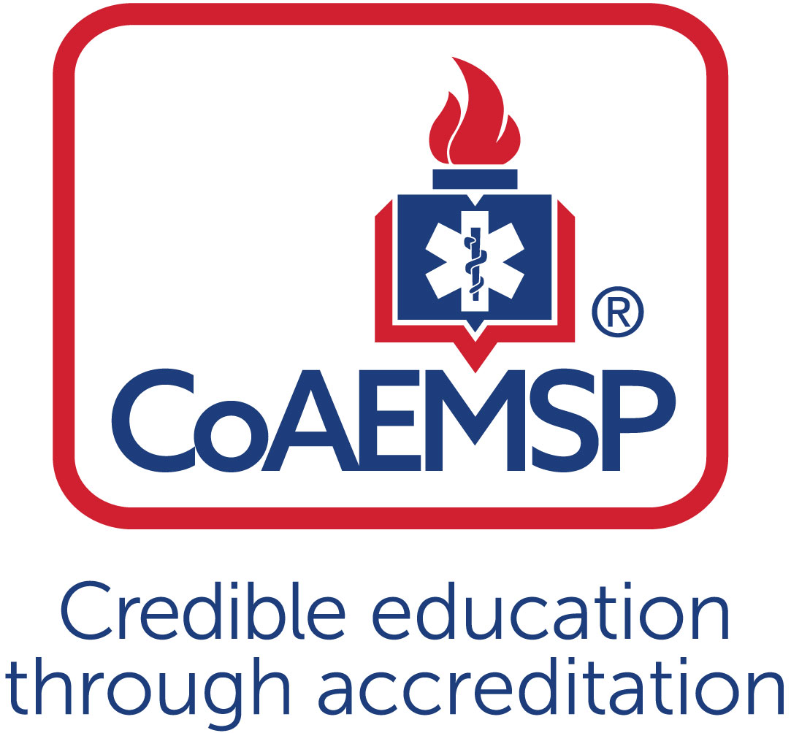
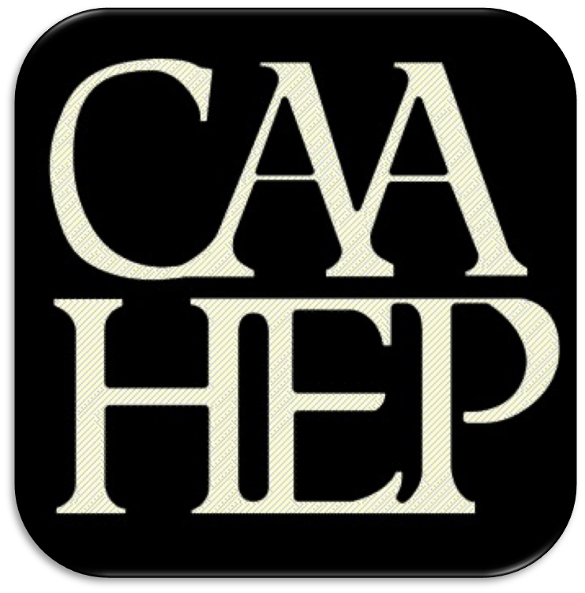

Advisory Committee Meeting Minutes

See last page for the purpose of the program’s Advisory Committee, including a description and list of responsibilities.

SPONSOR / INSTITUTION NAME: | Palomar College
CoAEMSP PROGRAM NUMBER: | 600177 | DATE, TIME, + LOCATION OF MEETING: | April 6, 2023/0900/Palomar College San Marcos (LRC-116)
CHAIR OF THE ADVISORY COMMITTEE: | Jason Hums

ATTENDANCE

Community of Interest | Name(s) – List all members. Multiple members may be listed in the same category. | Present – Place an ‘x’ for each person present | Agency/Organization
Physician(s) (may be fulfilled by Medical Director) | Dr. John Serra | X/Z | Palomar College
 | Dr. Chris Kahn |  | UCSD/Palomar College
Employer(s) of Graduates Representative | Andrew Pederson | X/Z | AMR
 | Jeanne McFarland | X/Z | Escondido FD
Key Governmental Official(s) | Gary Laugen |  | San Diego Co. EMS
 | Cody Rogers | X/Z | San Diego Co. EMS
Police and Fire Services | Jenny Duffy | X/Z | San Marcos FD
 | Ted Chialtas | X | San Diego FD
 | Jeremy Brandt | X | Oceanside FD
Public Member(s) | Scott Gommel | X | Mission Hills High School
 | AJ Heightman | X/Z
 | Marti Napier | X | Vista High School
Hospital / Clinical Representative(s) | Amy Clark | X/Z | Palomar Hospital
Other | Ally Do | X/Z | Palomar College
Faculty | Andrew Page | X | Palomar College
Faculty | Michael Finton | X | Palomar College
 | Jeff Pachek | X | Palomar College
 | Patty Boyle | X/Z | Palomar College
 | Jill Wright | X | Palomar College
 | Wally Brame | X | Palomar College
 | Sean Peck | X | Palomar College
 | Jason Bell | X/Z | Palomar College
 | Jason Hums | X | Southwestern College
 | Rick Foehr | X/Z | EMSTA College
Sponsor Administration² | Susan Wyche |  | Palomar College
Student (current) | Julia Martin/Emilee Logee | X | Palomar College
Graduate | Dennis Prestie | X | Palomar College
Program Director, ex officio, non-voting member | Sarah De Simone | X | Palomar College
Medical Director, ex officio, non-voting member | Dr. John Serra | X/Z | Palomar College
 | Dr. Chris Kahn |  | UCSD/Palomar College

Agenda Item |  | Discussion | Action Required | Lead | Goal Date
 | Call to order |  | Yes / No
 | Roll call |  | Yes / No
 | Review and approval of meeting minutes | Reviewed and approved | Yes / No
 | Endorse the Program’s minimum expectation  [CAAHEP Standard II.C. Minimum Expectation]  - “To prepare competent entry-level Paramedics in the cognitive (knowledge), psychomotor (skills), and affective (behavior) learning domains with or without exit points at the Advanced Emergency Medical Technician and/or Emergency Medical Technician, and/or Emergency Medical Responder levels.”  - Establish / review additional program goals | We would like to change this to match the Program Learning Outcome to maintain Consistency.  To prepare paramedics in the cognitive, psychomotor and affective behavioral domains who demonstrate competency as an entry level paramedic by consistently performing thorough patient assessments and integrating pathophysiological principles and assessment findings. To prepare paramedics to formulate and execute proper treatment plans for a patient experiencing a medical and/or traumatic emergency according to current national, state of California, and San Diego County protocols. | Yes / No
 | Endorse the Program’s required minimum numbers of patient/skill contacts for each of the required patients and conditions  [CAAHEP Standard III.C.2. Curriculum]  - Student Minimum Competency (formerly known as the Appendix G)  - Review summary graduate tracking reports | We reviewed the SMC and agreed that we will maintain the minimum requirements as set forth by CoA and NREMT for Cohorts 59-61. We are assessing Cohorts 59 and 60 and based on the results will make appropriate changes for Cohort 63 that will begin in Jan. 2024. We will email suggested changes out for review and approval | Yes / No | J. Hums | 1/2024
 | Review the program’s annual report and outcomes  [CAAHEP Standard IV.B. Outcomes]  - Annual Report data  - Thresholds/Outcome data results  - Graduate Survey results  - Employer Survey results  - Resources Assessment Matrix results  - Other | We are currently assessing the data for the annual report and once the report is complete, we will send the results out to the Advisory Board for review and comments.  We reviewed the annual report from 2020. We met all requirements and had positive feedback from both students and employers despite the multiple adversities that were faced during the pandemic. | Yes / No | S. Desrochers
 | Review the program’s other assessment results  [CAAHEP Standard III.D. Resource Assessment]  - Long-range planning  - Student evaluations of instruction and program  - Faculty evaluations of program  - Course/Program final evaluations  - Other evaluation methods | We spoke about the classroom space or lack thereof for the program and the need for a facility that will allow the program to grow. The administration is aware and long-term planning is occurring.  We identified the need to begin evaluating instructors for every cohort (both faculty and student evaluations). The faculty are evaluated every three years but we will present the need to evaluate after every cohort and assure the faculty and union the evals are for planning purposed and self-development and will not be used in a punitive manner | Yes / No | S. Desrochers
 | Review program changes (possible changes)  - Course changes  (schedule, organization, staffing, other)  - Preceptor changes  - Clinical and field affiliation changes  - Curriculum changes  - Content  - Sequencing | We spoke at length about the schedule for the paramedic academy and the strain it is placing on the students. We offer 2 full time programs. One is traditional and one is based off the Kelly schedule. Unfortunately, most of the students are having to work full time and coming to class after being on shift or are not able to make it to class because they are force hired or held over. We will continue to work with the agencies to create a unique schedule will allow students to maintain employment but also have more days off to rest and study. The students in attendance agreed the schedule was extremely demanding and they struggled to keep. The students agreed that offering a part time program might be beneficial. The students also voiced concern over the lack of communication and understanding of the requirements for clinical rotations specifically at Palomar Hospital. We are working with Amy Clark and have implemented a plan that should alleviate the communication and documentation mishaps.  We identified the dire need to revamp the structure of the paramedic program and the need for additional faculty. Andy Page is working on a special project that is focusing on the structure of our program compared to other paramedic programs in Southern California. We are noticing that many programs do not assign the responsibilities of the entire program to just one person and in fact have several “lead” instructors. Our plan is to assign a lead instructor to each block (Intro, Medical, Trauma, and OB/Peds). The lead will be responsible for that block but will report to Andy and main Lead. We are going to trial this in fall. We are also looking to change the sequence of the curriculum and move away from blocks and decrease the number of days in didactic. This is all on a drawing board right now and as details become clearer, we will advise the advisory board. We do need to increase the number of clinical affiliates and begin having discussions with the clinical affiliates about allowing students to begin clinical rotations during didactic.  We discussed the dwindling number of applicants to the program and the potential barriers. About 1.5 years ago, we increased the required number of EMT experience hours from 1040 or 6 months to 1 year or 2000 hours. This was a discussion among the 4 program directors in the county and agreed that each program would increase the EMT experience hours. This was done because most EMTs in the county only had experience on BLS ambulances with very little ALS experience. In the past 1.5 years, the majority of the No Co FD have transitioned from dual medics on ambulances to Medic/EMT configuration. Since this change, we are noticing paramedic candidates are more prepared. This has been noticed at every program. The program directors are going to meet in the next couple of weeks to agree upon the number of EMT experience hours. The advisory board will be made aware of the suggested changes. We also thought it would be best to allow students who are currently enrolled in prerequisite courses (A&P and Paramedic Prep) to apply if they received a letter from the instructor stating they were in good standing. This was approved by the AB. | Yes / No | S. Desrochers
 | Review substantive changes (possible changes)  [CAAHEP Standard V.E. Substantive Change]  - Program status  - Sponsorship  - Sponsor administrative personnel  - Program personnel: PD, Lead Instructor, other  - Addition of distance education component  - Addition of satellite program | We are scheduled for the site visit in December. The EA was shared with the committee. There are a few items we need to address but we are feeling confident and hope for a smooth site visit.  Dr. Kahn has suggested that Dr. Serra take over as the primary medical director. All support this change and now we are working with UCSD to make sure we can maintain the contract for the students to attend Cadaver Lab and Burn rotations. Dr. Kahn is affiliated with UCSD and is our sponsor at this time. We are hoping he can remain our sponsor without having to be the medical director. | Yes / No | S. Desrochers
 | Other identified strengths | Dedicated instructional staff and support personnel. | Yes / No | S. Desrochers
 | Other identified weaknesses | Space and workload and schedule. | Yes / No | S. Desrochers
 | Identify action plans for improvement | We are working on restructuring the program to create better span of control and a more balanced work environment | Yes / No | S. Desrochers
 | Other comments/recommendations |  | Yes / No
 | Staff/professional education | We would like to attend more EMS Professional Development conferences, but most are in states that are banned by California | Yes / No | S. Desrochers
 | CoAEMSP/CAAHEP updates | None | Yes / No | S. Desrochers
 | Next accreditation process  (i.e., self-study report, site visit, progress report) | Self-study was completed in 2021. EA was reviewed and site visit is scheduled for some time in December. | Yes / No | S. Desrochers
 | Other business | We discussed the EMT Program and the new prerequisite course that was created. We are assessing the opportunities for dual enrollment and articulation agreements with local high schools.  The attrition rate in the EMT Program is higher than we would like. We strongly believe that will begin to change because of the new prerequisite course that is designed to better prepare the student for the EMT course. | Yes / No | S. Desrocher
 | Next meeting(s) | April 2024 | Yes / No
 | Adjourn | 1215 | Yes / No

Minutes prepared by Sarah Desrochers Date: 4/10/2023
Minutes approved by Date
If item #5 above was acted on, then:
Medical Director’s signature Date
- Attach Student Minimum Competency (formerly known as the Appendix G) > Table 1 to verify which required minimum numbers were reviewed and endorsed (if item #4 above was acted on)

PURPOSE OF THE ADVISORY COMMITTEE
The Advisory Committee must be designated and charged with the responsibility of meeting at least annually to assist program and sponsor personnel in formulating and periodically revising appropriate goals and learning domains, monitoring needs and expectations, and ensuring program responsiveness to change, and to review and endorse the program required minimum numbers of patient contacts. [CAAHEP Standard II.B. Appropriate of Goals and Learning Domains]

Additionally, program-specific statements of goals and learning domains provide the basis for program planning, implementation, and evaluation. Such goals and learning domains must be compatible with the mission of the sponsoring institution(s), the expectations of the communities of interest, and nationally accepted standards of roles and functions. Goals and learning domains are based upon the substantiated needs of health care providers and employers, and the educational needs of the students served by the educational program. [CAAHEP Standard II.A.]

Responsibilities of the Advisory Committee
- Review and endorse the minimum program goal.
- Review and endorse the required minimum numbers of patient/skill contacts for each of the required patients and conditions.
- Verify that the Paramedic program is adhering to the National Emergency Medical Services Education Standards.
- Review Program performance based on outcomes thresholds and other metrics (at a minimum credentialing success, retention, and job placement).
- Provide feedback to the Program on the performance of graduates as competent entry level Paramedics (for employers).
- Provide feedback to the Program regarding clinical and field opportunities and feedback on students in those areas.
- Provide recommendations for curricula enhancements based on local needs and scope of practice.
- Assist with long range planning regarding workforce needs, scheduling options, cohort size, and other future needs.
- Complete an annual resource assessment of the program.

The best practice is that the chair is not the Program Director. The Advisory Committee is advising the program.
Additional faculty and administration are ex-officio members.
Add rows for multiple members of the same community of interest If the program has additional named communities of interest, list the community of interest and the name(s) that represent each.
Additional program goals are not required by the CAAHEP Standards. If additional program goals are established, then the program must measure them.

