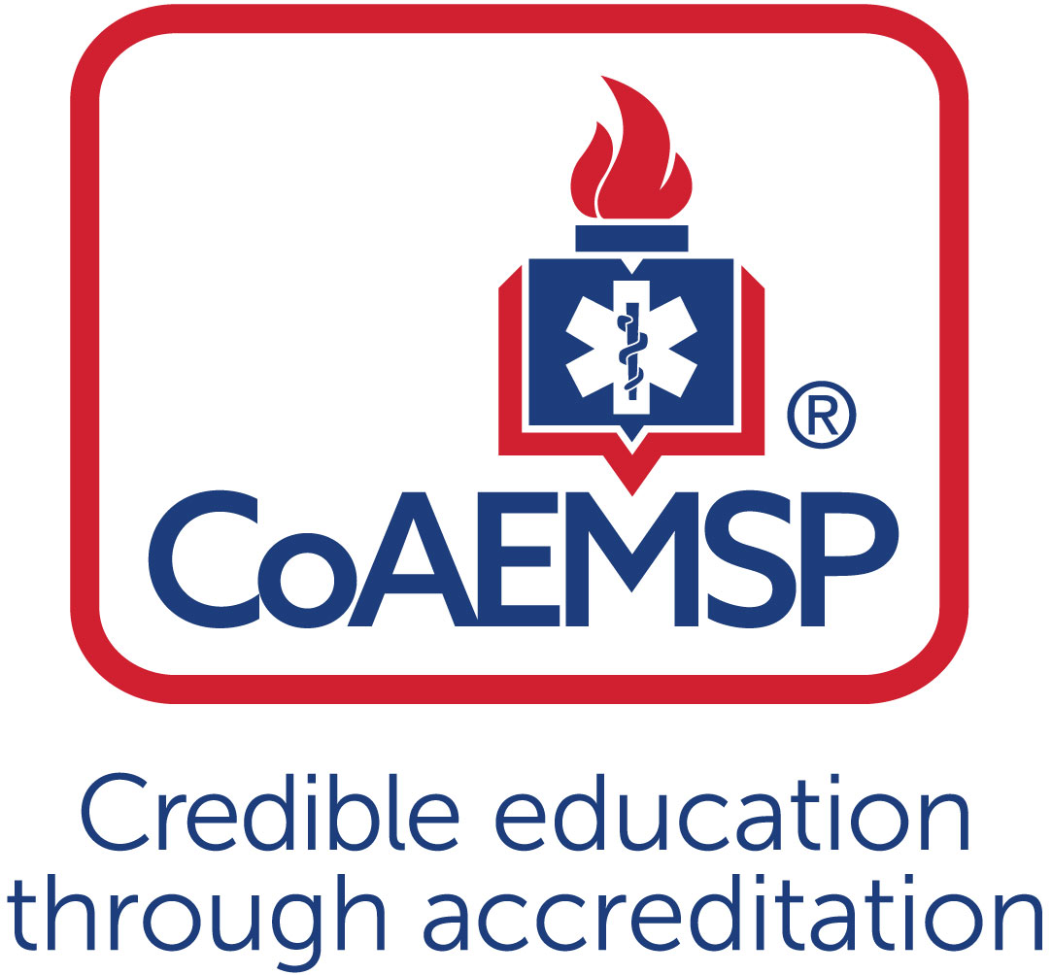

Advisory Committee Meeting Minutes

SPONSOR / INSTITUTION NAME: | Palomar College
CoAEMSP PROGRAM NUMBER: | 600177 |  | DATE, TIME, + LOCATION OF MEETING: |  |  | 4/11/18, AMR Headquarters, 1100-1230  Following the CPAC Committee Meeting
CHAIR OF THE ADVISORY COMMITTEE: | Note to Program: As a best practice, programs should appoint someone other than the Program Director to serve as the Advisory Committee Chair. The Advisory Committee is advising the program.
ATTENDANCE
Community of Interest |  | Name(s) – List all members. Multiple members may be listed in a single category. |  | Present | Agency/Organization
Physician(s)
may be fulfilled by Medical Director
Employer(s) of Graduates Representative |  | Don Sullivan, Dan Aker, Jeanne McFarland, Jenny Duffy |  | X | American Medical Response, San Marcos Fire Department, Escondido Fire Department
Key Governmental Official(s) |  | Jim Kirkpatrick |  | X | San Diego Co. EMS Authority
Police and Fire Services |  | Jeanne McFarland, Jenny Duffy |  | X | Escondido FD, San Marcos FD
Public Member(s)
Hospital / Clinical Representative(s) |  | Mary Meadows Pitt |  | X | Sharp Grossmont Hospital
Other
Faculty  ex officio, non-voting member, |  | Pete Ordille, Sarah De Simone, Ron Unger, Jason Hums, Loretta Coruthers, Silvia Cornejo, Rick Foehr |  | X | Palomar College, Palomar College, Southwestern College, Southwestern College, Southwestern College, Southwestern College, EMSTA
Sponsor Administration,
ex officio, non-voting member
Current Student |  | Joseph Breda, Britta Venstrom |  | X | Palomar College
Graduate |  | Eldon McCarthy |  | X | Palomar College
Program Director  ex officio, non-voting member |  | Pete Ordille, Ron Unger, Rick Foehr |  | X | Palomar College, Southwestern College, EMSTA
Medical Director
ex officio, non-voting member

 | Agenda Item | Acted | Discussion | Action Required | Lead | Goal Date
 | Call to Order | 11:00 |  |  | Rick Foehr (Chair)
 | Review and Approval of Meeting Minutes |  | Reviewed and approved | No Action | Rick Foehr (Chair)
 | Program Goals & Learning Objectives  [CAAHEP Standard II.C. Minimum Expectation]  - Endorse the language verbatim for the Minimum Expectation  “To prepare competent entry-level Paramedics in the cognitive (knowledge), psychomotor (skills), and affective (behavior) learning domains with or without exit points at the Advanced Emergency Medical Technician and/or Emergency Medical Technician, and/or Emergency Medical Responder levels.”  - Establish / review any additional program goals |  | The language for the minimum expectation was reviewed and read verbatim and was endorsed unanimously. |  | Pete Ordille
 | Review and endorse the program’s required minimum numbers of patient/skill contacts for each of the required patients and conditions  [CAAHEP Standard III.C.2. Curriculum]  - Appendix G: Student Minimum Competency Matrix (effective July 1, 2019) |  | The group reviewed and unanimously endorsed the minimum numbers of patient/ skill contacts for each of the required patients and conditions.  The group discussed Palomar College Fisdap goals and the new minimum competency (Appendix G) regulations set by COAEMSP that will be required by July 1, 2019. Link to website: http://coaemsp.org/Documents/Appendix%20G%20-%20Student%20Minimum%20Competency%20Matrix%20-%20effective%20July%201%202019.xlsx | No action required | Pete Ordille
 | Annual Report and Outcomes  [CAAHEP Standard IV.B. Outcomes]  - Graduate Surveys  - Employer Surveys  - Resources Assessment Matrix  - Thresholds/Outcomes |  | The group discussed the revised annual report and the necessity behind the revision. Palomar College, SWC and EMTSA were not picked as pilot programs for the revision. The entire group agreed that revising the annual report to make it real time rather than a year behind was a necessary change. | No action required | Rick Foehr
 | Other Assessment Results  [CAAHEP Standard III.D. Resource Assessment]  - Long-Range Planning  - Student  - Faculty  - Program  - Other |  | Palomar College reported a new campus is opening in Fallbrook and they will begin offering classes there. There is a good possibility the “North Center” will become a regional public safety training facility.  They are also beginning construction of a new simulation center. Palomar College and SWC proposed an idea to the FD to help with their hiring process by offering to conduct the simulation and skills testing. It would be a standardized testing process and if the candidate passed they would be issued a “simulation certification card” that would let the potential employer know they performed in a competent manner.  SWC reported they have developed a strong relationship with the US Border Patrol and will begin offering CE classes for them.  SWC reported they are interviewing for a new Program Director.  Palomar College reported Pete Ordille will be retiring in July and they are hiring a new faculty member. A current faculty member (Sarah De Simone) will be stepping in as the program director.  Jim Kirkpatrick discussed the need for students to begin learning about ePCR documentation during their training and asked if the colleges had the ability to accommodate the training. Palomar College reported they have several iPads that were purchased for this reason but there is currently no training program available. Jim agreed stating Image Trend does not have a training ePCR but he is looking into options. Jim also mentioned that there will be an influx of EMT students that will be renewing but will require the updated enhanced skills training. This will go into effect July 1 2019.  All agencies identified students were struggling with communication and interacting with patients on a personal level. They also have a knowledge deficiency with capnography and physical exams. | - Follow up with SD County EMS in regards to development of possible training ePCR app for paramedic training agencies.  - Develop CE form that will be provided to EMT students to verify they have received the new required training (TECC/Active Shooter, IM Narcan, IN Narcan, BGM, EPI Pen administration) | Ordille  Foehr  Hums
 | Discuss challenges to the effectiveness of clinical and capstone field internship  This may include the impediments to attaining or retaining affiliates |  | This entire discussion focused on the availability of preceptors. There is a continuous shortage of preceptors. All agency are working closely with the colleges but the struggle is a result of agencies training new hires.  Escondido FD is working on a program that will allow the department to accommodate more interns. The proposal is the interns would intern at Escondido FD and if they met the standard would immediately be offered a job. The theory is this would stop the constant turnover of non safety personnel reducing the amount of employee training resulting in their ability to take more interns.  Don Sullivan discussed a blended internship. There are plenty of preceptors but many are on the engines. In the past, students have not been allowed to complete their internship on an engine. The proposal is to have the student spend part of their internship on an engine and then transfer to a transporting unit. This will allow more preceptors the opportunity to precept. He also discussed extended their FTO time to help the new paramedic develop.  Pete Ordille discussed the possibility of using Fisdap’s preceptor training as the county approved preceptor training. | - Continue to provide training and certify additional qualified field preceptors.  - Continue to explore creative field preceptor options (engine/  ambulance combinations. | Pete Ordille
 | Program Changes (possible changes)  - Course changes  - Preceptor changes  - Clinical and field  - Curriculum  - Content  - Sequencing |  | No major changes
 | Substantive Change (possible changes)  [CAAHEP Standard V.E. Substantive Change]  - Program Status  - Sponsorship  - Sponsor Administrator Personnel  - Program Personnel  - Addition of Distance Education  - Addition of Satellite Program |  | SWC is interviewing for a new program director. Ron Unger is the Interim Program Director.  Palomar College has a new Medical Director (Dr. Chris Kahn)  Palomar College interviewing for full time faculty position to replace vacancy when Pete Ordille retires end of July 2018. This new hire would start Fall Semester 2018.
 | Other Identified Strengths |  | Palomar College:  Diverse faculty and students coming in with life experience and degrees.  Partnerships with fire tech and police academy. Fast Track program of military students into Fire and Paramedic Programs
 | Other Identified Opportunities |  | Jim Kirkpatrick mentioned that there was an opportunity for the training agencies to become involved with new hire firefighter/paramedic testing by offering the mega-code/scenario testing required of new hires. This would be followed up to the agencies with testing results. Palomar reviewed this at the San Diego County Fire Chiefs Section meeting and it was very well received).
 | Other Identified Threats |  | Not really a threat but with addition of a fourth paramedic training agency (San Diego Fire Rescue) field preceptors and clinical site rotations may start to get a bit more challenging. Training agencies have agree to follow a shared training calendar to keep this issue to a minimum.
 | Other Identified Weaknesses |  | None
 | Action Plan for Improvement |  | Continue to monitor trends of weaknesses and strengths of paramedic interns.
 | Other Business |  | - Paramedic Program Projected Graduates over Next Year:  - Palomar: 55-60  - Southwestern: 25  - EMSTA: 40  - San Diego Fire just graduated first class of 16 students on April 9, 2018. Will be starting Class 2 mentioned August 2018.  - Workforce Projections/Department hiring needs:  Lakeside: recruiting for vacancies  Carlsbad- hiring 4-5 this year.  Escondido-continually recruiting for non-safety position. Hiring 3 non safety paramedics.  San Marcos- hiring 3 FF/PM’s, retirements  AMR Rural- near staffing.  AMR City- continual hiring.  SDFD- current fire academy in progress.  Continual recruiting.  North County Fire Department- hiring  single role paramedics and EMT’s (5) since  going to a new delivery system.  Other departments not available to  Report.
 | Next Meeting(s) |  | April 2019 (Advisory Board Meeting)
 | Adjourn | 1230 Hours

Minutes prepared by: Sarah De Simone/Pete Ordille, Palomar College
Meeting date: 4/11/18
Submitted by: Pete Ordille, 4 /16/2018

Additional program goals are not required by the CAAHEP Standards. If additional program goals are established, then the program must measure them.

