Advisory board minutes
Graphic Communications – Palomar College
April 11, 2017 Palomar College, Room MD-134

Members Present:

NAME TITLE PROFESSIONAL AFFILIATION
Acosta, Gabriel Owner / Student Brain Machine
Alcaraz, Roberto Freelance Video Producer
Altomare, Brent Executive Producer Groovy Like a Movie
Bealo, Mark Faculty, GC Dept. Palomar College
Bierle, Peter Owner Churchill Graphics
Fisher, Gary Owner Wahoo International, Inc.
Fontanella Judith Owner Artbytes
Fowler, Gracie Faculty, GC Dept. Palomar College
Haas, Andrew Senior Graphic Designer Hot Shoppe Designs, Inc.
Helming, Kelly Web Coordinator Palomar College
Juarez, Ivan Student Palomar College
Kaye, Laura Web & Video Producer Wahoo International, Inc.
Kelley, Gregg Part-time Faculty Palomar College
Long, Cody Filmmaker Cody Long
Marty, Kevin Student / Freelance Palomar College
Morales, Teddy Student Palomar College
Payn, Lillian Board Chair/Faculty, GC Dept. Palomar College
Rollins, Wade Faculty, GC Dept. Palomar College
Schultz, Jay Faculty, Arts Dept. Palomar College
Smith, Wendy Purchasing Mission Imprintables
Starck, Ray Digital Media VP Trina Turk

The meeting of Advisory Board for Graphic Communications at Palomar College was called to order at 8:05 a.m. by the Advisory Board Chair, Lillian Payn.

Welcome and Introductions

The members introduced themselves and their specializations.

Statement of Purpose

Lillian Payn outlined the purpose of this meeting and the Advisory Board:
- Making recommendation on equipment and software for our program.
- Providing information about entry level skills and changing technology.
- Providing labor market status to keep our program connected to industries.
- Making suggestions about our current curriculum to prepare students for jobs.

Approval of 2016 Meeting Minutes

Lillian Payn asked those present to review and approve two sets of 2016 minutes. She explained that there were two separate meetings last year. This year, we combined GCIP and GCMW, and this year we shall break into small groups based on members’ specialty. She asked for any comments or concerns about the minutes, none were addressed. Brent Altomare moved to approve the two minutes. Gracie Fowler seconded the motion. Action: Motion carried unanimously.

Program Updates

- Labor Market Update

Lillian shared the labor market info from EDD (Attachment 1). She pointed out that Web Developers (48.3%) is shown as one of the Top 100 fastest growing occupations in the state. Members discussed the necessity of learning HTML, CSS, or other software other than Wordpress for setting up business web sites. Several members agreed that most company use Wordpress for content management, but as web designers or developers, it is important to have deeper knowledge to design and develop the sites.

Wade Rollins stated that he used North County’s labor market data instead of San Diego County when applied for Perkins grant, because the number is higher. Jay Schultz pointed out that EDD doesn’t have the labor market data for new technology like 3D printing and drone technology.

- Enrollment: Statistics

Graphic Communications Enrollment Report
Semester | Class | Course Section | Total Enrollment | Semester | Class | Course Section | Total Enrollment
Fall 2015 | 20 | 42 | 1,006 | Spring 2016 | 19 | 42 | 801
Fall 2016 | 23 | 50 | 1,101 | Spring 2017 | 17 | 39 | 799
Fall 2017 | 28 | 64 |  | Spring 2018
Note: The enrollment data is based on Palomar College WSCH & FTES Comparison Report (Census Day) created by Research and Planning.

Mark reported on our “college size” status, which impacts our funding. Due to decreased enrollment figures, we have been moved from the “large college” category to “medium size college”. Lillian commented on the enrollment report. She reported that the new president, Dr. Blake, is trying to increase enrollment by adding sections like summer, intersessions, and online classes. Gracie said that one response would be to offer more programs that are 100% online. The GC Dept. has been impacted by this enrollment decrease. Wade asked members feedback on offering online classes. Members replied that it’s helpful especially for professionals who cannot take face-to-face classes. The quality of instructions is still important. Gracie Fowler reported that she has received the Strong Workforce grant to develop an on-line program that will be effective in fall 2018.

Gary Fisher suggested teaching introductory classes in languages other than English, “i.e., Spanish. Lillian replied that we tried it with ESL Dept. for several years as part of the Learning Community program at that time. We had positive results, but the Learning Community program was discontinued. A recommendation is to brainstorm how we can do something similar or totally innovative in order to reach the Spanish-speaking audience. Photoshop would be a popular introduction into our industry if we were to pilot software instruction in Spanish.

- Curriculum Updates and Recommendations

Lillian introduced our handout package with the Summer 2017 and Fall 2017 schedules, as well as the list of Graphics programs and courses. The schedules show that we are not offering as many courses as before. Mark Bealo asked members’ input on condensing the programs by removing the courses that are no longer offered. Are our programs overdeveloped? There should be further discussion.

Mark reported that they are applying for a grant to set up a Makerspace on campus. Several members agreed that Makerspaces in educational environment is a major trend. Lillian agreed, and that in fact the Horizon Report, which analyzes emerging technology trends in education, listed Makerspaces as a two to three-year trend.

The conversation included branding identity and social media marketing when Ray commented on what he was doing in LA, as well as the trends there.

- New Program: 3D Printing for Artists Certificate (Art/GC)

Jay Schultz announced a new collaborative program that will encourage Arts students to learn how to digitize their artwork. Jay recommends that students need to develop their aesthetic skills, not just technical. He requested suggestions regarding members for 3D Printing Advisory Board. Ray Starck shared that many of his clients are artists or jewelry designers who need help to convert they artworks to 3D files. The fashion industry faces these issues every day. Brent added that it is important to have a specialty and still know everything else in general and also soft skills. Brent pointed out that the SD Unified District has similar discussions, where the high school students are expected to know everything when they learn an application, so their knowledge is broader, but shallower. As we connect with the high schools it will be helpful to know where they want to go in college so they can specialize and build stronger skills in target areas.

Jay presented the tentative list of required courses for the program as below:

- ART 101 Methods and Materials
OR
ART 140 Foundry Techniques/Sculpture 1
OR
ART 150 Jewelry/Metalsmithing Design
- ARTI 246 3D Design/Modeling (Maya)
OR
ARTI 248 3D Design/Sculpture (ZBrush)
- GCIP 150 3D Product Development/Marketing
- ARTD 230 3D Printing for Artists = NEW
- BMGT 105 Small Business Management

Lillian asked those present to approve the program. Mark moved to approve the program. Cody Long seconded the motion. Action: motion carried unanimously.

- Equipment / Facilities

Lillian reported that there are two new education centers: North Center (Fallbrook) and South Center (Rancho Bernardo). Both are scheduled to open in Summer 2018.

Wade reported that since Fall 2016, we have offered a dual enrollment program at Bonsall High School. The high school students take the courses for which they earn both college and high school credits. The plan is to offer one or two foundation classes each semester. The classes include GCIP140, GCIP106, GCIP170, and GCIP105. We hope the program can help bring them to college after graduate from high school. Jay asked about high school teachers teaching the dual enrollment classes. Lillian clarified that, based on the Faculty Senate meeting held last week, all teachers in the dual enrollment program should be hired by Palomar College and meet the faculty requirements.

Mark explained each item on the proposed new equipment list (Attachment 2) was included in our Perkins grant application. Kevin Marty moved to approve the list. Brent seconded the motion. Action: Motion carried unanimously.

Other Business / Group Discussion

Lillian asked members to break into three small groups: Print, Web, and Multimedia to discuss eight listed topics.

Group Discussion – Print Recommendations
(Group leader: Gracie Fowler. Group Members: Peter Bierle, Gary Fisher, Andrew Haas, Laura Kaye, and Wendy Smith.)

- Trends In The Industry
Drone; UV-Cure; Less Offset And More Digital; Sublimation/Garment Design; Digital Fabric Cutting; Pattern Design; Auto Wraps; Screen Printing Onto-Blends And Polyester; Signs And Banners.

- Your Favorite App, Software, Hardware, Etc.
Facebook Social Media; Adobe CS; Mac OS.
- Software, Hardware, Equipment
Get A Savvy Buyer; 2nd Hand Equipment Ok; RIP Programs (Caldera Visual RIP); Vinyl Plotters; Fabric Digital Cutter (Zund)

- New Concepts / Topics We Should Be Offering
Track Student Hired; Vinyl Application/Graphics; Wide Format Printing; Signs & Graphics; Materials For Display.
- Entry Level Skills Needed
Typography; Small Business Management; Graphic Design – Photoshop; Screen Printing & Ink Classes.

- How To Make Connections With Industry
Spanish Speaking; Dyslexics – Ask John Van Hamersveld; On Line; Cold Calling With Flyers; Social Media; TV Ads

- How To Make Connections With Millennial Students
School Tours; Field Trips; Go To Work Place; Social Media; TV Ads; High School Speakers.

- Other Recommendations? Ideas?
Classes Closer to Mexico Border; El Cajon Highest Iraqi Population; Identify Industry and Companies Locally.

Group Discussion – Web Recommendations
(Group Leader: Lillian Payn. Group Members: Judy Fontanella, Kelly Helming, Gregg Kelley, and Ray Starck.)

- Trends In The Industry
Less technology; narrowing of disciplines; LA: social media influences and marketing; fashion and food are hot topics; ½ million sites per year in WP, then use professional developers to customize; Content management is a billion dollar industry; Simplification; Blogging platforms; CTAs everything in a nutshell; Z-clicks Hierarchical Web design, SEO; Mobile and tablet; Responsive design; Interactive; Animation in background; bigger bandwidth; Parallax Web/responsive design.

- Your Favorite App, Software, Hardware, Etc.
Zen Garden themes, Photoshop, Dreamweaver, Illustrator, InDesign for wireframing and ePubs; Dropbox; Sublime Text, Thinglink Interactive Media, Omeka, Grammarly; messaging, texting, Creative Cloud software; Google Docs; Productivity Software.
- Software, Hardware, Equipment
VR to connect content and create a visual experience; Stitching SW for GoPro; Vuze to download and submit legal audio and video content; Outsourcing to customize; mobile browser; cross-device texting; SDKs for mobile/Phone gap.

- New Concepts / Topics We Should Be Offering
Adobe XD is an upgraded Muse for comps; Wrap experience by telling a story, and integrating with know-how; 3D integration with Web/mobile; Dreamweaver lack of relevance; Magento for e-commerce/CSS; Need to know what’s possible to communicate with developers; content management systems, i.e., WordPress; Designers need to give direction to developers.

- Entry Level Skills Needed
HTML, CSS, Dreamweaver; Web design, Photoshop skills, advanced video; File organization; labeling; File-naming conventions; Written communication; soft skills; Deign branding; Typography; ; Grid systems; Translate brand guidelines to other media; digital portfolios; teamwork; keeping personal separate from professional

- How To Make Connections With Industry
Chamber of commerce; Show up; SDX SD Ad Club; SD AWA; SD Direct; LinkedIn Profile; Personal branding awareness; Internships

- How To Make Connections With Millennial Students
Marketing — staff and school online presence; Build relationships with High School Teachers and Counselors. Makerspaces; customization;

- Other Recommendations? Ideas?
Group Discussion – Multimedia Recommendations
(Group Leader: Wade Rollins. Group Members: Roberto Alcaraz, Gabriel Acosta, Brent Altomare, Mark Bealo, Ivan Juarez, Cody Long, Kevin Marty, Teddy Morales, and Jay Schultz.)

Recommendation of Equipment List
DSLR:
- Panasonic GH5
- Sony A7, 2150 4K, A7SII
- Nikon D500
- Red Camera – RAW Weapon
- Blackmagic
- Canon Mark IV 5D
- Ronin Gimbal

Color Correction:
- Blackmagic Mini & Micro

3D:
- Perception Neuron – Motion Capture

VR:
- HTC Vive
- GoPro Cube

Recommendation of Software List
3D:
- Video Copilot Element 3D
- Cinema 4D
- 3D Studio Max-CHD – thinking portals
- Maya – Z Brush
- Marvelous Designer
- Houdini
- Blender
- V-Ray – Renderer
- Render Farm for Makerspace
- Octane – Render
- Keyshot
- Redshift
- Fabric Engine

Overlay Editors:
- Red Giant Plugins
- Particular System
- After Effect – Aescripts.com
- Motion
- Nuke
- Fusion
- Copilot Element 3D

Software:
- Color Correction – Davinci Resolve – Free
- Adobe Premiere
- Apple Final Cut X
- Avid
- Vegas
- Boris Plugins
- Sound – Logic, Pro Tools, Reaper, Addition, Ableton Live, iZotope, Kontakt, Remix for length.

Lillian asked members to send feedback and recommendations as they continue think about our educational capabilities and potential to meet local industry needs. The meeting was adjourned at 9:56 A.M.

Attachment 1: Labor Market Info
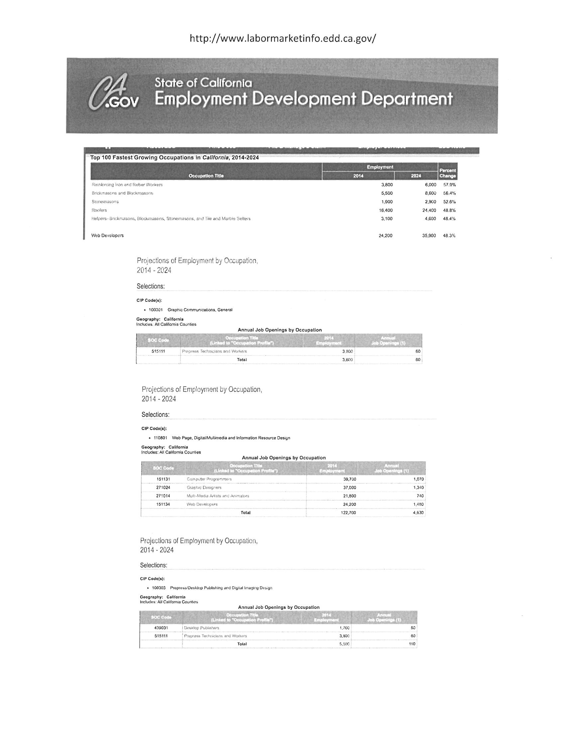

Attachment 2: Equipment/Software List

PALOMAR COLLEGE PERKINS BUDGET SHEET 2017-2018
Program or Service Name:
Top Code:
Purchase Description | Quantity | Cost per unit | Total Cost | Previously funded by Perkins? (Y/N) | Previously funded by general fund OR other funding sources? (Y/N) | If yes, what year(s) (ie. 15-16) | Item included in Program Review and described in your Section II/III of Perkins Local Application? (Y/N) | Comments/Additional Information
(Include taxes, shipiing, installation fees, room # of where item will reside, estimate of salary/benefits. Quotes for supplies, software, equipment required with submittal of application.)
Graphics Day Speakers | 10 | $100.00 | $1,000.00 | Y | N | 15,16 | Y
Student Hourly | 1 | $14,600.00 | $14,600.00 | N
Motion Control for VFX and Stop Motion, MD-119A | 1 | $16,520.00 | $16,520.00 | N
Audio Interface, technology and multi-touch control surface, MD-119 | 1 | $17,350.00 | $17,350.00 | N
Portable Three-Axis Motion Control System,MD-119 | 3 | $1,850.00 | $5,550.00 | N
Software and plugins | 1 | $5,500.00 | $5,500.00 | N
Travel for annual conferences, trade shows and expos | 1 | $16,500.00 | $16,500.00 | N
 |  |  | $0.00
TOTAL |  |  | $77,020.00
Check all types of activities to be funded with CTE funds:
Professional Development | X
Instructional Equipment Purchase/Replacement | X
Curriculum Development
Program Marketing and Outreach | X
Instructional Materials Purchase/Replacement (including Software) | X
Program/Services for Special Populations
Other( Please specify):

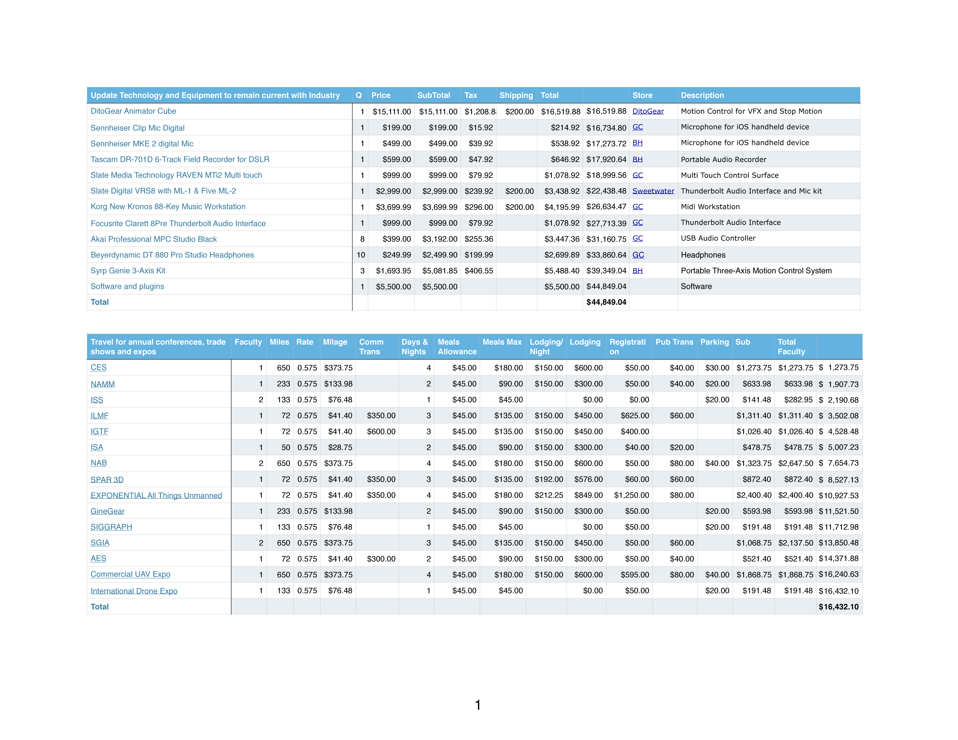

PALOMAR COLLEGE PERKINS BUDGET SHEET 2017-2018
Program or Service Name:
Top Code:
Purchase Description | Quantity | Cost per unit | Total Cost | Previously funded by Perkins? (Y/N) | Previously funded by general fund OR other funding sources? (Y/N) | If yes, what year(s) (ie. 15-16) | Item included in Program Review and described in your Section II/III of Perkins Local Application? (Y/N) | Comments/Additional Information
(Include taxes, shipiing, installation fees, room # of where item will reside, estimate of salary/benefits. Quotes for supplies, software, equipment required with submittal of application.)
GoPro 5 Black | 5 | $425.00 | $2,125.00 | Y | N | 15,16 | Y
GoPro Karma Grip | 3 | $300.00 | $900.00 | N
GoPro Karma Copter and Case | 1 | $1,250.00 | $1,250.00 | N |  |  |  | GoPro Drone
GoPro Mounts Various | 1 | $1,000.00 | $1,000.00 | Y | Y | 15,16 | Y
Panasonic Lumix 4K DMC G7 14-140 | 3 | $900.00 | $2,700.00 | N
Panasonic Lumix 4K DMC G7 14-42 | 3 | $600.00 | $1,800.00 | N
 |  |  | $0.00
 |  |  | $0.00
TOTAL |  |  | $9,775.00
Check all types of activities to be funded with CTE funds:
Professional Development | X
Instructional Equipment Purchase/Replacement | X
Curriculum Development
Program Marketing and Outreach | X
Instructional Materials Purchase/Replacement (including Software) | X
Program/Services for Special Populations
Other( Please specify):

