CAREER TECHNICAL & EXTENDED EDUCATION DIVISION MEETING
October 5, 2012
10:00 am – 11:00 pm
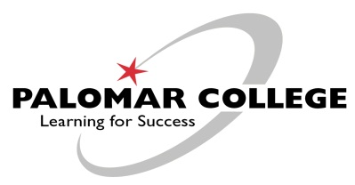

ATTENDEES:
Sergio Hernandez, Janet Hoffman, Jamie Moss, Wilma Owens, and Debi Workman

SUMMER 2013:
Weekly Paid Contact Hours (WPCH) have been slightly reduced for Summer 2013; Wilma will send out the WPCH allocation for each department. The Escondido Center will be closed for renovation during the summer; everyone will be moved to the San Marcos campus. Jaime Moss gave a detailed report on the renovation; construction has already started and will be completed by the end of summer.

Wilma announced that the Mt. Carmel site will be closed at the end of the Fall 2012 semester.

CURRICULUM:
Faculty is being asked to generate a course change proposal to remove repeatability from their courses prior to November 9. Wilma will send out information from the latest Curriculum Committee meeting outlining details related to repeatability. Wilma suggested that while working in Curricunet, this would be a good time to complete other needed updates, i.e., Student Learning Outcomes and Assessments. Our mid-term accreditation report is due in March 2013. She also reminded everyone to hold their advisory committee meetings.

SUBSTITUTE ACCOUNT:
The substitute budget is running very low; Wilma asked that substitute instructors be used sparingly.

SHORT-TERM EMPLOYEES:
Wilma reminded everyone to submit their Short-term Employment Action Forms on a timely basis and also to make sure employees do not start working until they have been approved by Human Resource Services.

POLITICAL ACTIVISM:
Wilma read from the Education Code 7050 through 7058 related to political activism; faculty cannot use their classroom as a venue for political activism.

JSPAC WORKSHOP:
A Joint Special Populations workshop will be held on October 26 at Palomar. The purpose is to give faculty additional skills to assist special population students.

Minutes submitted by Donna DeYarman.

