ADVISORY BOARD MINUTES
Internet and Multimedia Graphic Communications – Palomar College
February 26, 2014, Palomar College, Room MD-‐155C

Members Present:
NAME TITLE PROFESSIONAL AFFILIATION
Allard, Josh Allen, Vanessa Altomare, Brent Bealo, Mark Crawford, Jason Dame, Jennifer Fowler, Gracie Fishlock, Leslie | Creative Services Producer Senior Marketing Manager Executive Producer Chair/Faculty, GC Dept. President  Account Executive Faculty, GC Dept. Founder & CEO | U-‐T TV  Active Network Groovy Like a Movie Palomar College Synphanie Media Apple  Palomar College Geek Girl
Gallegos, Shaeden  Long, Cody Miyamoto, Norma Ngo, Tina  Payn, Lillian Rollins, Wade Silas, Frank Starck, Ray Weissman, Jen | Student Representative  Executive Producer Dean, AMBCS Research Manager  Board Chair/Faculty, GC Dept. Faculty, GC Dept.  Creative Director  VP of Digital & E-‐commerce Principle | Palomar College  U-‐T TV  Palomar College  San Diego Workforce Partnership Palomar College  Palomar College Pixlwise  Trina Turk Project X Media

The meeting of the Multimedia and Internet Advisory Board for Graphic Communications at Palomar College was called to order at 7:36 am, February 26, 2014 by the Advisory Board Chair, Lillian Payn.

Welcome and Introductions

The members introduced themselves and their specializations.

Statement of Purpose

Lillian Payn outlined the purpose of this meeting and the Advisory Board:

- Providing information about changing technology.

- Providing labor market status to keep our program connected to industries.

- Making suggestions about our current curriculum to prepare students for jobs.

- Making recommendation of how to make connections between college and companies,
e.g. The Career Day.
Approval of 2013 Meeting Minutes

Lillian Payn asked those present to review and approve the February 6, 2013 minutes. Frank Silas moved to approve the minutes. Jen Weissman seconded the motion. Action: Motion carried unanimously.

Program Updates

- Enrollment: Statistics

Lillian Payn reported the enrollment for the academic year 13-‐14:

Graphic Communications Enrollment Report

Semester | Class | Couse Section | Total Enrollment | Semester | Class | Couse Section | Total Enrollment
Fall 2012 | 30 | 79 | 1527 | Spring 2013 | 28 | 68 | 1395
Fall 2013 | 30 | 67 | 1266 | Spring 2014 | 28 | 58 | 1080
Note: The data is based on Palomar College WSCH & FTES Comparison Report (Census Day) created by Research and Planning.

Lillian Payn explained that we were asked to cut sections due to budget cuts. We haven’t offered summer classes for the past 3 years. This year will be the first time that we offer summer classes again. She also reported that two new centers are currently under constructions: Rancho Bernardo and Fallbrook. We will offer classes in these centers when they are done.

Gracie Fowler pointed out that the new repeatability policy is also affecting our enrollment. Students can no longer repeat any of our classes.

Wade Rollins addressed that the enrollment of his beginning video classes is growing. It indicates that more students are taking it for general use, not for professional purpose.

- Curriculum Updates and Recommendations

Lillian Payn asked members to review the courses and programs that are listed in 13-‐14 Catalog and give commends.

Mark Bealo reported that GCMW229 has been modified and has a new name “Content Publishing for Mobile, Web and Apps”. It’s in process of approving and should be
offered in Spring 2015 semester. The class will be working with Athletics Dept. to develop content for mobile devices, web sites, and screen media. He also announced that GCIP249 Page Layout and Design II will add mobile devices and apps to the class content.

The software used for GCMW105 Web Page Layout with CMS was discussed. Several members suggested Wordpress. Brent Altomare added that most designers would like Joomla, and programmers prefer Drupal. Using DreamWeaver for Web Design classes was also discussed.

Wade Rollins asked for solutions on how to embed video into apps. Dreamweaver extension, InDesign and Muse were mentioned that may be able to do it. Further investigation is needed.

The usage of digital signage in local area was discussed. It’s not as popular as in Vegas, but it is still seen in all sport stadiums.

GCIP122 and 222 Corel Painter class was discussed. It has features to create some art effects that Photoshop cannot create as easily.

Jason Crawford suggested a class that teaches design for applications. Mark Bealo said GCIP249 Page Layout and Design II is the class that teaches digital publishing to mobile devices and apps. Members suggested that the title needs to be changed to reflect the current technology and trends. Lillian Payn added that GCMW112 Mobile Devices/Web Page Layout is using Dreamweaver extensions to develop apps.

Mark Bealo asked members their thoughts about 3D printers like Objet and 3D Systems
/ Z Corp. He reported that there will be a new class to design, create, print, package, and market the 3D products. 3D software like Blender, Maya, and Solidworks was discussed.

Wade Rollins asked for video content for Vine, Instagram, Pinterest, and social media. Members suggested creating 3 sections advertisement: 1 min, 30 second, and 15 seconds.

Mark Bealo reported that our department has ability to shoot 4K and asked thought of 4K usage. Ray Starck commented that the major electronic companies are still pushing customers to buy TVs. Brent Altomare has shot 4K for the past 6 years and stated that 4K is not only for TV, it’s also for digital signage and streaming, because new H.265 Kodak can stream 4K content at SD data rates.

- Labor Market Update
Tina Ngo provided data regarding local labor market. She stated that the numbers do not include self-‐employed, so are not reliable. San Diego area is growing for about 2%. It is growing slowly and steadily.

Several members addressed the importance of students having not just technical skills, but also soft skills like critical thinking, working ethics, communications and social skills, data management, and to follow up projects. Strong portfolio that is available online and/or in digital version is also essential.

Leslie Fishlock also suggested the school building relationship with local major companies.

- Graphics Mission Statement (Attachment 1)

Lillian Payn presented Graphics program’s mission statement.

- Instructional Technology / Mac Platform Recommendation (Attachment 2)

Mark Bealo explained about the Mac Lab computer rotation on campus. Cost benefits of Macs over PCs were discussed. Tina Ngo shared the results that were generated by her organization.

Lillian Payn explained the computer lab situation and difficulties. She asked members to review and approve the recommendation. Jason Crawford moved to motion. Brent Altomare and Frank Silas seconded the motion. Action: Motion carried unanimously, with one abstention by Jennifer Dame.

- Equipment / Facilities

Mark Bealo explained the equipment and software specifics (Attachment 7). He asked members to review and approve the list. Jason Crawford moved to approve it. Brent Altomare seconded the motion. Action: Motion carried unanimously.

Mark Bealo also asked members feedbacks to solve MD-‐119 storage issue. Brent Altomare moved the motion to approve a storage area network/SAN Mac base solution managed locally in MD-‐119 and separately from IS to serve 4K video and other files for students. Cody Long seconded the motion. The other possible solution will be RAID Storage with thunderbolt serving each row.

Mark Bealo reported that we are buying RT Motion 3 channel lens control system. Currently the department has a Blackmagic BMCC that shoots in raw. He asked if we need to do a color grading class. Brent Altomare and Cody Long agreed. Cody Long offered to help write the class.
Mark Bealo explained that GCMW206 Motion Graphics Production & Compositing was originally teaching Nuke, but because the software is expensive, he is now teaching in After Effects.

Lillian Payn thanked everyone for their contributions. The meeting was adjourned at 9:27 a.m.

Attachments:

- Mission Statement
- Mac Platform Recommendation
- E-‐mail from Josh Martelli from Mad Media
- E-‐mail from Rodney Bass from Apple
- E-‐mail from Ray Starck from Trina Turk
- E-‐mail from Frank Silas from Pixlwise
- Equipment / software list
Attachment 1:

PROGRAM’S MISSION STATEMENT

The mission of Graphic Communications is to provide our students with technical and creative skills through visual literacy and progressive technology with a foundation for career and educational advancement. We prepare students for: entry into skilled employment; achieving competency and currency in graphic communications-‐related industries; transfer to pursue advanced degrees and personal enrichment; and relevance in a multicultural and global market place. Our courses, programs, and diverse faculty offer a foundation in design and practical applications using industry-‐standard software, hardware and equipment for multiple output and delivery systems. By collaborating with multiple departments, Graphics creates a bridge among various disciplines.

HOW OUR MISSION IS ALIGNED WITH THE PALOMAR COLLEGE MISSION STATMENT

The Graphic Communications Department Mission is aligned with the Palomar College Mission Statement by providing an engaging teaching and learning environment for students of diverse experiences, needs, abilities, and goals. We offer transfer-‐readiness, general education, basic skills, career and technical training, aesthetic and cultural enrichment, and lifelong education. We are committed to helping our students achieve the learning outcomes as global citizens living creatively in an interdependent and ever-‐changing world.
Attachment 2:

Graphic Communications Advisory Board Mac Platform Recommendation February 26, 2014

Since the Mac Platform is the industry standard for the Graphics industry and fundamental to the creation and production for multimedia and web,

This Advisory Board recommends that the college support the GCMW program and all of the Mac users in the district by:

- Ensuring adequate staffing and up-‐to-‐date training for Mac specialists to support faculty and students
- Seeking ACSA certification for the adequate administration of Mac computers and network
- Providing specific Mac servers that will
  - Function more efficiently with the Mac computers in the district
  - Facilitate networking across campus
  - Allow personalized student logon with student ID (currently done as general account)
(PC labs allow Student ID logon, which is an accreditation compliance issue)
Attachment 3:

E-‐mail from Josh Martelli from Mad Media:

Hey Wade,
Here's a rundown on our camera recommendations:

GoPro Hero 3 cameras remain a staple of ours and we highly recommend them for beginning students.

They support multiple frame rates, but don't require iris and focus operation -‐ making their use in the filed quite easy, and easy to edit with as well.
We would encourage you to seek funding for "kits" that hold 2-‐4 cameras, mounts, LARGE CF cards, and various case options.

There are many many aftermarket GoPro mounting solutions that are great too. We buy most of ours from www.bhphotovideo.com

On cool tool that has come out recently for GoPro's is the Phantom 2 RC Helicopter.

Check it out: http://www.dji.com/product/phantom-‐2
This is a very cool way to add "jib" or "dolly" moves to GoPro production at a very affordable rate.

We have two of these units and we use them when we're filming in dangerous spots.

Moving up the costs scale -‐ we still like the Panasonic cameras for run and gun shooting. They are great ENG (Electronic News Gathering) solutions when cinematic shooting is not necessary.

Both the $3,800 AG-‐HPX170PJ and the $7K AG-‐HPX255 offer incredible results for the cost investment.
Obviously a good tripod and high-‐quality wireless mic kit -‐ like the Sennheiser G3 Camera Mount Wireless Microphone System (Mfr # EW112PG3-‐A) will add to the learning experience of the students.

The next level of acuity really derives from learning how to film on a "cine" camera system. Here we still value the cost-‐effective Canon 5D Mark III option.
Yes this is a still camera principally -‐ but the resulting image on the video side is simply stellar. A very well outfit kit can be assembled for $10,000 that allows students to really begin to learn advanced focus/iris moves and film quality storytelling.
From there you should look again at the RED options. Both the Scarlet and Epic camera systems.
These days the RED camera packages are quickly becoming the norm on all professional productions.

We use both and find that our staff that learn on Canon 5D systems easily adapt to the RED cameras.

This opens up a whole new world to the kids in terms of understanding advanced film and video production.

Pricing is on RED.com

Lastly one honorable mention. The Phantom Micro.

http://www.visionresearch.com/Products/High-‐Speed-‐Cameras/Miro-‐eX4/
If you're interested in teaching an advanced class in high-‐speed cinematography this is the rig to get.
Capable of frame rates in excess of 1000/per second -‐ it's definitely a niche camera system. But it's one that commands typically $5k-‐$10K a day for an experienced shooter with the
camera system.

There are lot's of guys making a good living on these systems.

As always -‐ we recommend the fastest available Macintosh computers and when possible, after market video processing cards like the Black Magic product line.
The newest crop of Mac Pro computers boast a lot of horsepower and we have been thrilled with the increase in render times.
We have moved away from Final Cut Pro X and back to Adobe as our principal editing and motion graphics software platform. Currently we are running the CS6 Adobe suite on all of our Macs under Mavericks. (10.9.1) **NOTE -‐ if you have not updated to Mavericks yet -‐ and are not forced to with software or hardware options -‐ DON'T. There have been a few bugs along the way and we aren't seeing any increase in speeds.**

Hope this helps Wade!

Have a great meeting tomorrow and give our best to all in attendance!

Joshua Martelli Chief Operating Officer Mad Media LLC
Attachment 4:

E-‐mail from Rodney Bass from Apple:

Rodney E. Bass February 25, 2014

Mobile application development

Hi Wade, based on our discussion earlier I have put together some ideas for currently used systems we might explore. If we look at how content is currently delivered to mobile platforms, it is obviously tied to wifi connectivity. Most development programs require constant linking to a server for dynamic updates and downloading of changing data. This means any app solution requires a server based delivery version. As I mentioned I am studying to learn File Maker pro 13 which can deliver to Mac OS, iOS devices as well as windows computers. There are four products in the file maker family each adds expandability to custom app creation. File maker Pro is the base app that can handle custom app development and share with 5 users simultaneously. Individual Licenses start at $329. Filemaker pro Advanced, at $549, however includes all of the features of FileMaker Pro 13, plus a suite of advanced development and customization tools. Filemaker Go is a free app download for iOS that is required for use. And when using File maker Server Pro FileMaker Server is fast, reliable server software for managing and sharing database solutions created using FileMaker Pro (separate purchase is required) and extending solutions to the web. Groups both small and large are able to simultaneously access the most up-‐to-‐date information, making them more productive than ever.

http://www.filemaker.com/products/index.html

I also mentioned iBooks Author which allows anyone to create iPad deliverable content as easy as using pages on any Mac computer. multimedia content such as video, interactive graphics and easy navigation. This is a free app that is only for OSX then the product is shared via usb to iPad.

I hope this helps with your meeting and Grant.
Attachment 5:

E-‐mail from Ray Starck from Trina Turk:

Great seeing you all again. Thanks again for including me in this process. Per my conversation with Lillian before I left today I wanted to mention an area of growth.

The design and development of Integrated APPs has really taken off. The Jetson's have arrived. From my view it started with the launch of things like the Nest (www.nest.com) as well as the fitness hardware such as FItbit and NikeFuel. The user experience and general design of the apps is light years ahead of what we for basic web design. NikeFuel isn't as useful as fitbit but great design from its mobile and web interfaces. There are opportunities for new designers as the designs aren't overly complex but elegance in their simplicity. I know that the next gen phones are trying to take the place of these hardware apps but its the elegance of the software that brings it all together

I'm also seeing alot of gamefication (can't stand that word) in ecomm. Experimentation with Loyalty and reward programs have moved out of just the social points and trophies ladders and finding value for the consumer as well as getting the consumer to visit more frequently. This requires unique design concepts and can go from cute to very brand specific experiences.

I mentioned that I'm seeing more product video in ecomm to Wade. The opportunity for videographers is wide open and increased their value in the ecomm industry which i thought really aligns with some of the questions Wade had on the distribution of video in segments of 1m, 30s, 6s video.

I would like to mention in my opinion that the value of SEO/SEM as a class is not worth what it once was. I've had friends shutter their businesses because alot of the tricks and strategies have been nullified by google/yahoo/bing algorithms. While i was at Yahoo, these were some of the things I worked on so I've known they were coming out better every year.

I thought Mark made a great point during the walk-‐through of the studio about getting the students to "create the content" instead of finding and editing other peoples media. I think this is immensely valuable as i see so many designers copying "apple". I know that copying is suppose to be the highest form of flattery but originality is getting trounced by speed and laziness.

Last note, how about > Web Layouts for Mobile Apps or Visual Design for Mobile Apps for a class name?

If you have any questions let me know. Ray
Attachment 6:

E-‐mail from Frank Silas from Pixlwise:

http://tv.adobe.com/watch/cs-‐55-‐web-‐premium-‐feature-‐tour-‐/dreamweaver-‐cs-‐55-‐creating-‐a-‐ native-‐mobile-‐application/

Creating mobile apps using DreamWeaver. Just in case you were still wondering.

-‐Frank Silas
Attachment 7:

Equipment / Software List

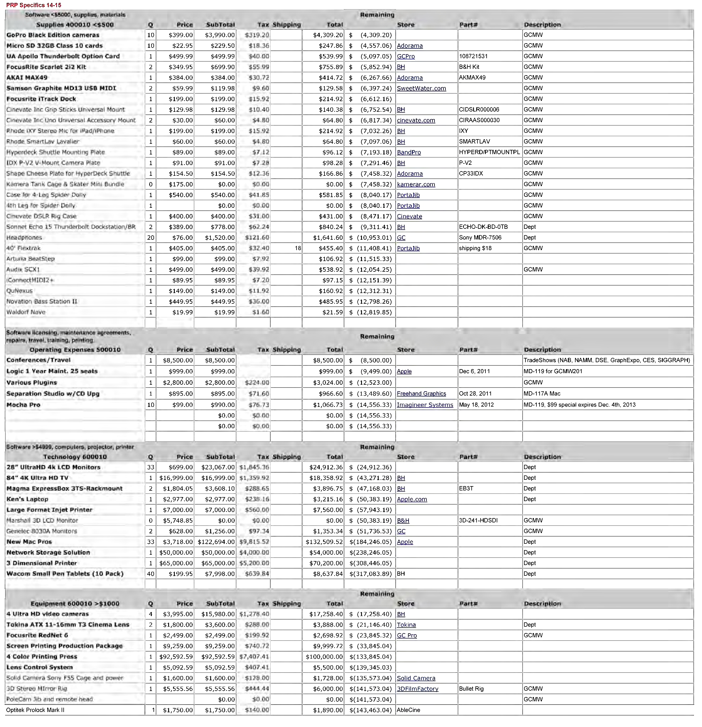
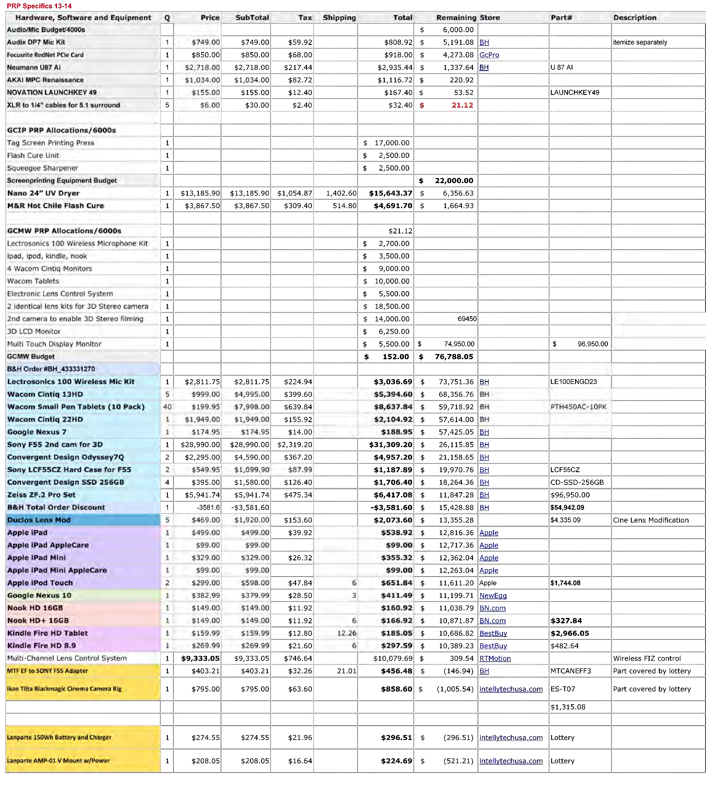

PRP Software Specifics 13-14

ISoftw•re Needs/5000s Q Price Subtotal Tax Shipping Total Left In Budget Store Purch•sed Description
s 9,820.00
Audinate Virtual Sound Card | 33 | $29.99 | $989.67 |  |  | $989.67 | $ 8 830.33 | Audinate
Converqent Desion 70 Quad HD Ootion | 2 | $795.00 | $1 590.00 |  |  | $1 590.00 | $ 7 240.33 |  |  | Software?
Converqent Desiqn 70 HD/2K RAW Option | 0 | $1 495.00 | $0.00 | $0.00 | I l!0.00 |  | $ 7,240.33 |  |  | Software?
Logic 1 Year Maint. 25 seats | 1 | $999.00 | $999.00 |  |  | $999.00 | $ 6,241.33 |  | Dec 6, 2011 | MD-119 for GCMW201
Presenter Creator Pro 3 | 0 | $1 254.00 | $0.00 | $0.00 |  | $0.00 | $ 6 241.33 | ActivateTheSoace | Presenter Creator Pro 3 | Diaital Sianaae software
Sedna Plaver for iPad | 0 | $309.00 | $0.00 | $0.00 |  | $0.00 | $ 6 241.33 | ActivateTheSoace |  | Diaital Sianaae software
Sedna Touch Creator | 0 | $2 595.00 | $0.00 | $0.00 |  | $0.00 | $ 6 241.33 | ActivateTheSoace |  | Touch Sionaae software
Sedna Touch Plaver | 0 | $1 295.00 | $0.00 | $0.00 |  | $0.00 | $ 6 241.33 | ActivateTheSoace |  | Touch Plaver software
Mocha Pro | 4 | $99.00 | $396.00 | $31.68 |  | $427.68 | $ 5 813.65 | Imaa ineer Svstems | Mav 18 2012 | MD-119 $99 soecial exoi res Dec. 4th 2013
Nuke X (Mark w/ Two Years uoorades) | 1 | $395.00 | $395.00 | $31.60 |  | $426.60 | $ 5 387.05 | Foundrv |  | MD-119 for GCMW206
Nuke X extended 2 vear uoorades | 1 | $99.00 | $99.00 | $7.92 |  | $106.92 | $ 5 280.13 | Foundry
RedGiant Trapcode Suite 12.1 | 2 | $409.95 | $819.90 |  |  | $819.90 | $ 4,460.23 | CE
StereoCAT 30 | 1 | $624.50 | $624.50 |  |  | $624.50 | $ 3 835.73 | Dashwood3D
Stereo3D Toolbox | 1 | $399.50 | $399.sol |  |  | $399.50 | $ 3 436.23 |  | I
Stereo3D Toolbox LE | 33 | $49.50 | $1 633.50 |  |  | $1 633.50 | $ 1 802.73 | $2 657.50
Separation Studio w/CD Upg | 0 | $895.00 | $0.00 | $0.00 |  | $0.00 | $ 1,802.73 | Freehand Gra12hics | Oct 28, 2011 | MD-117A Mac
Waves Platinum Bundle | 0 | $899.00 | $0.00 | $0.00 |  | $0.00 | $ 1 802.73 | Sweetwater | 101901536 | For Audio Room
Waves Mercurv Bundle | 0 | $2 174.25 | $0.00 | $0.00 |  | $0.00 | $ 1 802.73 | JRR Shoo |  | Waves Mercurv Native - Download License
Svmohonv 3.5 uoarade CD | 0 | $2 332.00 | $0.00 | $0.00 |  | $0.00 | $ 1802.73 | Xante | Dec 6 2011 | MD-117A PC
Graohite vs 25 Pack | 1 $1 125.00 |  | $1 125.00 |  |  | Sl 125.00 | $ 677.73 | For Ken Packaaina | Mav 6 2010 | MD-133 1$99 uoarade oer seat)
Native Instruments Komolete9 Ultimate | 0 | $998.99 | $0.00 | $0.00 |  | $0.00 | $ 677.73 | JournevEd |  | 5-Lab oack
MotionVFX mObiect | 1 | $399.00 | $399.00 | $31.92 |  | $430.92 | $ 246.81 | MotionVFX
Font Lab | 1 | $600.00 | $600.00 | $48.00 |  | $648.00 | $ (401.19)

""C QI O'Q
fl)
-
I-'
V'I
0
I-'
CTI
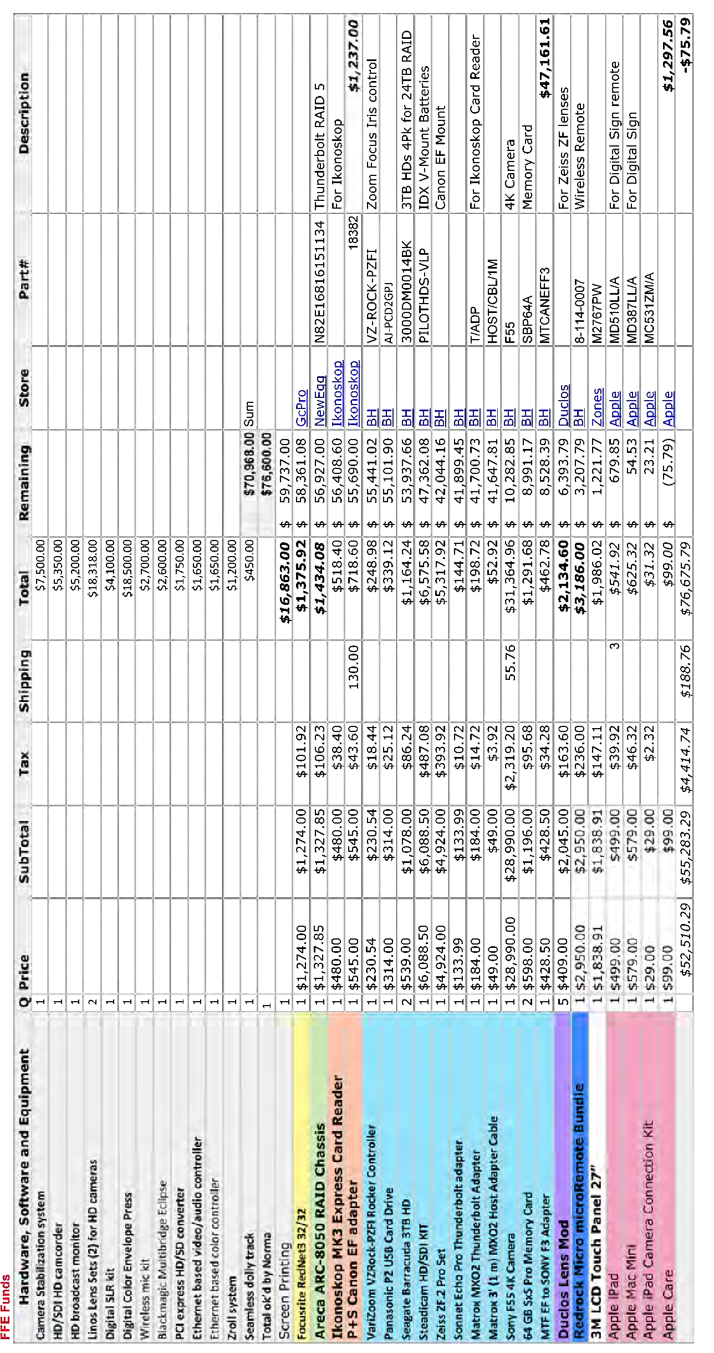

Page 16 of 16
Attachment 8:
Industry Trends, Compiled by Tina Ngo, San Diego Workforce Partnership Research Manager.

San Diego Workforce Partnership, Inc.



3910 University Avenue, Suite 400 San Diego, California 92105 619.228.2900

Occupation Report

San Diego County

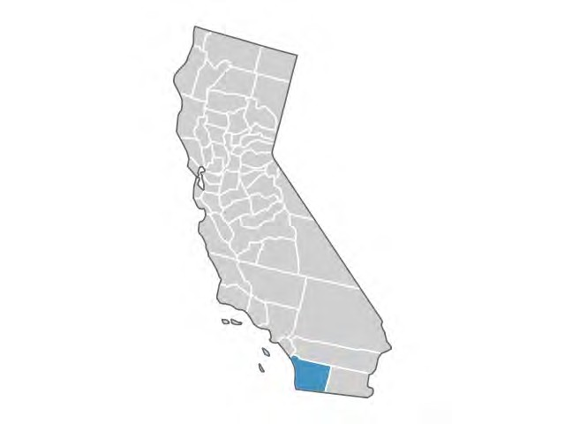
Report Info

Dataset Version 2013.4 Class of Worker

Class of Worker Categories QCEW Employees + Non-QCEW Employees + Self-Employed

Timeframe 2012 - 2017

Region Name San Diego County

Counties

San Diego, CA (6073)

Graphic Designers

SOC 27-1024: Design or create graphics to meet specific commercial or promotional needs, such as packaging, displays, or logos. May use a variety of mediums to achieve artistic or decorative effects.

Related O*NET Occupations:

Graphic Designers (27-1024.00)

Job Distribution

Overview
Annual Openings Estimate (2013) |  | 111
Related Completions (2012) |  | 481
Current Job Postings |  | 96
Gender
Male | 49%
Female | 51%
Age
14-18 | 0%
19-24 | 6%
25-44 | 53%
45-64 | 36%
65+ | 4%

3,597  Jobs (2013)  National Location Quotient: 1.30 | -1.6%  % Change (2012-2017)  Nation: 1.1% | $21.73/hr Median Earnings Nation: $20.37/hr

San Diego County | Growth for Graphic Designers (27-1024)

3,609  2012 Jobs | 3,550  2017 Jobs | -59  Change (2012-2017) | -1.6%  % Change (2012-2017)

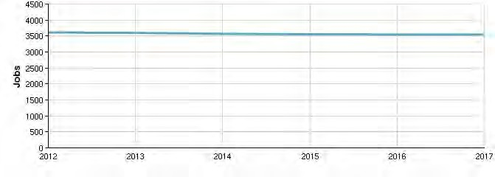
San Diego County | Percentile Earnings for Graphic Designers (27-1024)

$15.04/hr  10th Percentile Earnings | $21.73/hr  Median Earnings | $32.59/hr  90th Percentile Earnings

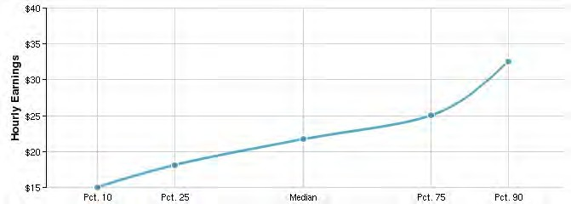

Educational Attainment (National)

Doctoral or professional degree 1%

Master's degree 7%

Bachelor's degree 43%

Associate's degree 14%

Some college, no degree 20%

High school diploma or equivalent 13%

Less than high school diploma 3%
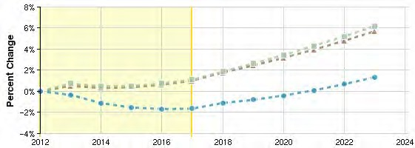
Regional Trends

Region |  | 2012 | 2017 | %
 |  | Jobs | Jobs | Change
A | San Diego County | 3,609 | 3,550 | -1.6%
B | Nation | 265,675 | 268,620 | 1.1%
C | California | 41,194 | 41,614 | 1.0%

Educational programs

6
Programs (2012)
481
Completions (2012)

Program | 2008 | 2009 | 2010 | 2011 | 2012
Graphic Design (50.0409) | 242 | 201 | 242 | 252 | 227
Computer Graphics (11.0803) | 143 | 137 | 108 | 123 | 107
Web Page, Digital/Multimedia and Information Resources Design (11.0801) | 91 | 75 | 74 | 56 | 93
Computer Software and Media Applications, Other (11.0899) | 0 | 1 | 0 | 1 | 37
Design and Visual Communications, General (50.0401) | 1 | 21 | 5 | 17 | 15

Inverse Staffing Patterns

Industry
Occupation
Jobs in Industry (2013)
% of Occupation in Industry
(2013)
% of Total Jobs in Industry (2013)

Graphic Design Services (541430) 697 19.4% 33.8%

Interior Design Services (541410) 488 13.6% 34.0%

Other Specialized Design Services (541490) 115 3.2% 30.6%

Industrial Design Services (541420) 108 3.0% 29.8%

Sporting and Athletic Goods Manufacturing (339920) 78 2.2% 3.5%

Data Sources and Calculations

State Data Sources

This report uses state data from the following agencies: California Labor Market Information Department

Occupation Data

EMSI occupation employment data are based on final EMSI industry data and final EMSI staffing patterns. Wage estimates are based on Occupational Employment Statistics (QCEW and Non-QCEW Employees classes of worker) and the American Community Survey (Self-Employed and Extended Proprietors). Occupational wage estimates also affected by county-level EMSI earnings by industry.

Institution Data

The institution data in this report is taken directly from the national IPEDS database published by the U.S. Department of Education's National Center for Education Statistics.

Completers Data

The completers data in this report is taken directly from the national IPEDS database published by the U.S. Department of Education's National Center for Education Statistics.

Staffing Patterns Data

The staffing pattern data in this report are compiled from several sources using a specialized process. For QCEW and Non- QCEW Employees classes of worker, sources include Occupational Employment Statistics, the National Industry-Occupation Employment Matrix, and the American Community Survey. For the Self-Employed and Extended Proprietors classes of worker, the primary source is the American Community Survey, with a small amount of information from Occupational Employment Statistics.

Industry Data

EMSI industry data have various sources depending on the class of worker. (1) For QCEW Employees, EMSI primarily uses the QCEW (Quarterly Census of Employment and Wages), with supplemental estimates from County Business Patterns and Current Employment Statistics. (2) Non-QCEW employees data are based on a number of sources including QCEW, Current Employment Statistics, County Business Patterns, BEA State and Local Personal Income reports, the National Industry- Occupation Employment Matrix (NIOEM), the American Community Survey, and Railroad Retirement Board statistics. (3) Self- Employed and Extended Proprietor classes of worker data are primarily based on the American Community Survey, Nonemployer Statistics, and BEA State and Local Personal Income Reports. Projections for QCEW and Non-QCEW Employees are informed by NIOEM and long-term industry projections published by individual states.

San Diego Workforce Partnership, Inc.

3910 University Avenue, Suite 400 San Diego, California 92105 619.228.2900

Industry Report

San Diego County

Report Info

Dataset Version 2013.4 Class of Worker

Class of Worker Categories QCEW Employees + Non-QCEW Employees + Self-Employed

Timeframe 2012

Dataset Category EMSI Complete

Region Name San Diego County

Counties

San Diego, CA (6073)

Graphic Design Services

NAICS 541430

Job Distribution

Overview
Establishments (2013) |  | 195
Jobs Multiplier |  | 1.35
Unemployed (8/2013) |  | Only Available for 2-Digit
Gender
Male | 46%
Female | 54%
Age
14-18 | 1%
19-24 | 4%
25-44 | 49%
45-64 | 40%
65+ | 6%

2,061  Jobs (2013)  National Location Quotient: 1.57 | -2.9%  % Change (2012-2017)  Nation: 0.7% | $34,004  Average Earnings Per Job (2013)  Nation: $45,193

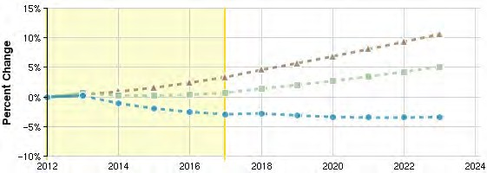
Regional Trends

Region |  | 2012 | 2017 | %
 |  | Jobs | Jobs | Change
A | San Diego County | 2,057 | 1,997 | -2.9%
B | Nation | 126,226 | 127,114 | 0.7%
C | California | 24,959 | 25,795 | 3.3%

Staffing Patterns

Occupation
Employed in
Industry (2013)
% of the Total
Jobs in Industry (2013)

Graphic Designers (27-1024) 697 33.8%

Interior Designers (27-1025) 475 23.1%

Commercial and Industrial Designers (27-1021) 112 5.5%

Art Directors (27-1011) 74 3.6%

Managers, All Other (11-9199) 73 3.6%

Industry Requirements

Industry Amount In-
Region

Out of Region

Temporary Help Services (561320) $1,469,296 80% 20%

Commercial Banking (522110) $1,248,659 57% 43%

Full-Service Restaurants (722110) $1,106,157 89% 11%

Engineering Services (541330) $1,055,253 74% 26%

Lessors of Residential Buildings and Dwellings (531110) $987,513 86% 14%

Top Regional Businesses

Business Name Local
 | Employees
Webtrend Graphics, Inc | 290
La Ccosta Silkscreen Inc. | 100
Parenti/clark Design Inc. | 57
Odm Inc. | 50
Bonus Saoer Coupons | 45

Source: Equifax Business-Level Data DISCLAIMER: Business Data by Equifax is third-party data provided by EMSI to its customers as a convenience, and EMSI does not endorse or warrant its accuracy or consistency with other published EMSI data.

Data Sources and Calculations

State Data Sources

This report uses state data from the following agencies: California Labor Market Information Department

Industry Data

EMSI industry data have various sources depending on the class of worker. (1) For QCEW Employees, EMSI primarily uses the QCEW (Quarterly Census of Employment and Wages), with supplemental estimates from County Business Patterns and Current Employment Statistics. (2) Non-QCEW employees data are based on a number of sources including QCEW, Current Employment Statistics, County Business Patterns, BEA State and Local Personal Income reports, the National Industry- Occupation Employment Matrix (NIOEM), the American Community Survey, and Railroad Retirement Board statistics. (3) Self- Employed and Extended Proprietor classes of worker data are primarily based on the American Community Survey, Nonemployer Statistics, and BEA State and Local Personal Income Reports. Projections for QCEW and Non-QCEW Employees are informed by NIOEM and long-term industry projections published by individual states.

Input-Output Data

The input-output model in this report is EMSI's gravitational flows multi-regional social account matrix model (MR-SAM). It is based on data from the Census Bureau's Current Population Survey and American Community Survey; as well as the Bureau of Economic Analysis' National Income and Product Accounts, Input-Output Make and Use Tables, and Gross State Product data. In addition, several EMSI in-house data sets are used, as well as data from Oak Ridge National Labs on the cost of transportation between counties.

Staffing Patterns Data

The staffing pattern data in this report are compiled from several sources using a specialized process. For QCEW and Non- QCEW Employees classes of worker, sources include Occupational Employment Statistics, the National Industry-Occupation Employment Matrix, and the American Community Survey. For the Self-Employed and Extended Proprietors classes of worker, the primary source is the American Community Survey, with a small amount of information from Occupational Employment Statistics.

Equifax Business-Level Data

Data for individual businesses is provided by Equifax (http://www.equifax.com/commercial/), which maintains a database of more than 20 million U.S. business entities. Note that in aggregate it will not be consistent with EMSI labor market data due to differences in definitions, methodology, coverage, and industry/geographic classification.

San Diego Workforce Partnership, Inc.

3910 University Avenue, Suite 400 San Diego, California 92105 619.228.2900

Industry Report

San Diego County

Report Info

Dataset Version 2013.4 Class of Worker

Class of Worker Categories QCEW Employees + Non-QCEW Employees + Self-Employed

Timeframe 2012

Dataset Category EMSI Complete

Region Name San Diego County

Counties

San Diego, CA (6073)

Computer Systems Design Services

NAICS 541512

Job Distribution

Overview
Establishments (2013) |  | 567
Jobs Multiplier |  | 2.16
Unemployed (8/2013) |  | Only Available for 2-Digit
Gender
Male | 70%
Female | 30%
Age
14-18 | 0%
19-24 | 5%
25-44 | 56%
45-64 | 36%
65+ | 3%

7,682  Jobs (2013)  National Location Quotient: 0.86 | 19.1%  % Change (2012-2017)  Nation: 24.2% | $116,057  Average Earnings Per Job (2013)  Nation: $117,774

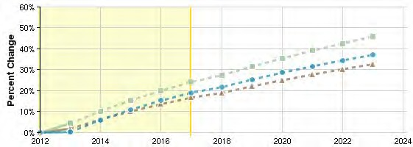
Regional Trends

Region |  | 2012 | 2017 | %
 |  | Jobs | Jobs | Change
A | San Diego County | 7,660 | 9,123 | 19.1%
B | Nation | 824,756 | 1,024,436 | 24.2%
C | California | 86,683 | 101,142 | 16.7%

Staffing Patterns

Occupation
Employed in
Industry (2013)
% of the Total
Jobs in Industry (2013)

Software Developers, Applications (15-1132) 890 11.6%

Software Developers, Systems Software (15-1133) 688 9.0%

Computer Programmers (15-1131) 673 8.8%

Computer Systems Analysts (15-1121) 581 7.6%

Computer User Support Specialists (15-1151) 415 5.4%

Industry Requirements

Industry Amount In-
Region

Out of Region

Engineering Services (541330) $36,761,409 74% 26%

Commercial Banking (522110) $35,629,929 57% 43%

Hotels (except Casino Hotels) and Motels (721110) $18,964,455 93% 7%

Wired Telecommunications Carriers (517110) $16,390,921 28% 72%

Corporate, Subsidiary, and Regional Managing Offices (551114) $15,654,016 61% 39%

Top Regional Businesses

Business Name Local
 | Employees
Cubic Data Systems, Inc. | 500
Divx Llc | 343
Caci | 300
Vector Planning & Services, Inc | 135
Advisor Publications, Inc | 99

Source: Equifax Business-Level Data DISCLAIMER: Business Data by Equifax is third-party data provided by EMSI to its customers as a convenience, and EMSI does not endorse or warrant its accuracy or consistency with other published EMSI data.

Data Sources and Calculations

State Data Sources

This report uses state data from the following agencies: California Labor Market Information Department

Industry Data

EMSI industry data have various sources depending on the class of worker. (1) For QCEW Employees, EMSI primarily uses the QCEW (Quarterly Census of Employment and Wages), with supplemental estimates from County Business Patterns and Current Employment Statistics. (2) Non-QCEW employees data are based on a number of sources including QCEW, Current Employment Statistics, County Business Patterns, BEA State and Local Personal Income reports, the National Industry- Occupation Employment Matrix (NIOEM), the American Community Survey, and Railroad Retirement Board statistics. (3) Self- Employed and Extended Proprietor classes of worker data are primarily based on the American Community Survey, Nonemployer Statistics, and BEA State and Local Personal Income Reports. Projections for QCEW and Non-QCEW Employees are informed by NIOEM and long-term industry projections published by individual states.

Input-Output Data

The input-output model in this report is EMSI's gravitational flows multi-regional social account matrix model (MR-SAM). It is based on data from the Census Bureau's Current Population Survey and American Community Survey; as well as the Bureau of Economic Analysis' National Income and Product Accounts, Input-Output Make and Use Tables, and Gross State Product data. In addition, several EMSI in-house data sets are used, as well as data from Oak Ridge National Labs on the cost of transportation between counties.

Staffing Patterns Data

The staffing pattern data in this report are compiled from several sources using a specialized process. For QCEW and Non- QCEW Employees classes of worker, sources include Occupational Employment Statistics, the National Industry-Occupation Employment Matrix, and the American Community Survey. For the Self-Employed and Extended Proprietors classes of worker, the primary source is the American Community Survey, with a small amount of information from Occupational Employment Statistics.

Equifax Business-Level Data

Data for individual businesses is provided by Equifax (http://www.equifax.com/commercial/), which maintains a database of more than 20 million U.S. business entities. Note that in aggregate it will not be consistent with EMSI labor market data due to differences in definitions, methodology, coverage, and industry/geographic classification.

San Diego Workforce Partnership, Inc.

3910 University Avenue, Suite 400 San Diego, California 92105 619.228.2900

Industry Report

San Diego County

Report Info

Dataset Version 2013.4 Class of Worker

Class of Worker Categories QCEW Employees + Non-QCEW Employees + Self-Employed

Timeframe 2012

Dataset Category EMSI Complete

Region Name San Diego County

Counties

San Diego, CA (6073)

Motion Picture and Video Production

NAICS 512110

Job Distribution

Overview
Establishments (2013) |  | 105
Jobs Multiplier |  | 1.72
Unemployed (8/2013) |  | Only Available for 2-Digit
Gender
Male | 67%
Female | 33%
Age
14-18 | 4%
19-24 | 18%
25-44 | 48%
45-64 | 27%
65+ | 3%

995  Jobs (2013)  National Location Quotient: 0.40 | 2.6%  % Change (2012-2017)  Nation: 4.9% | $39,780  Average Earnings Per Job (2013)  Nation: $93,730

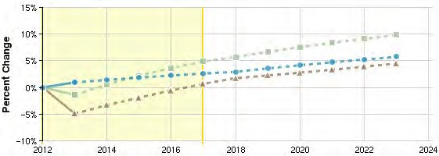
Regional Trends

Region |  | 2012 | 2017 | %
 |  | Jobs | Jobs | Change
A | San Diego County | 986 | 1,011 | 2.6%
B | Nation | 245,730 | 257,702 | 4.9%
C | California | 122,323 | 123,151 | 0.7%

Staffing Patterns

Occupation
Employed in
Industry (2013)
% of the Total
Jobs in Industry (2013)

Producers and Directors (27-2012) 196 19.7%

Film and Video Editors (27-4032) 90 9.0%

Camera Operators, Television, Video, and Motion Picture (27-4031) 65 6.5%

Actors (27-2011) 58 5.8%

Managers, All Other (11-9199) 54 5.5%

Industry Requirements

Industry Amount In-
Region

Out of Region

Motion Picture and Video Production (512110) $11,862,264 10% 90%

Independent Artists, Writers, and Performers (711510) $2,585,467 36% 64% Administrative Management and General Management Consulting Services (541611) $1,631,028 50% 50% Lessors of Residential Buildings and Dwellings (531110) $1,288,407 86% 14% Lessors of Nonresidential Buildings (except Miniwarehouses) (531120) $1,286,817 86% 14%

Top Regional Businesses

Business Name Local
 | Employees
Kpbs Video & Production Services | 150
Invisible Children Inc | 102
Cinemastar Luxury Theaters, Inc | 100
Sbk Enterprises Of California Inc | 38
Kpbs Video & Production Svc. | 37

Source: Equifax Business-Level Data DISCLAIMER: Business Data by Equifax is third-party data provided by EMSI to its customers as a convenience, and EMSI does not endorse or warrant its accuracy or consistency with other published EMSI data.

Data Sources and Calculations

State Data Sources

This report uses state data from the following agencies: California Labor Market Information Department

Industry Data

EMSI industry data have various sources depending on the class of worker. (1) For QCEW Employees, EMSI primarily uses the QCEW (Quarterly Census of Employment and Wages), with supplemental estimates from County Business Patterns and Current Employment Statistics. (2) Non-QCEW employees data are based on a number of sources including QCEW, Current Employment Statistics, County Business Patterns, BEA State and Local Personal Income reports, the National Industry- Occupation Employment Matrix (NIOEM), the American Community Survey, and Railroad Retirement Board statistics. (3) Self- Employed and Extended Proprietor classes of worker data are primarily based on the American Community Survey, Nonemployer Statistics, and BEA State and Local Personal Income Reports. Projections for QCEW and Non-QCEW Employees are informed by NIOEM and long-term industry projections published by individual states.

Input-Output Data

The input-output model in this report is EMSI's gravitational flows multi-regional social account matrix model (MR-SAM). It is based on data from the Census Bureau's Current Population Survey and American Community Survey; as well as the Bureau of Economic Analysis' National Income and Product Accounts, Input-Output Make and Use Tables, and Gross State Product data. In addition, several EMSI in-house data sets are used, as well as data from Oak Ridge National Labs on the cost of transportation between counties.

Staffing Patterns Data

The staffing pattern data in this report are compiled from several sources using a specialized process. For QCEW and Non- QCEW Employees classes of worker, sources include Occupational Employment Statistics, the National Industry-Occupation Employment Matrix, and the American Community Survey. For the Self-Employed and Extended Proprietors classes of worker, the primary source is the American Community Survey, with a small amount of information from Occupational Employment Statistics.

Equifax Business-Level Data

Data for individual businesses is provided by Equifax (http://www.equifax.com/commercial/), which maintains a database of more than 20 million U.S. business entities. Note that in aggregate it will not be consistent with EMSI labor market data due to differences in definitions, methodology, coverage, and industry/geographic classification.

San Diego Workforce Partnership, Inc.

3910 University Avenue, Suite 400 San Diego, California 92105 619.228.2900

Occupation Report

San Diego County

Report Info

Dataset Version 2013.4 Class of Worker

Class of Worker Categories QCEW Employees + Non-QCEW Employees + Self-Employed

Timeframe 2012 - 2017

Region Name San Diego County

Counties

San Diego, CA (6073)

Software Developers, Applications

SOC 15-1132: Develop, create, and modify general computer applications software or specialized utility programs. Analyze user needs and develop software solutions. Design software or customize software for client use with the aim of optimizing operational efficiency. May analyze and design databases within an application area, working individually or coordinating database development as part of a team. May supervise computer programmers.

Related O*NET Occupations:

Software Developers, Applications (15-1132.00)

Job Distribution

Overview
Annual Openings Estimate (2013) |  | 232
Related Completions (2012) |  | 889
Current Job Postings |  | 548
Gender
Male | 78%
Female | 22%
Age
14-18 | 0%
19-24 | 4%
25-44 | 63%
45-64 | 31%
65+ | 1%

7,452  Jobs (2013)  National Location Quotient: 1.16 | 8.6%  % Change (2012-2017)  Nation: 13.0% | $46.26/hr Median Earnings Nation: $43.05/hr

San Diego County | Growth for Software Developers, Applications (15-1132)

7,356  2012 Jobs | 7,990  2017 Jobs | 634  Change (2012-2017) | 8.6%  % Change (2012-2017)

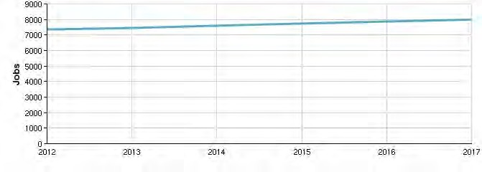
San Diego County | Percentile Earnings for Software Developers, Applications (15-1132)

$28.83/hr  10th Percentile Earnings | $46.26/hr  Median Earnings | $66.05/hr  90th Percentile Earnings

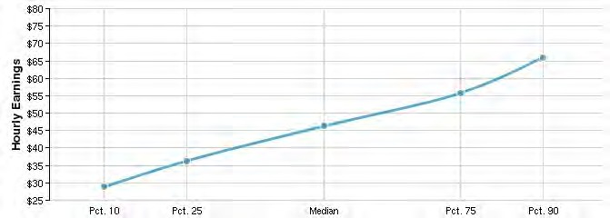

Educational Attainment (National)

Doctoral or professional degree 4%

Master's degree 29%

Bachelor's degree 50%

Associate's degree 5%

Some college, no degree 9%

High school diploma or equivalent 3%

Less than high school diploma 0%
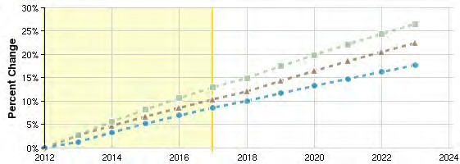
Regional Trends

Region |  | 2012 | 2017 | %
 |  | Jobs | Jobs | Change
A | San Diego County | 7,356 | 7,990 | 8.6%
B | Nation | 606,629 | 685,394 | 13.0%
C | California | 86,094 | 95,057 | 10.4%

Educational programs

8  Programs (2012) |  |  | 889  Completions (2012)
Program | 2008 | 2009 | 2010 | 2011 | 2012
Computer Science (11.0701) | 440 | 435 | 423 | 505 | 591
Computer Programming/Programmer, General (11.0201) | 33 | 20 | 121 | 107 | 133
Computer Engineering, General (14.0901) | 72 | 62 | 72 | 100 | 85
Information Technology (11.0103) | 54 | 53 | 67 | 62 | 50
Bioinformatics (26.1103) | 39 | 35 | 12 | 21 | 30

Inverse Staffing Patterns

Industry
Occupation
Jobs in Industry (2013)
% of Occupation in Industry
(2013)
% of Total Jobs in Industry (2013)

Custom Computer Programming Services (541511) 1,320 17.7% 11.5%

Computer Systems Design Services (541512) 890 11.9% 11.6%

Software Publishers (511210) 620 8.3% 14.5%

Research and Development in the Physical, Engineering, and Life Sciences (except Biotechnology) (541712)

423 5.7% 2.2%

Corporate, Subsidiary, and Regional Managing Offices (551114) 297 4.0% 1.6%

Data Sources and Calculations

State Data Sources

This report uses state data from the following agencies: California Labor Market Information Department

Occupation Data

EMSI occupation employment data are based on final EMSI industry data and final EMSI staffing patterns. Wage estimates are based on Occupational Employment Statistics (QCEW and Non-QCEW Employees classes of worker) and the American Community Survey (Self-Employed and Extended Proprietors). Occupational wage estimates also affected by county-level EMSI earnings by industry.

Institution Data

The institution data in this report is taken directly from the national IPEDS database published by the U.S. Department of Education's National Center for Education Statistics.

Completers Data

The completers data in this report is taken directly from the national IPEDS database published by the U.S. Department of Education's National Center for Education Statistics.

Staffing Patterns Data

The staffing pattern data in this report are compiled from several sources using a specialized process. For QCEW and Non- QCEW Employees classes of worker, sources include Occupational Employment Statistics, the National Industry-Occupation Employment Matrix, and the American Community Survey. For the Self-Employed and Extended Proprietors classes of worker, the primary source is the American Community Survey, with a small amount of information from Occupational Employment Statistics.

Industry Data

EMSI industry data have various sources depending on the class of worker. (1) For QCEW Employees, EMSI primarily uses the QCEW (Quarterly Census of Employment and Wages), with supplemental estimates from County Business Patterns and Current Employment Statistics. (2) Non-QCEW employees data are based on a number of sources including QCEW, Current Employment Statistics, County Business Patterns, BEA State and Local Personal Income reports, the National Industry- Occupation Employment Matrix (NIOEM), the American Community Survey, and Railroad Retirement Board statistics. (3) Self- Employed and Extended Proprietor classes of worker data are primarily based on the American Community Survey, Nonemployer Statistics, and BEA State and Local Personal Income Reports. Projections for QCEW and Non-QCEW Employees are informed by NIOEM and long-term industry projections published by individual states.

San Diego Workforce Partnership, Inc.

3910 University Avenue, Suite 400 San Diego, California 92105 619.228.2900

Industry Report

San Diego County

Report Info

Dataset Version 2013.4 Class of Worker

Class of Worker Categories QCEW Employees + Non-QCEW Employees + Self-Employed

Timeframe 2012

Dataset Category EMSI Complete

Region Name San Diego County

Counties

San Diego, CA (6073)

Software Publishers

NAICS 511210

Job Distribution

Overview
Establishments (2013) |  | 94
Jobs Multiplier |  | 4.67
Unemployed (8/2013) |  | Only Available for 2-Digit
Gender
Male | 64%
Female | 36%
Age
14-18 | 0%
19-24 | 4%
25-44 | 62%
45-64 | 33%
65+ | 2%

4,266  Jobs (2013)  National Location Quotient: 1.43 | 7.3%  % Change (2012-2017)  Nation: 13.4% | $151,551  Average Earnings Per Job (2013)  Nation: $158,788

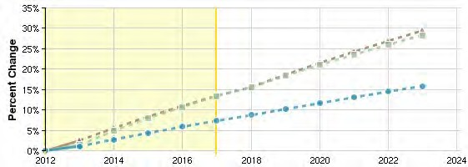
Regional Trends

Region |  | 2012 | 2017 | %
 |  | Jobs | Jobs | Change
A | San Diego County | 4,220 | 4,530 | 7.3%
B | Nation | 284,160 | 322,180 | 13.4%
C | California | 49,706 | 56,400 | 13.5%

Staffing Patterns

Occupation
Employed in
Industry (2013)
% of the Total
Jobs in Industry (2013)

Software Developers, Applications (15-1132) 620 14.5%

Software Developers, Systems Software (15-1133) 479 11.2%

Computer Programmers (15-1131) 293 6.9%

Computer User Support Specialists (15-1151) 276 6.5%

Sales Representatives, Wholesale and Manufacturing, Technical and Scientific Products (41-4011)

193 4.5%

Industry Requirements

Industry Amount In-
Region

Out of Region

Corporate, Subsidiary, and Regional Managing Offices (551114) $102,450,789 61% 39%

Temporary Help Services (561320) $98,766,479 80% 20%

Office Administrative Services (561110) $55,809,963 59% 41%

Commercial Banking (522110) $52,479,915 57% 43%

Offices of Lawyers (541110) $51,610,614 82% 18%

Top Regional Businesses

Business Name Local
 | Employees
Intuit Inc.-consumer Tax Group | 800
Accelrys, Inc. | 580
Stratagene Genomics, Inc | 400
Emc Captiva | 316
Blackbaud San Diego | 281

Source: Equifax Business-Level Data DISCLAIMER: Business Data by Equifax is third-party data provided by EMSI to its customers as a convenience, and EMSI does not endorse or warrant its accuracy or consistency with other published EMSI data.

Data Sources and Calculations

State Data Sources

This report uses state data from the following agencies: California Labor Market Information Department

Industry Data

EMSI industry data have various sources depending on the class of worker. (1) For QCEW Employees, EMSI primarily uses the QCEW (Quarterly Census of Employment and Wages), with supplemental estimates from County Business Patterns and Current Employment Statistics. (2) Non-QCEW employees data are based on a number of sources including QCEW, Current Employment Statistics, County Business Patterns, BEA State and Local Personal Income reports, the National Industry- Occupation Employment Matrix (NIOEM), the American Community Survey, and Railroad Retirement Board statistics. (3) Self- Employed and Extended Proprietor classes of worker data are primarily based on the American Community Survey, Nonemployer Statistics, and BEA State and Local Personal Income Reports. Projections for QCEW and Non-QCEW Employees are informed by NIOEM and long-term industry projections published by individual states.

Input-Output Data

The input-output model in this report is EMSI's gravitational flows multi-regional social account matrix model (MR-SAM). It is based on data from the Census Bureau's Current Population Survey and American Community Survey; as well as the Bureau of Economic Analysis' National Income and Product Accounts, Input-Output Make and Use Tables, and Gross State Product data. In addition, several EMSI in-house data sets are used, as well as data from Oak Ridge National Labs on the cost of transportation between counties.

Staffing Patterns Data

The staffing pattern data in this report are compiled from several sources using a specialized process. For QCEW and Non- QCEW Employees classes of worker, sources include Occupational Employment Statistics, the National Industry-Occupation Employment Matrix, and the American Community Survey. For the Self-Employed and Extended Proprietors classes of worker, the primary source is the American Community Survey, with a small amount of information from Occupational Employment Statistics.

Equifax Business-Level Data

Data for individual businesses is provided by Equifax (http://www.equifax.com/commercial/), which maintains a database of more than 20 million U.S. business entities. Note that in aggregate it will not be consistent with EMSI labor market data due to differences in definitions, methodology, coverage, and industry/geographic classification.

San Diego Workforce Partnership, Inc.

3910 University Avenue, Suite 400 San Diego, California 92105 619.228.2900

Occupation Report

San Diego County

Report Info

Dataset Version 2013.4 Class of Worker

Class of Worker Categories QCEW Employees + Non-QCEW Employees + Self-Employed

Timeframe 2011 - 2017

Region Name San Diego County

Counties

San Diego, CA (6073)

Web Developers

SOC 15-1134: Design, create, and modify Web sites. Analyze user needs to implement Web site content, graphics, performance, and capacity. May integrate Web sites with other computer applications. May convert written, graphic, audio, and video components to compatible Web formats by using software designed to facilitate the creation of Web and multimedia content. Excludes “Multimedia Artists and Animators” (27-1014).

Related O*NET Occupations:

Web Developers (15-1134.00)

Job Distribution

Overview
Annual Openings Estimate (2013) |  | 57
Related Completions (2012) |  | 1,712
Current Job Postings |  | 875
Gender
Male | 71%
Female | 29%
Age
14-18 | 1%
19-24 | 8%
25-44 | 66%
45-64 | 24%
65+ | 1%

1,907  Jobs (2013)  National Location Quotient: 1.35 | 10.5%  % Change (2011-2017)  Nation: 15.6% | $24.98/hr Median Earnings Nation: $27.69/hr

San Diego County | Growth for Web Developers (15-1134)

1,822  2011 Jobs | 2,013  2017 Jobs | 192  Change (2011-2017) | 10.5%  % Change (2011-2017)

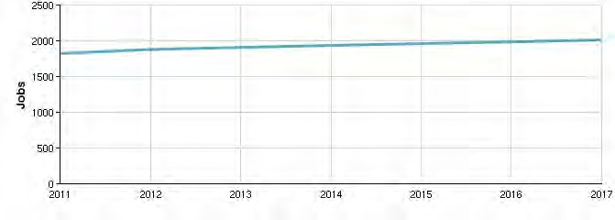
San Diego County | Percentile Earnings for Web Developers (15-1134)

$15.37/hr  10th Percentile Earnings | $24.98/hr  Median Earnings | $36.39/hr  90th Percentile Earnings

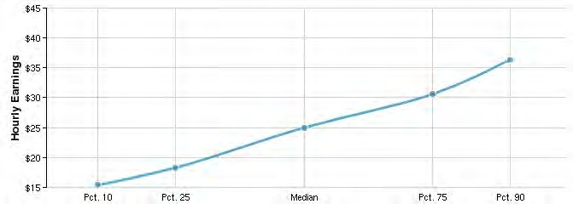

Educational Attainment (National)

Doctoral or professional degree 1%

Master's degree 12%

Bachelor's degree 43%

Associate's degree 13%

Some college, no degree 22%

High school diploma or equivalent 8%

Less than high school diploma 1%
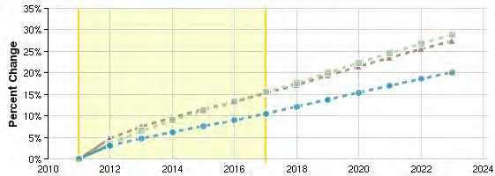
Regional Trends

Region |  | 2011 | 2017 | %
 |  | Jobs | Jobs | Change
A | San Diego County | 1,822 | 2,013 | 10.5%
B | Nation | 128,550 | 148,543 | 15.6%
C | California | 19,043 | 21,949 | 15.3%

Educational programs

13
Programs (2012)
1,712
Completions (2012)

Program | 2008 | 2009 | 2010 | 2011 | 2012
Computer Science (11.0701) | 440 | 435 | 423 | 505 | 591
Computer Systems Networking and Telecommunications (11.0901) | 262 | 271 | 313 | 397 | 581
Computer Programming/Programmer, Genera (11.0201) | l 33 | 20 | 121 | 107 | 133
Web Page, Digital/Multimedia and Information Resources Design (11.0801) | 91 | 75 | 74 | 56 | 93
Computer Engineering, General (14.0901) | 72 | 62 | 72 | 100 | 85

Inverse Staffing Patterns

Industry
Occupation
Jobs in Industry (2013)
% of Occupation in Industry
(2013)
% of Total Jobs in Industry (2013)

Custom Computer Programming Services (541511) 366 19.2% 3.2%

Computer Systems Design Services (541512) 239 12.5% 3.1%

Internet Publishing and Broadcasting and Web Search Portals (519130) 96 5.0% 5.8%

Other Scientific and Technical Consulting Services (541690) 54 2.9% 0.5%

Corporate, Subsidiary, and Regional Managing Offices (551114) 52 2.7% 0.3%

Data Sources and Calculations

State Data Sources

This report uses state data from the following agencies: California Labor Market Information Department

Occupation Data

EMSI occupation employment data are based on final EMSI industry data and final EMSI staffing patterns. Wage estimates are based on Occupational Employment Statistics (QCEW and Non-QCEW Employees classes of worker) and the American Community Survey (Self-Employed and Extended Proprietors). Occupational wage estimates also affected by county-level EMSI earnings by industry.

Institution Data

The institution data in this report is taken directly from the national IPEDS database published by the U.S. Department of Education's National Center for Education Statistics.

Completers Data

The completers data in this report is taken directly from the national IPEDS database published by the U.S. Department of Education's National Center for Education Statistics.

Staffing Patterns Data

The staffing pattern data in this report are compiled from several sources using a specialized process. For QCEW and Non- QCEW Employees classes of worker, sources include Occupational Employment Statistics, the National Industry-Occupation Employment Matrix, and the American Community Survey. For the Self-Employed and Extended Proprietors classes of worker, the primary source is the American Community Survey, with a small amount of information from Occupational Employment Statistics.

Industry Data

EMSI industry data have various sources depending on the class of worker. (1) For QCEW Employees, EMSI primarily uses the QCEW (Quarterly Census of Employment and Wages), with supplemental estimates from County Business Patterns and Current Employment Statistics. (2) Non-QCEW employees data are based on a number of sources including QCEW, Current Employment Statistics, County Business Patterns, BEA State and Local Personal Income reports, the National Industry- Occupation Employment Matrix (NIOEM), the American Community Survey, and Railroad Retirement Board statistics. (3) Self- Employed and Extended Proprietor classes of worker data are primarily based on the American Community Survey, Nonemployer Statistics, and BEA State and Local Personal Income Reports. Projections for QCEW and Non-QCEW Employees are informed by NIOEM and long-term industry projections published by individual states.

San Diego Workforce Partnership, Inc.

3910 University Avenue, Suite 400 San Diego, California 92105 619.228.2900

Industry Report

San Diego County

Report Info

Dataset Version 2013.4 Class of Worker

Class of Worker Categories QCEW Employees + Non-QCEW Employees + Self-Employed

Timeframe 2012

Dataset Category EMSI Complete

Region Name San Diego County

Counties

San Diego, CA (6073)

Custom Computer Programming Services

NAICS 541511

Job Distribution

Overview
Establishments (2013) |  | 1032
Jobs Multiplier |  | 1.86
Unemployed (8/2013) |  | Only Available for 2-Digit
Gender
Male | 70%
Female | 30%
Age
14-18 | 0%
19-24 | 5%
25-44 | 55%
45-64 | 36%
65+ | 3%

11,456  Jobs (2013)  National Location Quotient: 1.37 | 7.2%  % Change (2012-2017)  Nation: 19.5% | $97,286  Average Earnings Per Job (2013)  Nation: $110,532

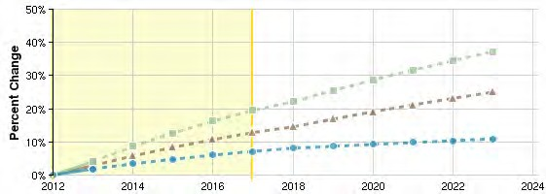
Regional Trends

Region |  | 2012 | 2017 | %
 |  | Jobs | Jobs | Change
A | San Diego County | 11,245 | 12,050 | 7.2%
B | Nation | 774,780 | 926,147 | 19.5%
C | California | 133,930 | 151,124 | 12.8%

Staffing Patterns

Occupation
Employed in
Industry (2013)
% of the Total
Jobs in Industry (2013)

Software Developers, Applications (15-1132) 1,320 11.5%

Software Developers, Systems Software (15-1133) 1,020 8.9%

Computer Programmers (15-1131) 1,005 8.8%

Computer Systems Analysts (15-1121) 870 7.6%

Computer User Support Specialists (15-1151) 617 5.4%

Industry Requirements

Industry Amount In-
Region

Out of Region

Temporary Help Services (561320) $35,244,035 80% 20%

Office Administrative Services (561110) $18,890,038 59% 41%

Corporate, Subsidiary, and Regional Managing Offices (551114) $17,683,950 61% 39%

Wired Telecommunications Carriers (517110) $15,749,645 28% 72%

Offices of Lawyers (541110) $15,290,426 82% 18%

Top Regional Businesses

Business Name Local
 | Employees
Mitchell International, Inc. | 700
Tapestry Solutions, Inc. | 400
Tapestry Solutions, Inc | 400
Eset, Llc | 250
Tritech Software Systems Inc. | 200

Source: Equifax Business-Level Data DISCLAIMER: Business Data by Equifax is third-party data provided by EMSI to its customers as a convenience, and EMSI does not endorse or warrant its accuracy or consistency with other published EMSI data.

Data Sources and Calculations

State Data Sources

This report uses state data from the following agencies: California Labor Market Information Department

Industry Data

EMSI industry data have various sources depending on the class of worker. (1) For QCEW Employees, EMSI primarily uses the QCEW (Quarterly Census of Employment and Wages), with supplemental estimates from County Business Patterns and Current Employment Statistics. (2) Non-QCEW employees data are based on a number of sources including QCEW, Current Employment Statistics, County Business Patterns, BEA State and Local Personal Income reports, the National Industry- Occupation Employment Matrix (NIOEM), the American Community Survey, and Railroad Retirement Board statistics. (3) Self- Employed and Extended Proprietor classes of worker data are primarily based on the American Community Survey, Nonemployer Statistics, and BEA State and Local Personal Income Reports. Projections for QCEW and Non-QCEW Employees are informed by NIOEM and long-term industry projections published by individual states.

Input-Output Data

The input-output model in this report is EMSI's gravitational flows multi-regional social account matrix model (MR-SAM). It is based on data from the Census Bureau's Current Population Survey and American Community Survey; as well as the Bureau of Economic Analysis' National Income and Product Accounts, Input-Output Make and Use Tables, and Gross State Product data. In addition, several EMSI in-house data sets are used, as well as data from Oak Ridge National Labs on the cost of transportation between counties.

Staffing Patterns Data

The staffing pattern data in this report are compiled from several sources using a specialized process. For QCEW and Non- QCEW Employees classes of worker, sources include Occupational Employment Statistics, the National Industry-Occupation Employment Matrix, and the American Community Survey. For the Self-Employed and Extended Proprietors classes of worker, the primary source is the American Community Survey, with a small amount of information from Occupational Employment Statistics.

Equifax Business-Level Data

Data for individual businesses is provided by Equifax (http://www.equifax.com/commercial/), which maintains a database of more than 20 million U.S. business entities. Note that in aggregate it will not be consistent with EMSI labor market data due to differences in definitions, methodology, coverage, and industry/geographic classification.

San Diego Workforce Partnership, Inc.

3910 University Avenue, Suite 400 San Diego, California 92105 619.228.2900

Industry Report

San Diego County

Report Info

Dataset Version 2013.4 Class of Worker

Class of Worker Categories QCEW Employees + Non-QCEW Employees + Self-Employed

Timeframe 2012

Dataset Category EMSI Complete

Region Name San Diego County

Counties

San Diego, CA (6073)

Internet Publishing and Broadcasting and Web Search Portals

NAICS 519130

Job Distribution

Overview
Establishments (2013) |  | 103
Jobs Multiplier |  | 2.19
Unemployed (8/2013) |  | Only Available for 2-Digit
Gender
Male | 69%
Female | 31%
Age
14-18 | 0%
19-24 | 7%
25-44 | 70%
45-64 | 21%
65+ | 1%

1,662  Jobs (2013)  National Location Quotient: 1.17 | 17.9%  % Change (2012-2017)  Nation: 26.7% | $91,323  Average Earnings Per Job (2013)  Nation: $162,453

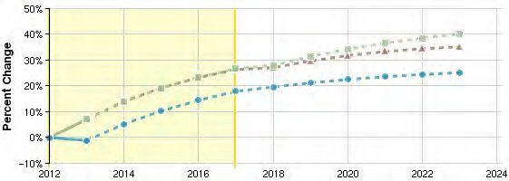
Regional Trends

Region |  | 2012 | 2017 | %
 |  | Jobs | Jobs | Change
A | San Diego County | 1,681 | 1,982 | 17.9%
B | Nation | 128,622 | 162,988 | 26.7%
C | California | 44,389 | 56,087 | 26.4%

Staffing Patterns

Occupation
Employed in
Industry (2013)
% of the Total
Jobs in Industry (2013)

Software Developers, Applications (15-1132) 111 6.7%

Customer Service Representatives (43-4051) 98 5.9%

Web Developers (15-1134) 96 5.8%

Sales Representatives, Services, All Other (41-3099) 69 4.1%

Advertising Sales Agents (41-3011) 56 3.4%

Industry Requirements

Industry Amount In-
Region

Out of Region

Wired Telecommunications Carriers (517110) $10,549,731 28% 72%

Corporate, Subsidiary, and Regional Managing Offices (551114) $7,809,466 61% 39% Lessors of Nonfinancial Intangible Assets (except Copyrighted Works) (533110) $5,591,894 55% 45% Administrative Management and General Management Consulting Services (541611) $5,399,600 50% 50% Offices of Lawyers (541110) $5,028,455 82% 18%

Top Regional Businesses

Business Name Local
Employees
Takelessons 5
Supersmarthealth 1
Finditbyme.com, Inc. 1
Source: Equifax Business-Level Data DISCLAIMER: Business Data by Equifax is third-party data provided by EMSI to its customers as a convenience, and EMSI does not endorse or warrant its accuracy or consistency with other published EMSI data.

Data Sources and Calculations

State Data Sources

This report uses state data from the following agencies: California Labor Market Information Department

Industry Data

EMSI industry data have various sources depending on the class of worker. (1) For QCEW Employees, EMSI primarily uses the QCEW (Quarterly Census of Employment and Wages), with supplemental estimates from County Business Patterns and Current Employment Statistics. (2) Non-QCEW employees data are based on a number of sources including QCEW, Current Employment Statistics, County Business Patterns, BEA State and Local Personal Income reports, the National Industry- Occupation Employment Matrix (NIOEM), the American Community Survey, and Railroad Retirement Board statistics. (3) Self- Employed and Extended Proprietor classes of worker data are primarily based on the American Community Survey, Nonemployer Statistics, and BEA State and Local Personal Income Reports. Projections for QCEW and Non-QCEW Employees are informed by NIOEM and long-term industry projections published by individual states.

Input-Output Data

The input-output model in this report is EMSI's gravitational flows multi-regional social account matrix model (MR-SAM). It is based on data from the Census Bureau's Current Population Survey and American Community Survey; as well as the Bureau of Economic Analysis' National Income and Product Accounts, Input-Output Make and Use Tables, and Gross State Product data. In addition, several EMSI in-house data sets are used, as well as data from Oak Ridge National Labs on the cost of transportation between counties.

Staffing Patterns Data

The staffing pattern data in this report are compiled from several sources using a specialized process. For QCEW and Non- QCEW Employees classes of worker, sources include Occupational Employment Statistics, the National Industry-Occupation Employment Matrix, and the American Community Survey. For the Self-Employed and Extended Proprietors classes of worker, the primary source is the American Community Survey, with a small amount of information from Occupational Employment Statistics.

Equifax Business-Level Data

Data for individual businesses is provided by Equifax (http://www.equifax.com/commercial/), which maintains a database of more than 20 million U.S. business entities. Note that in aggregate it will not be consistent with EMSI labor market data due to differences in definitions, methodology, coverage, and industry/geographic classification.

