To add a Preferred Name – Navigate to My Profile

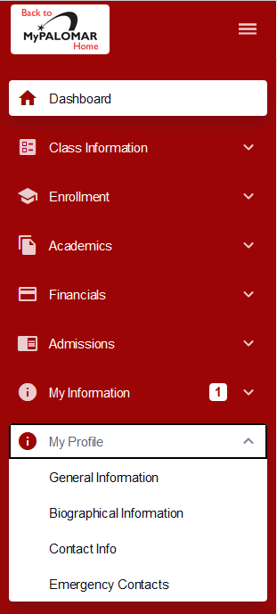

Then select Biographical Information then Add Name.

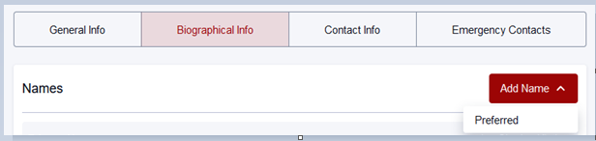

**Note – you may add or change a first name and/or middle name but to change your last name – you must take proper identification to the Student Services Center Building on the San Marcos Campus.

