|  |  |  |
| --- | --- | --- |
| **Annual Report of Hawaiian T&E Plants, at Palomar Community College** | 101_2314 2.jpg  March, 22nd  2018  Volume 5 | |
| *This report indicates the current status of the seeds and any subsequent seedlings from the collections made of cultivated T&E seeds from the Honolulu Botanic Gardens, National Tropical Botanic Garden, and the Waimea Valley Arboretum in the spring of 2013.* | |  |

Prepared by:

**Antonio Rangel**

**Palomar Community College**

**Facilities Department, Grounds Services**

**&**

**Friends of the Palomar College Arboretum**

**1140 West Mission Road   
San Marcos, California 92069**

**Introduction**

In the summer of 2012, I contacted the Hawaii Department of Forestry and the US Fish and Wildlife Service to request approval to collect seeds of some Threatened and Endangered plant species native to the Hawaiian Islands from botanical gardens in Hawaii and bring them back to the mainland.

The collected species include:

* ***Sesbania tomentosa***
* ***Abutilon mensiesii***
* ***Abutilon sandwicensis***
* ***Hibiscadelphus distans***
* ***Polycias racemosum***
* ***Caesalpinia kaviaensis***

Currently only *Sesbania tomentosa* is in the garden. This species, along with a host of other Polynesian plants are providing visitors a chance to see how beautiful and diverse our world is and hopefully entice at least a few to take some active role in the efforts to protect the species.

**The Following Botanical institutions provided seeds for nearly all of the Hawaiian Native plants in these gardens.**

**The National Tropical Botanical Garden**

**NTBG -- The Honolulu Botanical Gardens**

**The Waimea Valley Botanical Garden**

**Campus Nursery & Soil Type for Planting**

Refer to Volumes 1 and 2 for more information on the campus nursery and soil types used for planting.

**Seed and Seedling Status, As Of Spring 2018**

As with last year, the chart below shows that only three species are still represented in the seed bank at the college. With the best represented species being *Sesbania tomentosa.* The species performed so well this year that we collected an abundance of seed from the three live plants in the Garden. There was so much seed that we decided to count out 759 seed from one plant and weigh them, as counting al the seed would have taken too long. The total weight of the 759 seed was 15.54g. The rest of the seed cleaned from the pods from all three plants weighed in at 219.7 grams*.* To derive an estimated seed total we then took the number 759 and divided that number by the 15.54 grams, which gave us 48.84 seeds per gram. We then took the 48.84 seeds per gram and multiplied it by the total of 219.7 grams, which gave us a total seed cleaned of 10,730.15. Then we added the original 759 seed count back to that number, which gave us 11,489.148 seeds cleaned from three different plants. The majority of the seed produced came from plant 4-1.

With the exhaustive time it took to remove the seed from the bean pods it was decided that we needed to find a way to derive an average number of seeds per pod, as continuing to process each pod would require additional man hours, and we had already committed 44 man hours in a 12 hr period, over the course of 2 days. The length of bean pods varies significantly, as do the number of seeds per pod. Not surprisingly, the longer the pod the more likely it is to have a greater number of seeds. In an attempt to save time, we decided to count viable seed yield per pod from a total of 88 bean pods, which were selected at random. Viability was assumed based on size, color, and thickness or turgidity. If a seed was significantly smaller than the norm, had any dark discoloration spots, or flattened areas, (often associated with ridges) the seed was assumed damaged or non-fertile and thus discarded.

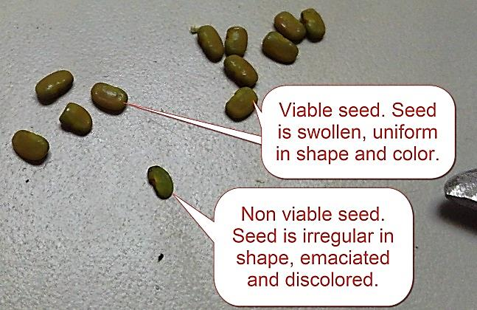

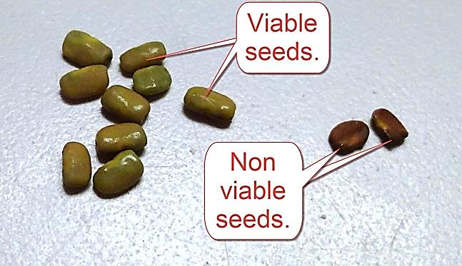

**The two images above show the differences between viable and non-viable seeds.**

From the 88 pods 937 seeds were counted. As mentioned above, the number of seeds per pod varied. Ranging from 3 to 22 viable seeds per pod. Unfortunately I did not track the number of non-viable seeds per pod, as at the time that number seemed insignificant, though in hindsight, in the future that number could be telling of the overall health of the plants. The yields most frequently seen were 9, 12, 13, and 11 in descending order. 3 was only counted twice and 22 seeds per pod only came up once in the 88 pods cleaned. To derive an average of viable seed per pod the 937 seed was divided by the 88 pods, which gave us 10.65 seeds per pod. Due to the fairly high variability we decided to remove those numbers that occurred less than 4 times in the count. 20 pod counts were removed from the tally accounting for 205 seeds. The math was done again removing the 205 from the 937, which gave us 732 seeds. From the 88 total bean pods we removed the 20 anomalous pods, which then gave us 68. The 732 was then divided by the 68 which gave us a new average of 10.7 seeds per pod.

At this point we then counted up the remaining pods and set them aside to dry. The total number of bean pods with the seed not removed was 1,741. 1,741 multiplied by 10.7 = 18,628.7 seeds estimated to be remaining in the pods. With most of these seeds gathered from the 4-1 plant. This put the total number of seeds gathered from the three plants in the garden this year at 11,489.15 + 18,268.7 = 29,757.85 seeds.

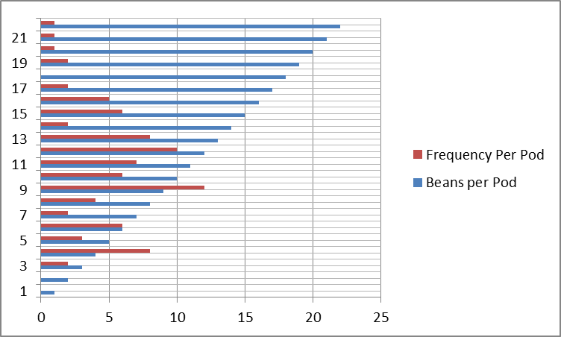

**The graph above shows the number of seeds per pod and the frequency for which those numbers occurred.**

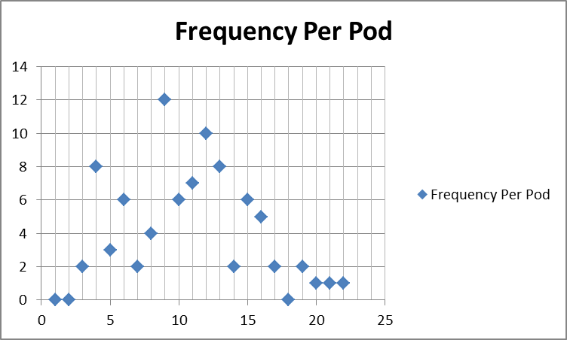

**The graph above shows the same information as that in the previous graph, only in a different format.**

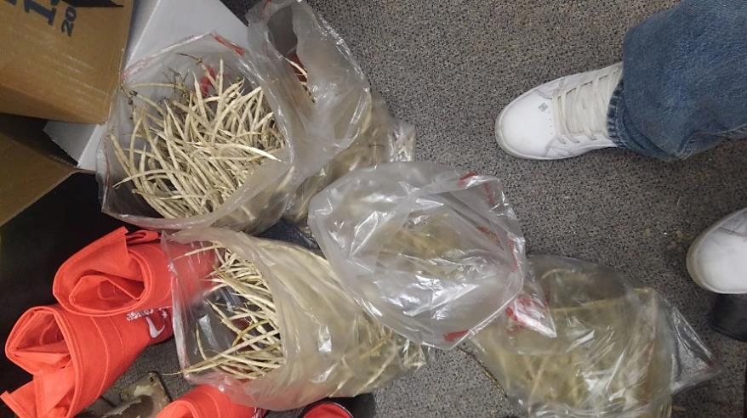

***Sesbania tomentosa* bean pods waiting to be cleaned.**



**I should clarify that *S. tomentosa* numbered 1 through 4 in the chart above, are from years prior and that #4 is the plant whose progeny are now living in the garden and producing seed. Hence 4-1, 4-2 and 4-3.**

As discussed in the previous editions of this report; *Sesbania tomentosa* has been a vigorous grower, both in the ground and in containers, often reaching sexual maturity within six to nine months of germination. There are three second generation *Sesbania tomentosa* currently growing in the garden.

We discovered this year from some correspondence with US Fish and Wildlife that our *Sesbania tomentosa*, which were grown from seed provided to us from plants at the National Tropical Botanical Garden on Kauai, actually came from plants whose lineage is now extinct in the wild on Kauai. Sesbania tomentosa is polymorphic, meaning its growth form varies. Most often it is a ground cover type plant. However; occasionally it develops as a bush or shrub. The flower color is also variable from colony to colony. **[1]** As it turns out, our form is the shrub or small tree form that was once found in Pilohale, Kauai. (**peers comm**).

Our *Polycias racemosum* grew substantially faster since we moved it out of the greenhouse and into the shade house in the spring of 2016. It was moved into a 15 gallon pot in 2017. However; it is still a relatively small plant, but is growing well. It does seem to respond well to fertilizer.

**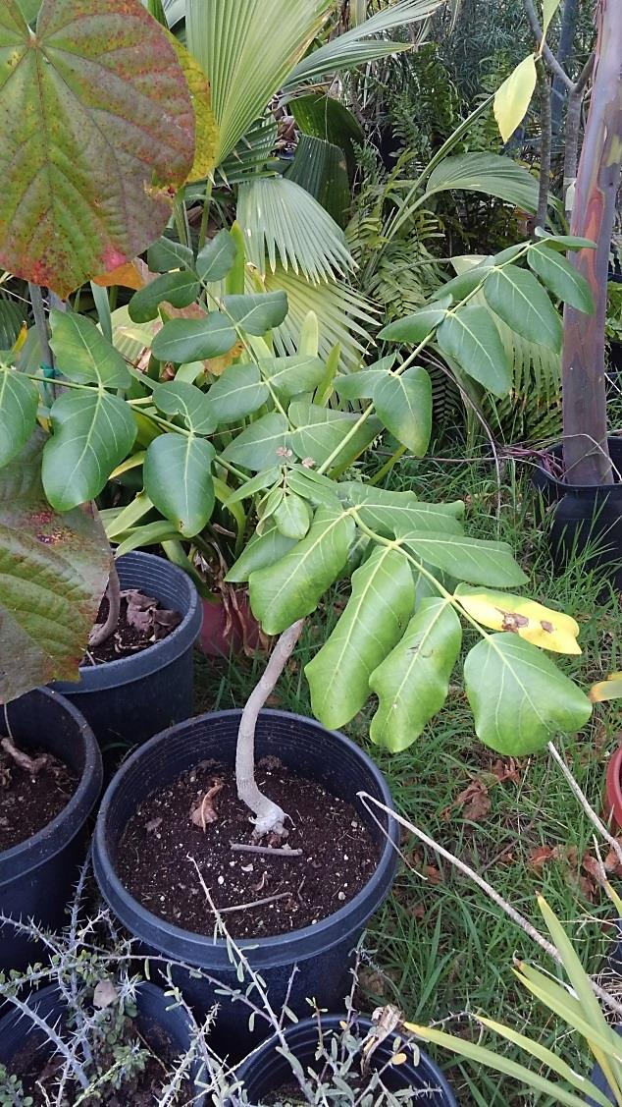**

***Polycias racemosum* in the nursery March 2018.**

The *Hibiscadelphus distans* performed well this year. Steady growth occurred again in spring and fall with blooms on the plant intermittently throughout the year, though the majority of the blooming occurred in the later winter, spring and fall months. We noticed that none of the flowers set, and thus no seed has been produced as of yet. However; we are looking at the intricacies of hand pollinating and have noticed ants, most likely *Linepithema humile* (**Argentine Ants**), in amongst the flowers and are hopeful they may incidentally act as pollinators.

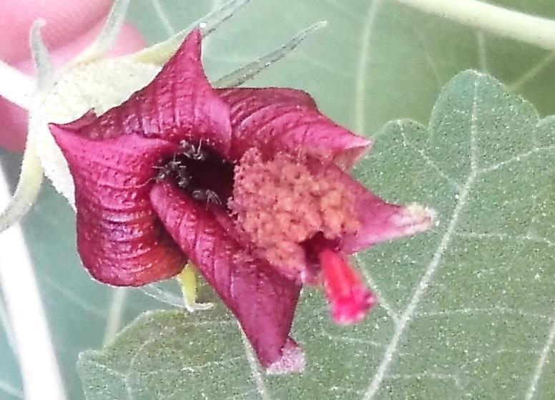

***A close up of Hibiscadelphus distans with ants in amongst the petals of the flower.***

**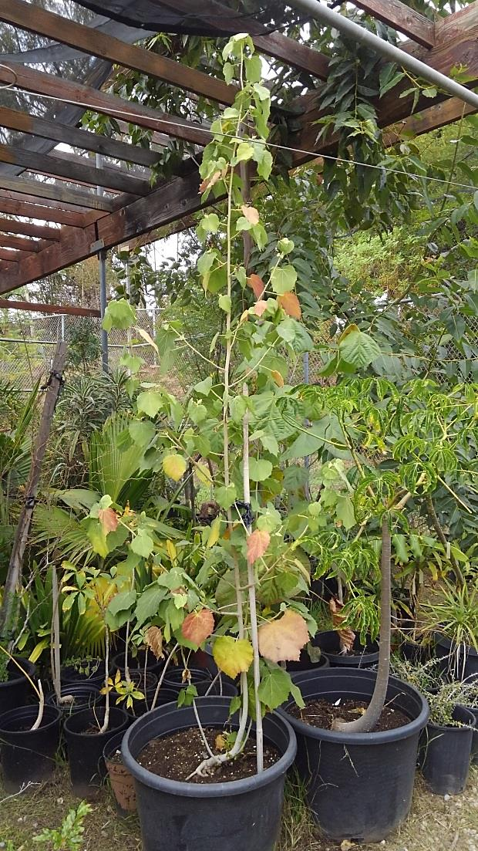**

***Hibiscadelphus distans* in the nursery March 2018. We moved it to a location with a bit more sun this year to test its sun tolerance. Oddly, it seems as a larger and older specimen it can tolerate more sun.**

**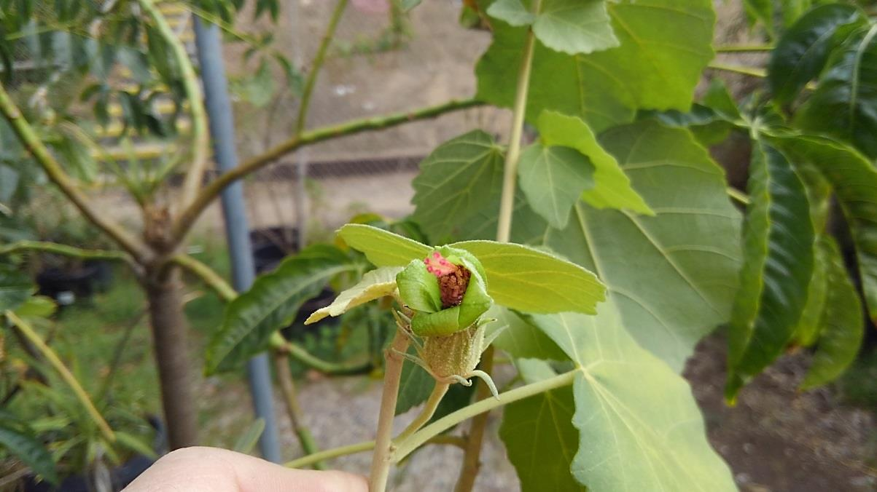**

**Young bloom on the *Hibiscadelphus distans*.**

**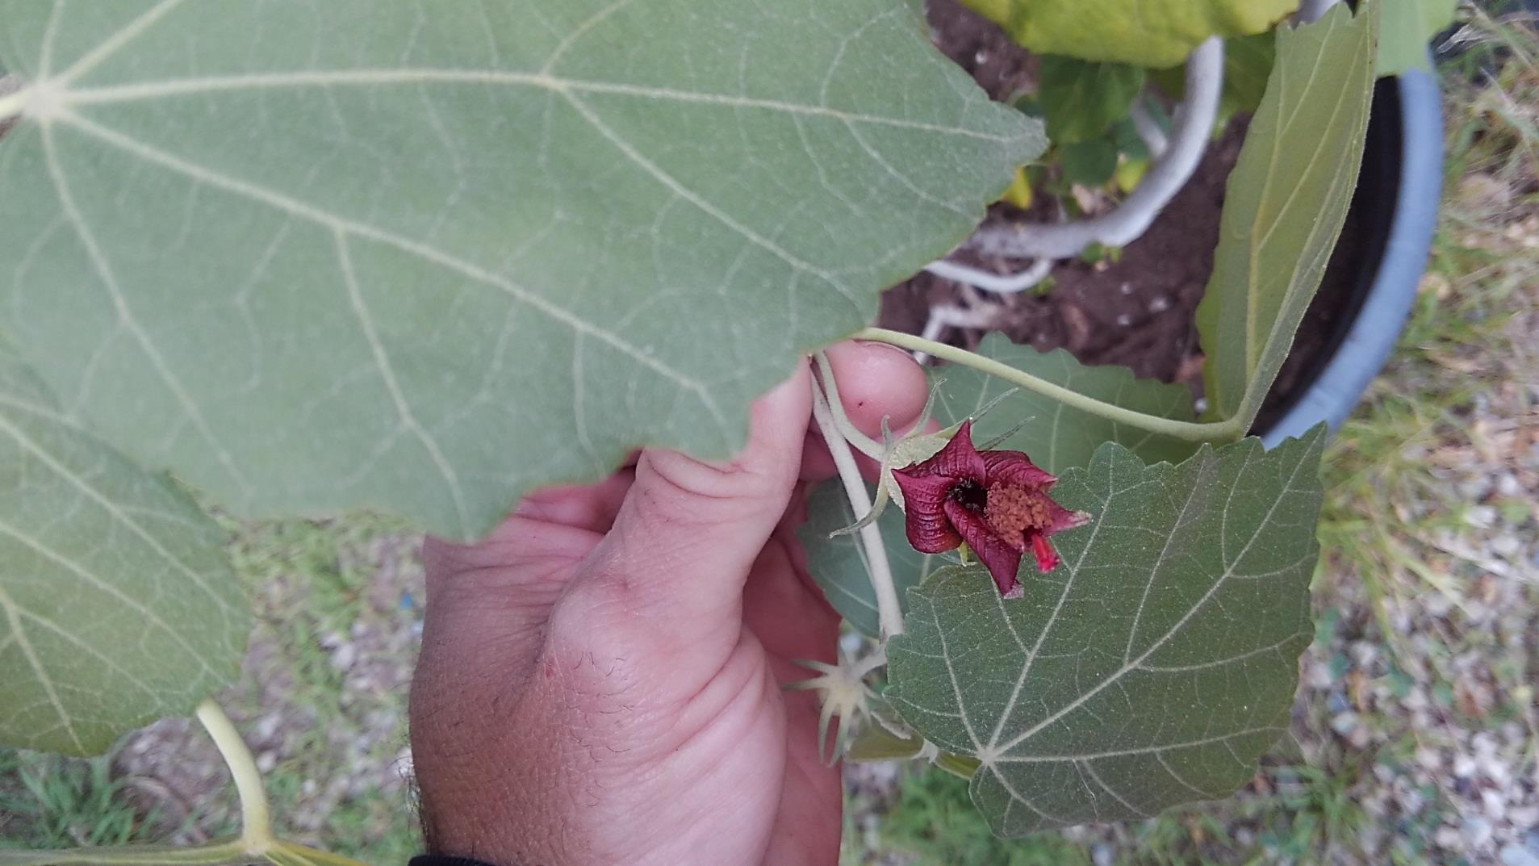**

**Older bloom on the same *HIbiscadelphus distans*.**

**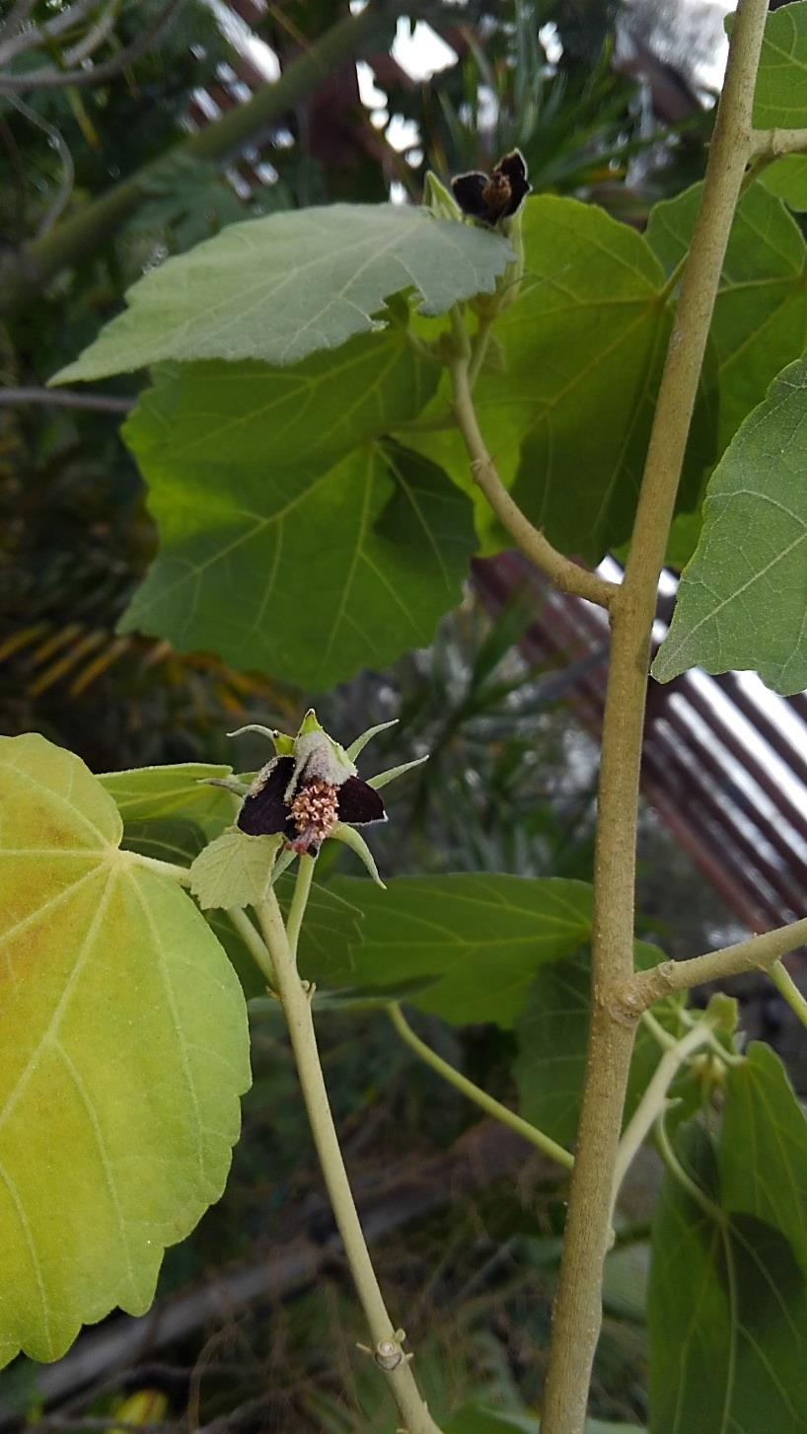**

**Nearly dead and abscised bloom on the same *Hibiscadelphus distans.***

**Pest Problems**

This year the plants in the garden struggled with the same two or three pests that attack them every year, though generally the infestations are mild.

**The plant pests listed below have shown an affinity for the plant species currently being grown in the nursery and landscape during 2017.**

* *Tetranychus sp.* -**Red Spider Mite**
* *Graphocephalla atropunctata –***Bluegreen sharpshooter**

The three specimens of *Sesbania tomentosa* in the Polynesian Garden during the summer of 2017 again developed a mild to moderate infestation of *Graphocephalla atropunctata* (**Blue-green sharpshooter**), which caused some mild defoliation. The plants were promptly treated with a systemic insecticide, which quickly resolved the issue.

Though we have historically seen Blue-green Sharp Shooters on the plants during the warmer months, we have occasionally seen the *Homalodisca vitripennis* the (Glassy-wing sharpshooter) on the *Sesbania* plants as well. Though rarely if ever in significant numbers. In the 2015 Annual Report, I briefly mentioned the possibility of Pierces Disease being vectored to the Sesbania plants in the landscape by the Glassy-wing sharpshooter. Though the concern is real, the likely hood is low. This year USFWS provided us with an approval letter to send some tissue samples of the plants to a lab for testing. If the plants come back as negative for *Xylella fastidiosa*, (which is the bacteria that causes **Pierces disease**) we can assume the seeds should be free of the disease as well. If the plants are found to be positive, we will then need to consider sending seeds off for testing. Though to date there is no known study that confirms *Xylella* can be vectored via seed. I expect to have more on this topic in next year’s annual report.

Historically Red spider mite has been voracious on the foliage of the *Sesbania tomentosa* in the green house, but until 2016 and 2017 it had not been a problem in the landscape. Oddly, the infestation of *Graphocephalla atropunctata* (**Blue-green sharpshooter**) on the *Sesbania tomentosa* was again this year followed by a Red Spider Mite infestation. To combat the Red Spider Mite, we sprayed the plants with horticultural oil, which we followed three weeks later with a weekly washing down, using a garden hose for the next two weeks. The end result was increased vigor on all of the plants.

**Response to Cold**

As mentioned before; *Sesbania tomentosa* is fast growing and tolerant of air temperatures to at least 29 degrees Fahrenheit. However, these plants are not tolerant of prolonged drought and seem slightly temperamental to prolonged root temperatures in the low 40s high 30sF.

The early part of this winter was very dry in California, with the first “Real” storm hitting in January. This storm dumped an estimated four inches of rain over the course of 24 hours. Until then it was mild as far as cold temperatures are concerned. In fact it was quite warm all winter until the January storm, which was followed by many cold nights and the occasional odd frost in late February.

Though many of the *Sesbania* plants are now (in late March) showing some bronzing of foliage and some leaf drop. This has been the norm for all of the landscape *Sesbania* plants at the end of winter here in Southern California. From past experience I expect at least two of the three plants in the garden to survive. The largest specimen, 4-1 looks to be on the decline, though time will tell. Interestingly, as the surrounding foliage has grown 4-1 is now exposed to a bit less sunlight in the winter than it may have received over the previous years. 4-3 at this time last year looked equally as bad, but as the weather warmed it grew back with vigor and stretched out into the sun. Although 4-3 is the smallest in the garden it looks quite healthy for this time of year.

**Response to Shade**

As the *Hibiscadelphus distans* grew it was moved to a larger pot and as a result became exposed to a bit more sun than in the last few years. Growth was not measuredly faster than in the previous year, however; flowering was substantially more prolific, though this could be a function of age and size of the plant, not directly due to more sun exposure. At this point I would still contend that it seems *Hibiscadelphus distans* and *Polycias racemosum* seem to prefer at least some shade over full sun here in Southern California, which seems concurrent with the previous assumption that they may prefer cooler temperatures that are likely similar to those of their native range.

Alternately, *Sesbania tomentosa* still seems to not prefer shade at all. All the plants that have been planted in the shade over the years, died within a few months, or stretched out towards the sun.

**Garden Areas as of March 2018**

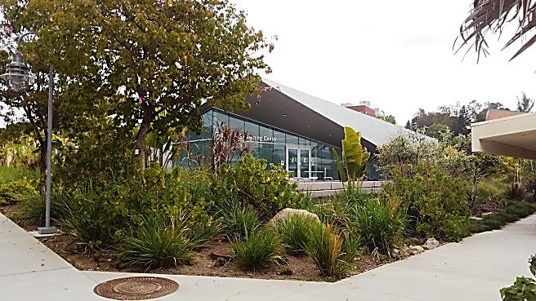

**A view of the South Plaza of the Teaching & Learning Center, March 2018.**

The image above shows a new look for the TLC buildings’ South Plaza. To reduce our water use, the old lawn was removed in 2017 and California Native grasses along with plants native to Madagascar were planted. Madagascar plants were chosen instead of Polynesian plants because the plants in the adjacent planters are from Madagascar. So we opted to use this small corner to continue the Madagascar theme.

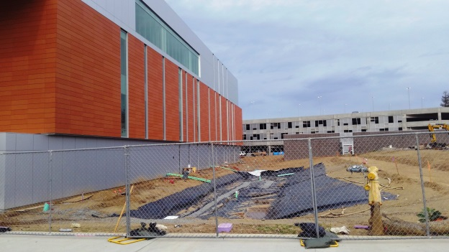

**The image above shows the north side of the newly constructed Library. The plants in this bed will focus on California natives and utilize many of the same grasses planted nearby in the Madagascar and Polynesian Gardens. The black liner in the photo is the underlayment for a storm water bio retention basin. The goal being that the water will filter through the soil and plant roots before reaching the drain at the bottom and then flowing down stream.**

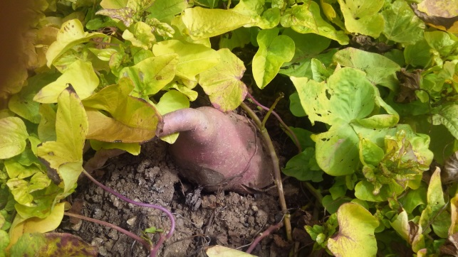

***Shown above is Ipomoea batatas ‘Margarita’* (Sweet Potato) growing in the Polynesian Garden, March 2018. This cultivar does not take frost as well as some other varieties, though it quickly grows back every spring.**

As discussed last year, drought conditions are common place events in California. In San Marcos at the main campus, it is rare to receive more than 18 inches of precipitation per year. As a result, water management strategies are a significant concern and play a major role in the garden design. The newly installed stream that flows though the “faux” lava field, is flowing because we were able to capture rain water off of the nearby Math Center roof. We have stored 1,500 gallons underground in a tank. The water is then pumped through the stream bed during the day, shut off at night, and then completely drained back into the underground tank until the timer turns the flow back on in the morning.

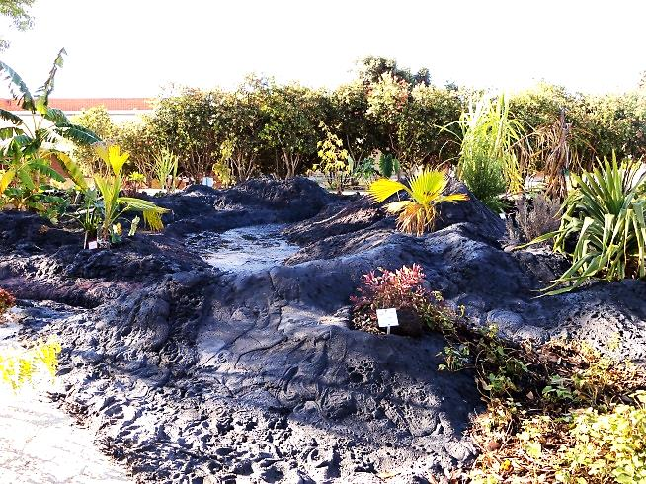

**An early morning view of the faux lava and the flowing stream, February 2017.**

**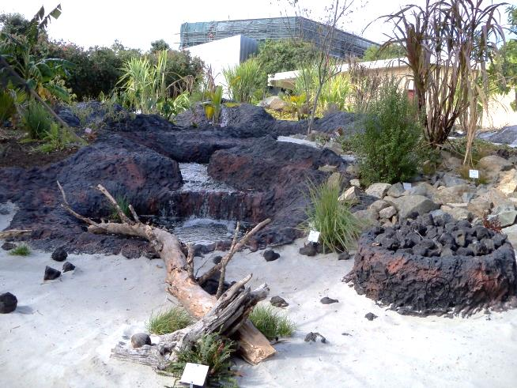**

**The end of the stream terminates at a white sand beach. What looks like a fire ring on the right, is actually the disguised water storage tank lid.**

**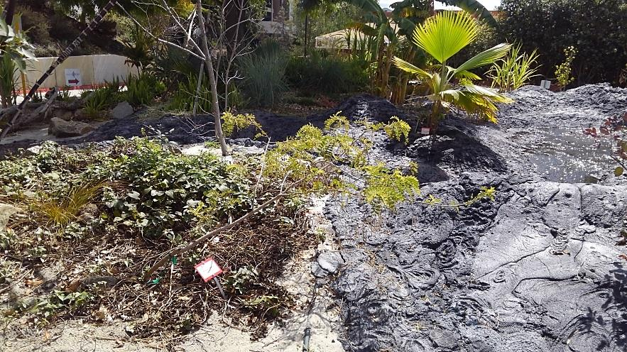**

**While a mild frost did damage to this variety of *Ipomoea batatas* (Sweet Potato), which is the ground ground cover in the image. This *Sesbania tomentosa* seems mostly un-phased by the icy chill that set in the area nearly 3 weeks earlier. Interestingly; this Sweet Potato is normally much hardier that the one in the previous picture. This *Sesbania* is 4-3 on the seed list.**

**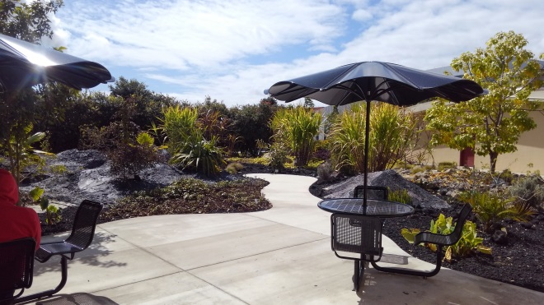**

**Seating areas in the Polynesian Garden are constantly in use. Students love to sit and enjoy the sights and sounds even on a cold day in February.**

**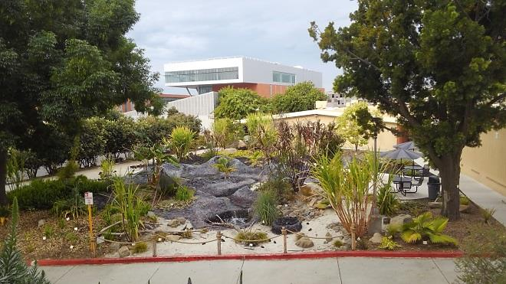**

**This is the view from the Natural Sciences building west terrace, looking west over the Polynesian Garden, with the new Library nearly complete in the background.**

**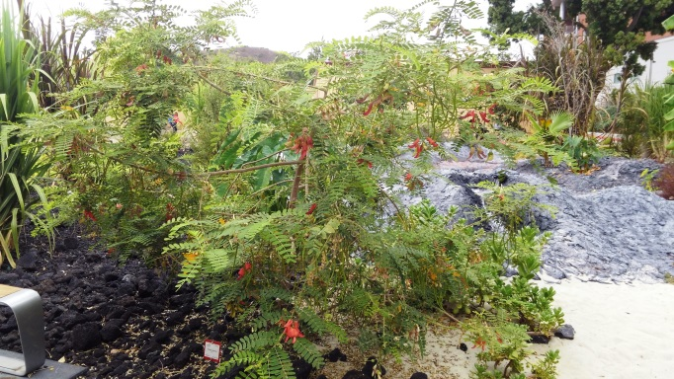**

***Sesbania tomentosa* in the Polynesian Garden. This is plant 4-1 on the seed list, which provided us with the majority of the seed harvested this year. The photo was taken in September 2017.**

**Future Nursery Site**

In the next 18 months or so, the Edwin and Francis Hunter Arboretum, (which is a beautiful, mature, roughly 10 acre garden, east of Comet Circle on the main campus in San Marcos) will be provided a trail and irrigation make over. This renovation will provide the collection that has been growing since the early 1970’s, a more modern irrigation system and a trail system that will allow visitors with disabilities to see a significant portion of the unique collection with ease. Up to this point no Handicap accessible route has been present. So with the renovation, we expect to increase visibility of the garden and increase the vigor of the plants and trees with the upgrades to the irrigation.

Adjacent to the “Formal Arboretum” is the site of the new Nursery Location. This location will be the future home of the new green house and grow out facilities. The new Facilities will be “state of the art” and provide us a larger more organized space than we have had to this point. Though the facility will be primarily used by “US” the Grounds Services division of the Maintenance and Operations Department, it will also be near the Natural Sciences building, which will better provide opportunities for Faculty to engage their students in the study of horticulture and plant sciences.

Adjacent to the greenhouse, shadehouse and grow out yards will be a pad set aside for a future Visitors Center. This center will also house a small seed bank and a lab for tissue culture, plant DNA, plant pathology and agronomic studies. Specifically the lab will focus on propagation and conservation of present and future district held accessioned collections. The visitor center will have a small foyer for museum displays, possibly a small book/gift shop and centralized computer access to the plant database. In the back will be an outdoor amphitheater for lectures. While the Visitor Center will require outside funding to be built, the nursery will be paid for with Prop M funding. The nursery site and the Edwin and Francis Hunter Arboretum will also have a new well that will be used for irrigation. This will alleviate some of our dependency on domestic or municipal water supplies.

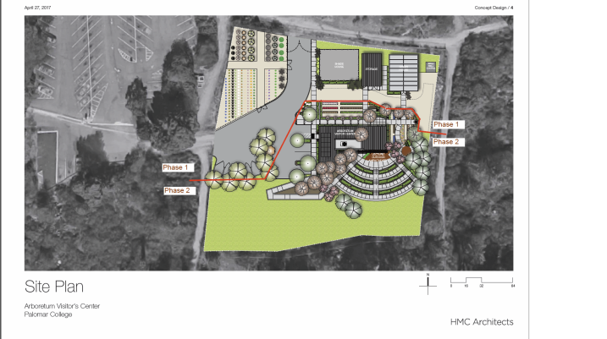

**The above is a conceptual image of the new nursery and Visitor Center site plan.**

**Educational Outreach**

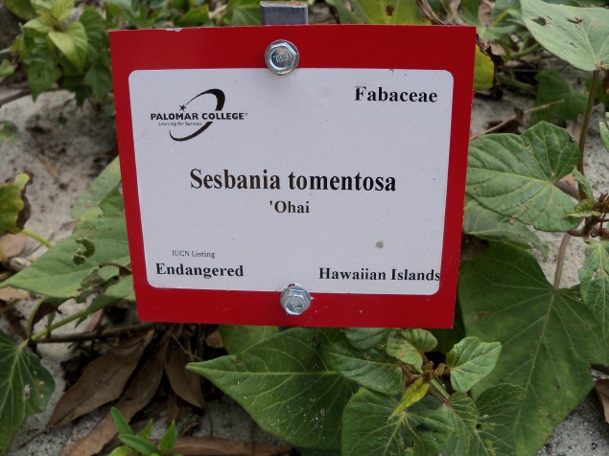

**An example of the new garden plant labels. [2]**

As mentioned in reports from years’ past, each species when they are planted in the garden are given a plaque or label. These labels provide some basic information concerning the plant. The scientific name of the plant is given, as well as the plant’s common name (often in Hawaiian or another Polynesian language), the place of origin, botanical family and the IUCN Red List status or USFWS listing status. By giving visitors insight to what they are looking at, these labels help to educate the public and have the effect of engaging them in thought and further discussion. In last year’s report I mentioned we changed the color of the label plates to better draw attention to those plants in the collection that are vulnerable, threatened or endangered. We did this by placing the label on a yellow plate for plants considered by the IUCN to be vulnerable or threatened and those that are endangered were placed on a red plate. The remaining plants in the collection are named in the field with a standard white label, placed on a white plate.

Growing T&E plants is a great undertaking and it comes with a responsibility to share knowledge and findings with others, as well as to take advantage of educational opportunities when they arise. Ex-situ and in-situ conservation efforts are important, but so is educating the public about why botanical institutions do the work we do. The intent of growing these species on campus (first and foremost) was to create a unique garden to showcase plants from Hawaii and Greater Polynesia that are in peril; this hopefully encourages people to become active in conservation efforts wherever they may live. This year, at least **4** formal tours, with 20-30 attendees on each tour, were shown the Polynesian Garden; countless other individuals were given personal tours of the garden. This year again, I personally saw students stopping to read the signs and then looking up plants on their cell phones.

Another opportunity for outreach is the Friends of the Edwin and Francis Hunter Arboretum News Letter. For example; Wayne Armstrong a former botany instructor and board member for the FEFH Arboretum, did a small article in the newsletter that is set for release this spring. The article covers the *Brighamia insignis* (**Alula**) plants that we have had for years. Interestingly last fall one of the plants produced capsules that contained tiny seed. We decided to gather the seed to see if it was viable. To our surprise the seed was indeed viable. As a result of the planting effort we ended up with a few seedlings from the experiment. What was shocking is that this year again the plant produced capsules with seed. Though we have not yet planted those seed, we assume they must be viable. The question is what is doing the pollinating? Some have assumed it might be ants, while others have suggested it might be a native hawkmoth? Whatever is doing the pollinating on campus, it is apparently not present on the Hawaiian Islands to pollinate the plants in the wild. Without a pollinator, no seeds can be developed and in addition to habitat destruction the lack of a pollinator has driven this species to inevitable extinction in the wild, as apparently only one specimen remains alive in habitat. **[3]** The plant is thankfully popular in cultivation, but sadly is not likely to ever be found in the wild again.



**Courtesy of Wayne Armstrong, who took this photo last fall in the Polynesian Garden on Campus.**

At this point, collectively, these approaches only scratch the surface of the possibilities. But they do meet our goal of conservation through education and cultivation. As time progresses, we will certainly improve upon our educational program and hope that the end result will be that our visitors are one step closer to contributing to a society that is willing to sacrifice, even if just a little, to preserve our planet’s beautiful biodiversity.

**Conclusion**

The opportunity to grow unique and rare plants such as the Hawaiian T&E species listed above has provided us new insight to their cultural requirements and tolerances. As we move forward in our efforts to grow many of these rare and unique species, we will no doubt continue to learn more about their adaptability and survivability in new habitats. This information may help in conservation efforts, but will at least provide us with an opportunity to share our discoveries with others. And no doubt, for some species that can adapt to California’s climate, they will have the chance to serve as ambassadors for conservation to the students, staff, faculty and the community.

**Bibliography**

**[1]** <https://dlnr.hawaii.gov/wildlife/files/2013/09/Fact-Sheet-Sesbania-tomentosa.pdf>

**[2]** The IUCN Red List of Threatened Species. Version 2014.3. <[www.iucnredlist.org](http://www.iucnredlist.org/)>. Downloaded on **03 March 2015**.

**[3]** <http://www.iucnredlist.org/details/44080/0>

**Palomar Community College District,**

**Interim Grounds Services Supervisor**

**I.S.A. Certified Arborists**

**WE-8721A -Antonio Rangel**

****

**Date:\_ March 22, 2018\_\_\_\_\_\_\_\_\_\_\_\_\_**