Spring Anthropology Courses
Introduction to Biological Anthropology – ANTH 100 (3 units)
*Satisfies Area 5B – Biological Sciences for IGETC CSU/UC
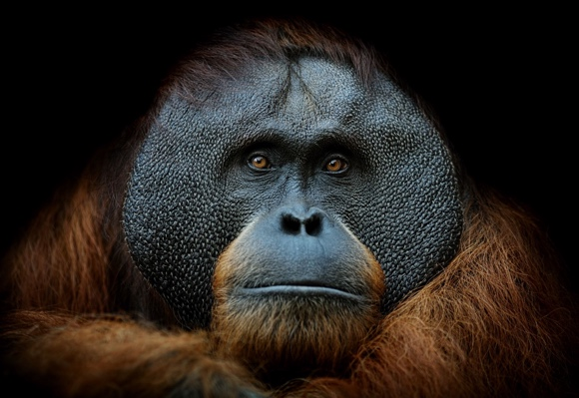
ANTH 100 MW 9:35-11:00 MD-124 SAN MARCOS
ANTH 100 MW 11:10-12:35 MD-124 SAN MARCOS
ANTH 100 MW 12:45-2:10 MD-124 SAN MARCOS
ANTH 100 TTH 9:35-11:00 MD-124 SAN MARCOS
ANTH 100 TTH 11:10-12:35 MD-124 SAN MARCOS
ANTH 100 TTH 12:45-2:10 MD-124 SAN MARCOS
ANTH 100 TUE 6:00 – 9:10 MD-124 SAN MARCOS
ANTH 100 ONLINE

Biological Anthropology Laboratory – ANTH 100L (1 unit)
*Satisfies Area 5C – Biological Sciences for IGETC CSU/UC
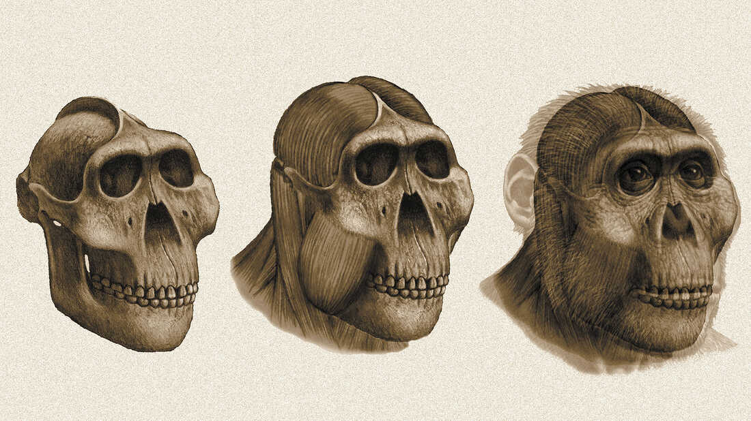
ANTH 100L THU 6:00-9:10 MD-124 SAN MARCOS
ANTH 100L FRI 11:20-2:30 MD-124 SAN MARCOS

Biological Anthropology Lecture and Lab – ANTH 101 (4 units)
*Satisfies Area 5B and 5C – Biological Sciences for IGETC CSU/UC
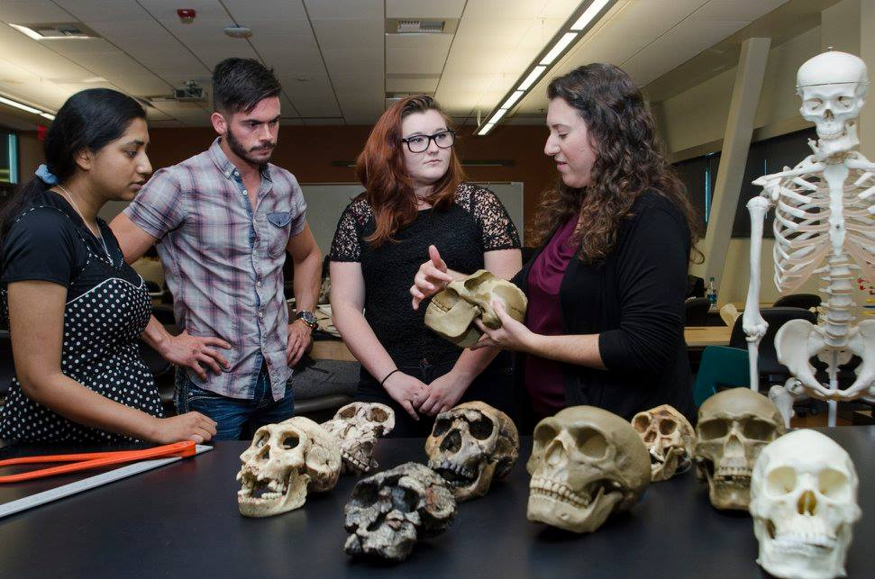
ANTH 101 TTH 2.40 - 5.50 MD-124 SAN MARCOS

Introduction to Cultural Anthropology – ANTH 105 (3 units)
*Satisfies Area 4 – Social and Behavioral Sciences for IGETC CSU/UC
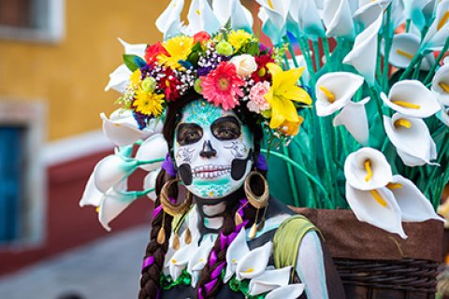
ANTH 105 MW 9:35-11:00 MD-221 SAN MARCOS
ANTH 105 MW 11:10-12:35 MD-221 SAN MARCOS
ANTH 105 TTH 9:35-11:00 MD-221 SAN MARCOS
ANTH 105 ONLINE

Introduction to Archaeology – ANTH 110 (3 units)
*Satisfies Area 4 – Social and Behavioral Sciences for IGETC CSU/UC
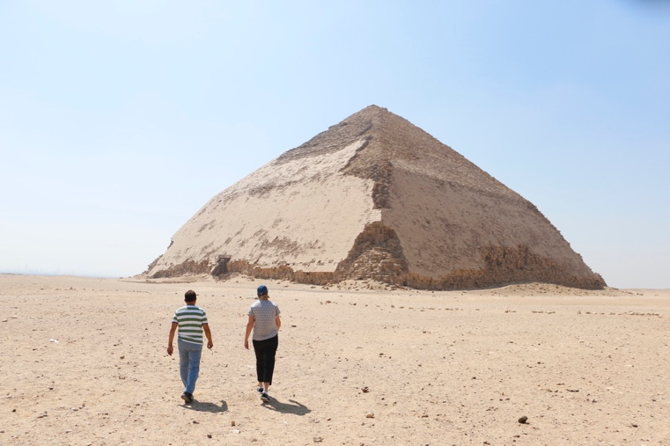
ANTH 110 TTH 11:10-12:35 MD-221 SAN MARCOS

APPLYING ARCHAEOLOGY – ANTH 115 (3 units)
*Satisfies Requirement for Archaeology Certificate/ Employment
ANTH 121 ONLINE
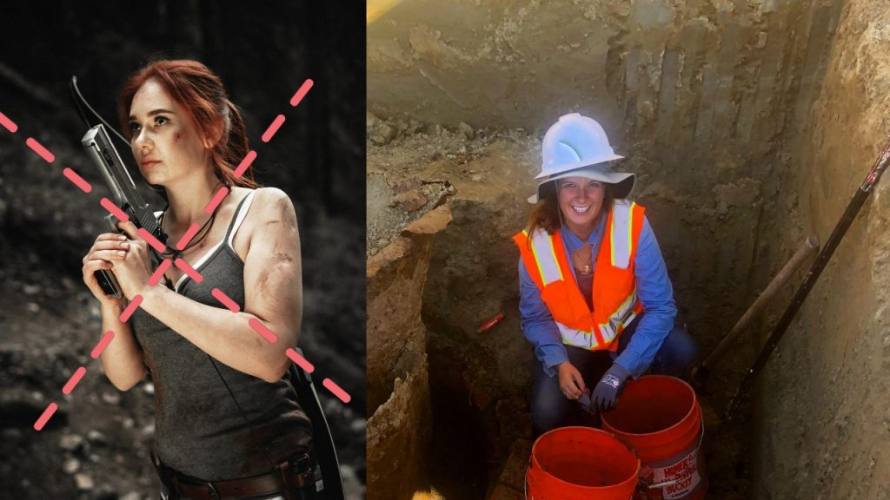

Magic, Witchcraft, and Religion – ANTH 135 (3 units)
*Satisfies Area 3B – Arts and Humanities for IGETC CSU/UC
ANTH 135 TTH 12:45 – 2:10 MD-221 SAN MARCOS
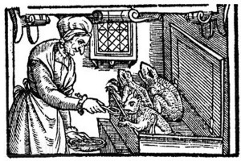

Archaeological Surveying/Advanced Archaeological Surveying – ANTH 210/220 (3 units)
*Satisfies Requirement for Archaeology Certificate/Field Work Employment
ANTH 210/220 FRI 8:00 -12:05 MD-221 SAN MARCOS
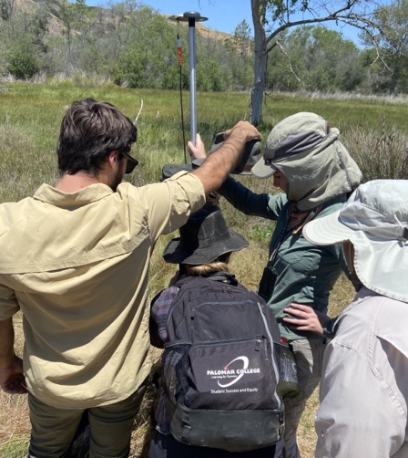

Archaeological Laboratory Analysis – ANTH 215 (3 units)
*Satisfies Requirement for Archaeology Certificate/ Employment
ANTH 215 WED 12:45-4:50 MD-121 SAN MARCOS
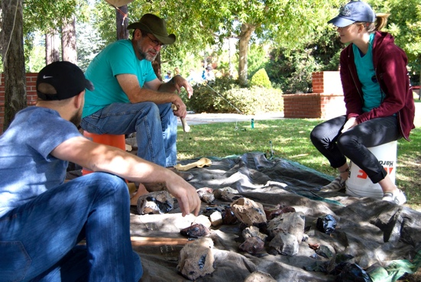

Historical Archaeology – ANTH 225 (3 units)
*Satisfies Requirement for Archaeology Certificate/ Employment
ANTH 225 FRI 12:30-2:00 MD-221 SAN MARCOS
(Lecture)
SAT 8:00-4:00 Elfin Forest Excavating at late 1800s adobe
(TBD) (Lab)

*The labs for this class take place at a historic structure in Elfin Forest. Eight Saturdays will be selected during the semester. No prerequisites are required for this class.
