þÿ

**STUDENTS Quick Start Guide**

# STEP 1: FIRST-TIME USERS--CREATE YOUR ACCOUNT (one time only)

* Go to your **Login** page at **ht**[**tps://w**](http://www.catema.com/palomar/)**ww.**[**catema.com/palomar/**](http://www.catema.com/palomar/)
* Click on **New Student =>** select **Create Account.** Follow the prompts to create your user account & click **Submit**. Your “Username” and “Password” will be automatically generated, based on your personal information (See the explanation below).

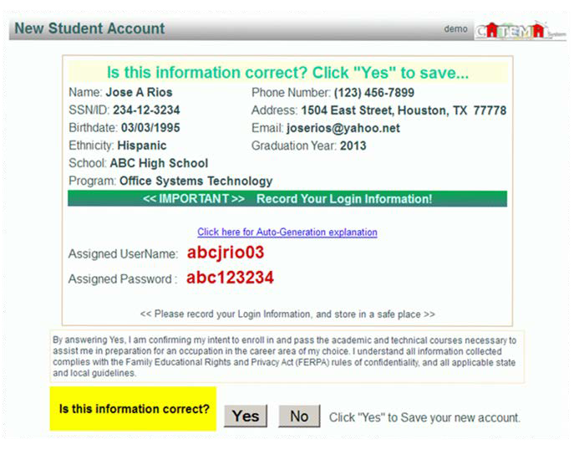

After your new student account has been created, make **note** of your **username** and **password**, and save it in a safe location. You must then “enroll” in your CTE articulated classes. Please **DON’T LOG OUT YET! => Enter your class enrollment record(s)…**

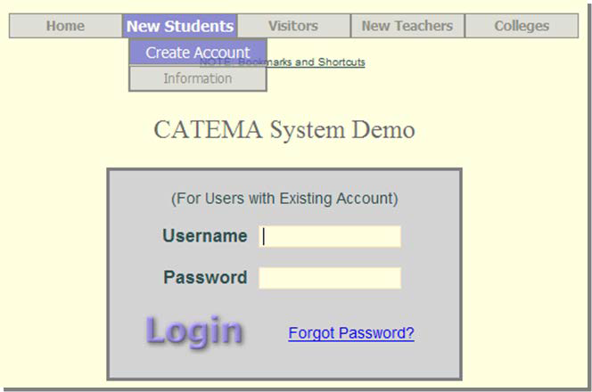

# STEP 2: CREATE CLASS ENROLLMENT RECORD(S)

* **Create an enrollment record** for each CTE articulated class you are taking.

## Select the following from the drop-down lists and **click Submit**…

* + 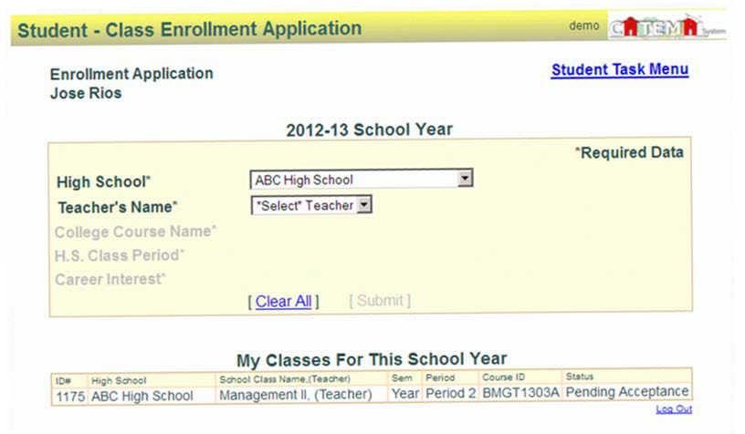**High School**
  + **Teacher**
  + **Class Name**
  + **Class Period**

Once your new account has been created, and you have “enrolled” in each class, please “**Log Out**”. Since you may be returning to the site to register for more classes in high school, **remember your Username and Password**. While logged in, you can view your class history and teacher recommendations, and update personal information.

**Auto – Generated Username and Password**

The **Username** is created by combining the following characters...

**=> First 3 letters of the high school name (lower case)**

**=> First letter of the first name (lower case)**

**=> First 3 letters of the last name (lower case)**

**=> Birth day - 2 digits (01, 02, 03, … 31) ; example - birthday July 9th - use 09**

EXAMPLE: For Central High School student Barry Jones, born on July 9th...

The **Username** will be "**cenbjon09**"

The **Password** is created in a similar manner...

**=> First (3) three letters of the high school name (lower case)**

**=> Last (6) six digits of your social security number OR student ID#**

EXAMPLE: Barry Jones from Central High School with a SS# 215-61-0121

The **Password** will be **"cen610121"**

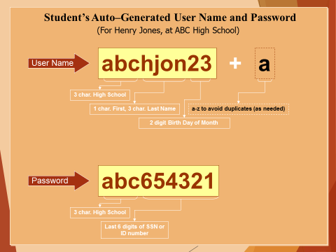

or use the “**Go To Student Login Assistant**” link on Login page.